Before you start the hands on, please note ...

publishing web site files
In tutorial we just moved our files to the W drive, and that's how you will also submit assignment 2. So this is just to let you know how publishing is done.

To tell Dreamweaver (DW) where your new site will be…
>Site (top toolbar) >New Site... >Basic tab

To tell DW where your html, css and graphics files will be on your computer …
>Advanced tab
>Cancel (since we will not go ahead with this)

When you have completed developing your html files, to publish them (put them on the web site) …
select the file in the Files pane
>Site >Put
Note: there is a log created so you have a history of publishing.

CSS examples
Go to CSS examples - w3schools

To make a style apply to all occurrences of a tag …
in the Text section > Set the color of the text

To make a style apply for some occurrences of a tag (class definitions) …
in the Text section > Control the letters in a text

You can copy and paste any css statements
- into your own css file
- or into your html file if the css is internal

 | - Do not change the name of your folder when you move the folder to the W drive.  - All your files can be in one folder – but if you use more than one folder (e.g. images in a separate subfolder) remember that most of the links are relative, and you have to maintain that relationship when you move the folders online.  - When you start a new file and choose a Layout, it comes with an embedded style sheet. In the first tutorial we used div to section off the web page but now we will have to add the style sheet.

Now the hands on . . .
You will create a web page with two frames, and there will be a total of 10 files when done.
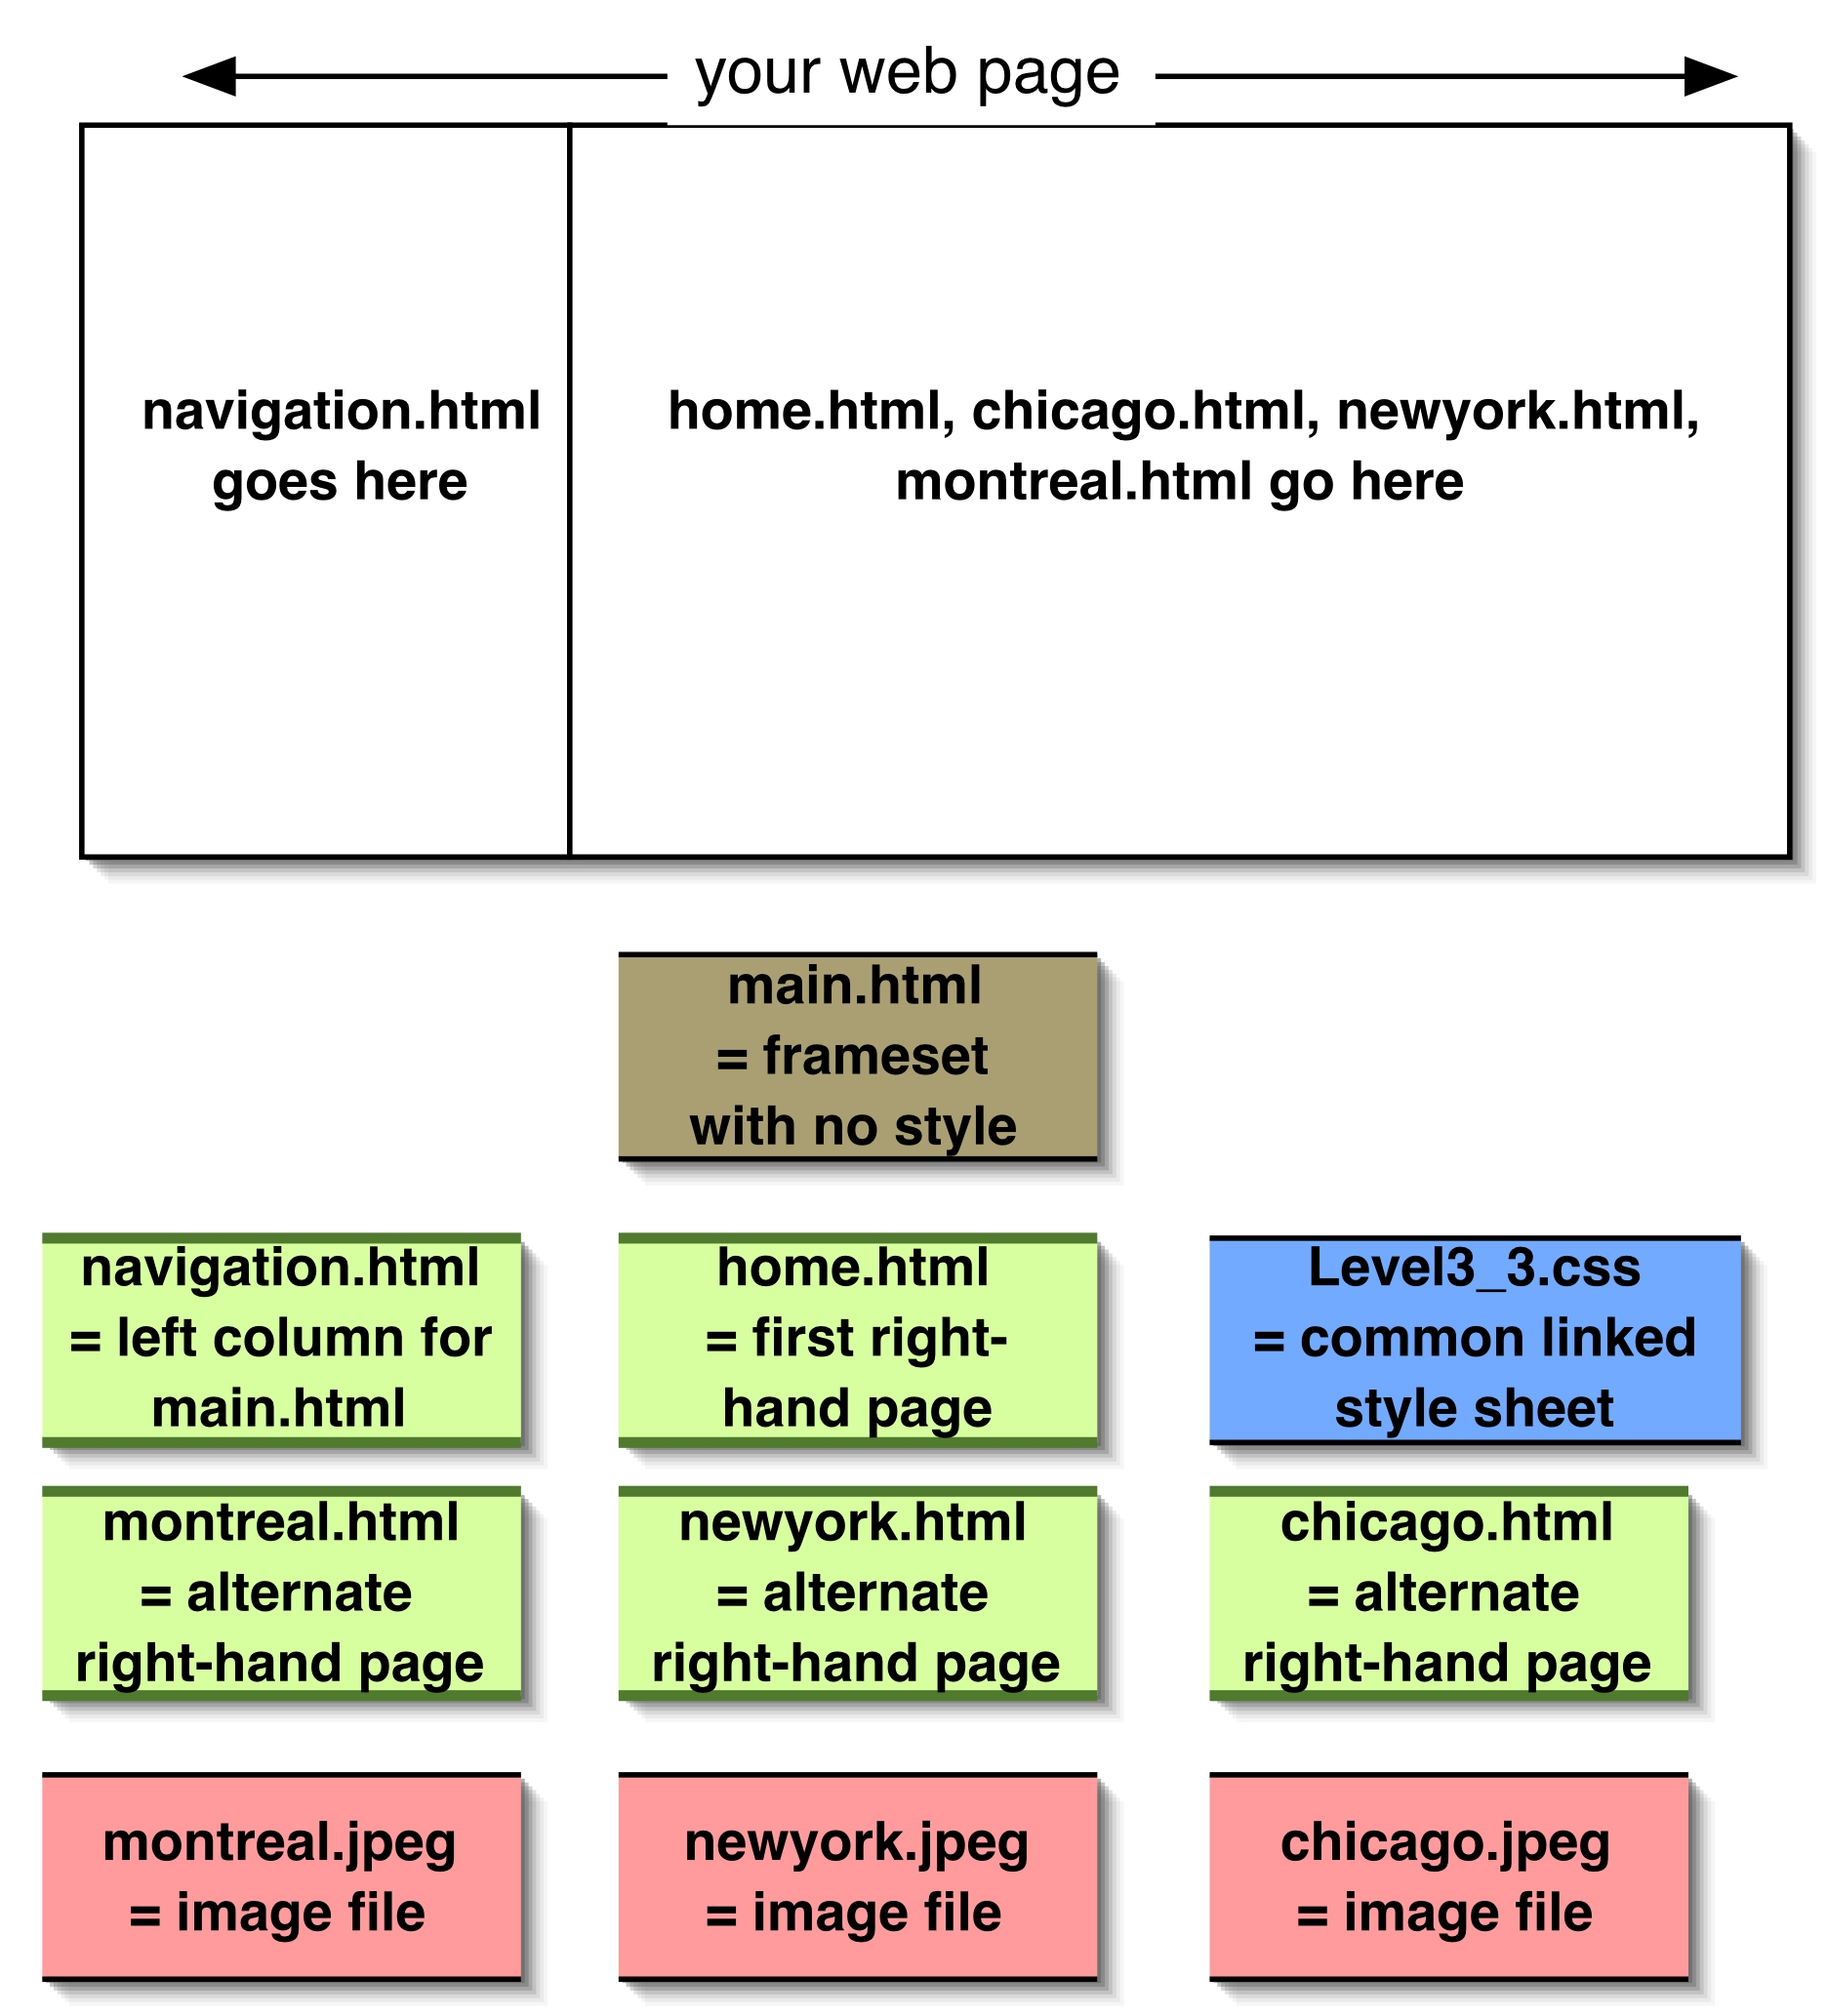

start by downloading some files
Create a new folder called A01Test02 on the desktop.
Go to the course web site, Tutorial page …
> June 9 tutorial files
Download all the files and put them into the A01Test01 folder.

give the html files an external style sheet
Open Dreamweaver
>File >Open
Select newyork.html in the A01Test02 folder >Open
(you can use Dreamweaver to change or fix any html file)
>CSS task pane > Attach Style Sheet >Sample Style Sheets
>Full Design: Verdana...
(note that the Save to goes to the same folder as the html file we are using)
>OK
select the words "New York"
>Style dropdown >"title" (an example of using the style)
click anywhere in the first paragraph
>Style dropdown >“dingbat” (changes the whole paragraph)
>Style dropdown >“none” (to make it normal again)

add an image and clean it up
click just before the word "Lorem"
>Insert bar >Common tab >Images dropdown >Image
>newyork (note: in the URL textbox you could enter a URL pointing
to another image somewhere else on the internet , creating an absolute link – but now it's going to be a relative link)
>OK add alternate text >OK

select the newyork image
>Align dropdown >Left
the text is too close to the image, so...
V Space = 10 H Space = 10
>save and close newyork.html

add the same styles to another page
>File >Open select chicago.html >Open
>CSS task pane > Attach Style Sheet
>Browse (we already have a stylesheet)
select Level3_3.css in A01Test02
>OK
>Add as: Link (to keep it as an external style sheet)
>OK
>save and close chicago

Do the same for montreal.html

You can add the images to montreal and chicago later.

create the frameset and the two frames
>File >New >Blank page >HTML >none (we don't want divisions this time)
>Create
>Insert toolbar >Layout tab >Frames dropdown >Left Frame
using the Frame: dropdown, give the frames titles
leftFrame title = navigation
mainFrame title = home
>OK

label and save the two frames
>left frame/column (note: file name = UntitledFrame)
change the Title to “navigation”
>File >Save Frame
save in A01Test02
File name = navigation
>Save (the file name has changed)

>right frame/column (note: file name = Untitled)
change the Title to “home”
>File >Save Frame
save in A01Test02
File name = home (the file name has changed)
>Save

label and save the frameset file
>border between the frames (when the cursor becomes double arrow)
(note: file name = UntitledFrameset)
change the Title to “Travel Agent” (this is the only title that shows on the browser)
>File >Save Frameset
save in A01Test02
File name = main
>Save

make sure all our files are visible
>Files task pane
R> in Files pane >Refresh (your should now see all 10 files)

add some contents
Type the following into the two frames
Travel Agent  Home  Chicago  New York  Montreal  google  email us | one heading  a couple of lines of text

Take a look at the web page so far (you still need the links and styles)

>Preview/Debug in Browser (it’s the earth icon)
>Preview in IE (or Firefox or …) (note: you could just >F12)
>OK to save
Each time you do the preview, you must refresh the browser page to see the latest changes.

If the left (navigation) frame is too narrow, click on the border between the frames and move the border.

add styles to the frames
>navigation frame
>CSS task pane > Attach Style Sheet >Browse (we already have a stylesheet)
>Level3_3.css in A01Test02
>OK
>Add as: Link (to keep it as an external style sheet)
>OK

repeat the above for the home frame
(each frame = separate page so could have different ccs for each frame)

use the styles
select the text "Travel Agent"
>Style >something larger

link the pages so the right-hand frame changes
first make sure you can see all the files – you may have to close the CSS frame
>Files task pane
R> in Files pane >refresh

select the text "Home"
>Link: Point to File button
drag to home.html in the Files pane
and because we don't want home.html to open in the navigation pane …
>target dropdown >mainFrame

do the Chicago, New York and Montreal links the same way

try it out
>F12 >OK save >refresh

add an absolute link to a new window
select the text “google”
into the Link text box, type …
http://www.google.ca
>Target dropdown >_blank (this will open a new window)

add an email address
select the text "email us"
>Insert toolbar >Common tab >Email Link icon
fill in the email address >OK

inspection
> the vertical bar between the navigation and the home frames so that the cursor becomes a double-headed arrow and you see the main.html file name.
>Code icon (so you can see the HTML code for main.html)
Look for the two <frame statements…

If you see that src=”file:///C etc.
then the reference is to your C drive and you need to fix it!
For example …

<frame src="file:///C|/Documents and Settings/wainbantin/Desktop/A01Test02/navigation.html" name="leftFrame" scrolling="No" noresize="noresize" id="leftFrame" title="navigation" />
<frame src="file:///C|/Documents and Settings/wainbantin/Desktop/A01Test02/home.html" name="mainFrame" id="mainFrame" title="home" />

carefully delete everything between src=“ and navigation.html”
carefully delete everything between src=“ and home.html”
so the src parameters look like this

<frame src="navigation.html" name="leftFrame" scrolling="No" noresize="noresize" id="leftFrame" title="navigation" />
<frame src="home.html" name="mainFrame" id="mainFrame" title="home" />

>Save All
close Dreamweaver

wrap-up

Move the A01Test02 folder to your W drive – don’t change the folder name, and don’t move the files one at a time.
Double click on any html file to test it.

In your browser use a full URL
http://www.utsc.utoronto.ca/~yourid/A01Test02/main.html
to test again

