If you don’t see what you want here, open tutorial 01, 02 or 03 instructions.
file used in this tutorial: A01TutExcel04*.xls

misc 1
formulas 1
background 1
if statements 1
examples 1
index and match functions 2
statistical functions 2
practice pivot tables 2

misc
if you have a spreadsheet that takes a long time to calculate
>Tools >Options >Calculation tab >Manual
then press function key F9 when you want the calculations to be done
to calculate all the time
>Tools >Options >Calculation tab >Automatic

formulas

background
order of operations is: Brackets
Exponents caret (^ )
Division forward slash ( / )
Multiplication asterisk (* )
Addition plus sign ( + )
Subtraction minus sign ( - )

if statements

examples
from the IF Statements – TechTrax link in the course site link page
if your formulas look like this
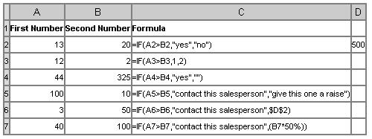
then the results will look like this
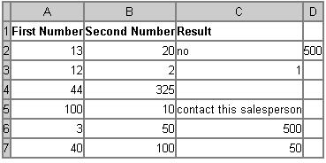
note that text (strings) must be enclosed in quote marks

=IF(A1="Charly",120, IF(A1="Mike",64, IF(A1="John",36,20) ) )

If A1 contains Charly the result will be 120
Mike 64
John 36
David 20

Question: In Excel, I need a formula in cell C5 that does the following:
IF A1+B1 <= 4, return $20
IF A1+B1 > 4 but <= 9, return $35
IF A1+B1 > 9 but <= 14, return $50
IF A1+B1 > 15, return $75
Answer: In cell C5, you can write a nested IF statement that uses the AND function as follows:
=IF((A1+B1)<=4,20,IF(AND((A1+B1)>4,(A1+B1)<=9),35,IF(AND((A1+B1)>9,(A1+B1)<=14),50,75)))

index and match functions
open A01TutExcel03PivotTable01.xls

we want to be able to enter the name of a player and find out what team they are on

>A211 enter Brenda
>B211 =INDEX(C2:C208,MATCH(A211,A2:A208,0))
match locates A211 in the column A2:A208 and gives the row number
index picks up from that row in column C2:C208

statistical functions
A sales manager might want to project the next quarter's sales (TREND function).
A teacher might want to grade on a curve based on average scores (AVERAGE, MEDIAN, or MODE).
A manufacturer checking product quality might be interested in the range of items that fall out of acceptable quality limits (STDEV or VAR).
A market researcher might need to find out how many responses in a survey fell within a range of responses (FREQUENCY).

open A01TutExcel04Variance.xls
we will be following the instructions for the exercise at the end of http://office.microsoft.com/training/
>Office 2003 >Excel 2003 >Excel statistical functions

practice pivot tables
open A01TutExcel04Pivot.xls
we will be following the instructions for the exercise at the end of
http://office.microsoft.com/training/
>Office 2003 >Excel 2003 >PivotTable III: Show off your PivotTable skills

