If you don’t see what you want here, open tutorial 01, 03 or 04 instructions.
file used in this tutorial: A01TutExcel02*.xls and A01TutExcel02Precipitation.csv

range names 1
navigating to a specific cell 1
bookmarks 1
range names 1
working with databases 2
buffer/isolate your database 2
sort by one column only 2
sort within sort 2
filters 2
misc skills 3
select multiple disbursed cells 3
adding gridlines and borders to a cell 3
fix column width 3
merging cells 3
viewing formulas 3
printing on one page 4
headers and footers 4
adding comments 4
loading non-excel files 4
charts 5
line chart 5
bar - clustered column chart 6
bar - stacked column chart 7
bar - clustered column chart 7
printing with charts 7

range names
open A01TutExcel02multi2001.xls

navigating to a specific cell
method #1 >Edit >Go to type in G14 >OK
method #2 type G17 into the Name Box (top left, just above cell A1)

bookmarks
specific cell addresses hard to remember, so we give cell a name
>F3
type "InterestRate" into the Name Box >Enter
we are working with range names – no spaces or special characters
>G5 >Name Box dropdown >InterestRate

>F4
type :DiscountRate into the Name Box >Enter
>G5 >Name Box dropdown >DiscountRate

range names
>Q1 tab
>C6 to C9
type "feb" into Name Box
>D6 to D9
type "mar" into Name Box
>C11 note formula is =sum(C6:C10)
replace the equation with =sum(feb)

>Q2 tab
>Name Box dropdown - note feb is available, but it doesn't make sense
so be careful when using ranges with multiple worksheets
you could have typed =sum(Feb) but it's a false range - so don't give range names that match column names (some tutorials advise using column headings as range names, but don't do it)
warning: range names are absolute – the range will not change when copying a formula to another cell
>Q1
>C11 >Ctrl+C
>D11 >Ctrl+V -look at result!
>Undo icon

working with databases

buffer/isolate your database
so sorts and filters work:
- no blank row between headings row and first row of data
- no blank column between label column and first column of data
- no completely blank rows or columns in the middle of your data
- one blank row (or no rows) above column headings
- one blank row after last row of data
- one blank column (or no columns) before label column
- one blank column after last column of data

open A01TutExcel02Database.xls
>Cars Sold List worksheet
take a minute to scroll down and to the left to see if the above rules are applied

sort by one column only
>any one cell in the Make column (don't select rows)
>AZ Sort Ascending icon
>any cell in the Price column
>ZA Sort Descending icon
we will do sort within sort later

sort within sort
>any cell in the database
>Data >Sort in the dropdowns you see the column headings
choose the column headings and ascending or descending >OK

filters
used to see only a subset of the data
to see only Ford cars priced between $10,000 and $20,000
>any cell in the database
>Data >Filter >AutoFilter to turn filter on (and off later)
note that the column headings now have drop-down capabilities
>Make dropdown >Ford
when a filter has been set on a field, the arrow turns blue
>Price dropdown >Custom
>is greater than or equal to type 10000
>And
>is less that or equal to type 20000 >OK
>Data >Filter >AutoFilter to turn filter off

to see only black and red cars priced over $2,000
>Data >Filter >AutoFilter to turn it back on again
>Colour dropdown >Custom
>equals >Black
>OR
>equals >Red >OK
>Year dropdown >Custom
>is greater than type 2000 >OK

misc skills

select multiple disbursed cells
select the first cell(s)
hold the SHIFT key down while you click on this cell again
hold the CTRL key while you click each additional cell.
make the cells yellow

adding gridlines and borders to a cell
>E67
> Format > Cells > Borders tab
choose double line for the top of the cell
useful for lines across the page – select the row, then add borders

fix column width
if you see #### in a numeric column or some text is not visible, column is too narrow
>any column
move cursor to the right of the column name, until cursor becomes a large + sign
>> to widen the column

or >Format >Column >Width and enter a larger number

merging cells
explore row 1 to see where the headings are
> C1: G1
>Merge and Center icon to merge the cells
>col E it's still selectable
>new merged cell
>Merge and Center icon to unmerge the cells

viewing formulas
>E67 >AutoSum >OK so we have a formula to view
> Tools > Options > View tab
> checkbox next to "Formulas" in the Window options area > OK
clear this checkbox to switch from formulas back to results

printing on one page
> File > Print Preview > Setup > Page tab
>Landscape
>adjust to (guess the percentage)
or >Fit to 1 by 1 >OK
try portrait to see if it looks better – generally you have to experiment to get the best results

headers and footers
it's better to put titles etc into header and footer because they will appear on every page, while row 1 will not
>View >Header and Footer >Custom Header
into Left Section type Carl's Cars
into Center Section type Cars Sold 1995-2002
into Right section add date and time using the date and time icons
select text "Cars Sold 1995-2002”
>A icon
make it bold and larger >OK >OK
delete row 1 because it’s now redundant
>Print Preview icon >Close

adding comments
>any interesting cell >Insert >Comment type something
>another interesting cell >Insert >Comment type something else
>first commented cell >Insert >Edit Comment make a change

>File >Page Setup >Sheet tab >Comment dropdown >At End of Sheet >OK
>Print Preview >Next

loading non-excel files
we will use A01TutExcel02Precipitation.csv, a Comma Separated Values file that looks like this

Comparison of Average Precipitation (mm)

City,Jan,Feb,Mar,Apr,May,Jun,Jul,Aug,Sep,Oct,Nov,Dec
Tokyo,45.1,60.4,99.5,125.0,138.0,185.2,126.1,147.5,179.8,164.1,89.1,45.7
Washington DC,68.9,68.9,80.6,68.7,93.9,86.0,96.4,99.2,84.0,76.4,79.2,79.3
San Francisco,110.5,80.6,77.7,34.8,4.9,2.8,0.9,1.5,7.6,31.0,70.7,78.6
Paris,54.3,46.0,53.6,44.9,63.2,57.2,53.7,51.5,53.6,58.2,56.2,55.5
Moscow,45.0,36.7,34.4,41.2,58.3,77.0,92.3,74.3,63.8,58.3,57.1,53.2
New Delhi,16.7,19.3,15.2,14.7,23.8,68.6,225.0,254.2,124.5,16.5,6.3,11.1
Bangkok,8.4,24.7,27.5,65.2,220.1,147.3,156.1,196.8,344.4,240.9,50.6,10.4
Beijing,2.7,5.9,9.1,26.5,28.8,70.8,175.7,182.1,48.8,19.0,6.2,2.3
Buenos Aires,119.3,118.0,133.1,95.6,73.9,62.4,67.8,69.1,75.1,118.8,107.1,113.6
in Excel
>File > Open
>Files of type: All Files so you can see it
>Precipitation file >Open this runs the Text Import wizard
> Next >Comma >Next >Finish
it will look like this
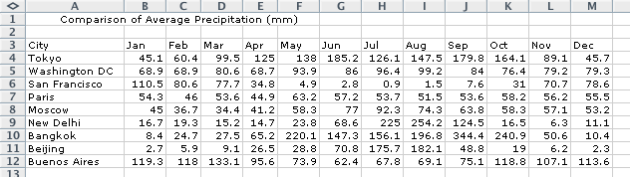

make the spreadsheet look like this

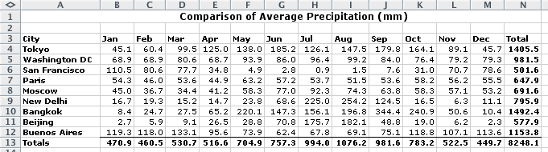
add the row and column totals
fix the column widths
format all numeric values to one decimal point
make row and column headings and totals bold
put a line above the totals row
title: merge the cells, center, bold and increase font size

charts
if you haven’t already done so, load the precipitation data (instruction are above)
use bar charts to compare categories of data
use line graphs to show fluctuation over time
how? select the range of data that is to be graphed
invoke the chart wizard
change the titles for the axes
specify if you want a legend

line chart
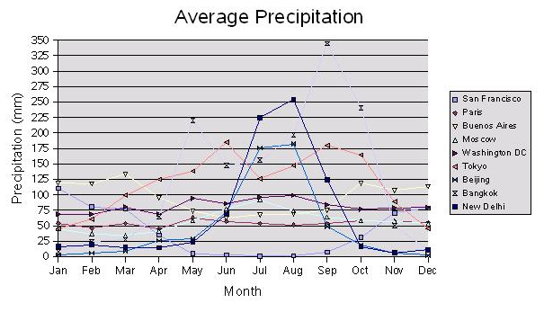
select cells that include the column headings (Jan, Feb, etc), row headings (city names), and all data values but not the totals row or column
> Insert > Chart the range should show: $A$3:$M$12
for each chart type select a sub-type >Press and hold to view sample
when finished playing
>Line chart type
>top left sub-type
>Next
>Series in Rows
>Next
go through each tab and play with it, but leave it as you started
>Next
>Place chart as object in Precipitation
>Finish
move the chart below the data
R> on chart
>Format chart area
go through each of the tabs
note if you click on the chart and >Ctrl+C you can paste it into Word, PowerPoint, Publisher, etc.

bar - clustered column chart
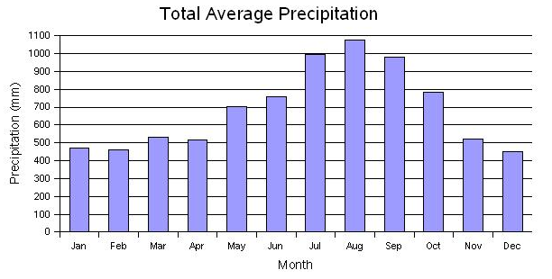
select the row for City and the row for the totals but not the totals column
reminder - select A3 through M3, hold shift key and click M3
then hold Ctrl key while you select A13 to M13
> Insert > Chart the range should show A$3:$M$3 and $A$13:$M$13
>Chart type Column >Chart sub-type top left
remove the legend
etc. >Finish

page setup landscape
preview

bar - stacked column chart
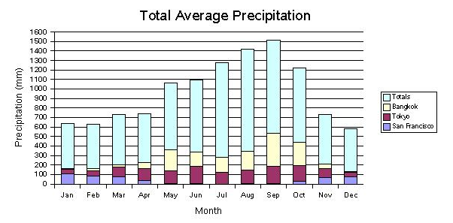
select the row for City, the row for San Francisco, the row for Tokyo, the row for Bangkok, and the row for the totals
cells A3:M3, A4:M4, A9:M9, A11:M11, A13:M13
> Insert > Chart the range should show: $A$3:$M$4 and $A$9:$M$9 and
$A$11:$M$11 and $A$13:$M$13
continue

bar - clustered column chart
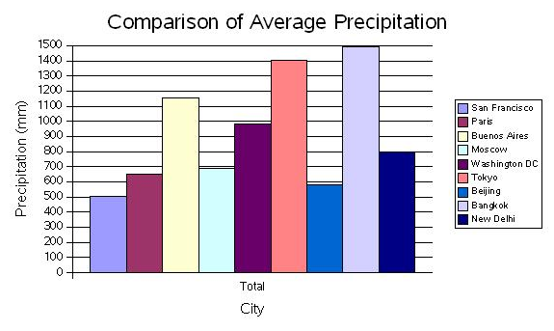
select the city names column (but not the word "total")
and select the totals column (same rows)
> Insert > Chart the range should show
$precipitation.$A$3:$A$12;$precipitation.$N$3:$N$12
etc.

printing with charts
make sure the chart is not selected - if a chart is selected only the chart is printed

