Bulletin of Concerned Asian Scholars, Vol. 31, No. 3 (1999): 47-51 ISSN 0007-4810 ® BCAS (Oakland, California)
Conference Report
Transformation, Subversion, and Feminist Activism:
Report on the Workshops of a Developmental Project, Xian, China
By Ping-Chun Hsiung
Since the 1980s, a number of Chinese scholars and activists have worked together creatively to develop a women's studies field that (1) focuses on unresolved issues embedded in the approach of the Chinese Communist Party (CCP) to gender equality, and (2) responds to the negative consequences of China's economic reforms on women. The fruits of the so-called women's studies movement include a large selection of new publications, many stimulating conferences, the establishment of women's studies centers in universities, and the emergence of women-centered nongovernmental organizations (NGOs). The movement has also brought about a diversity of efforts to present and re-present Chinese woman, a task that until recently was the sole preserve of the CCP State and the All China Women's Federation.'
Demographically, the majority of scholars and activists who are active in the women's studies field today belong to the Cultural Revolution generation. They spent their adolescent years in the countryside and-inspired by the Maoist political doctrine that "women hold up half the sky"-they grew to become the equal of men. Many of the women were drawn to the field of women's studies in the mid-1980s in search of ways to address problems faced by women during the reform era that began in the late 1970s under Deng Xiaoping. The enthusiasm and commitment they bring to their work are a mixture of selflessness and self-realization that is reminiscent of the ethos of the Cultural Revolution. Given the fact that women in China retire at the age of 50 or 55, determining how to pass on the torch to the younger generation is always an urgent question.
Institutionally, even though quite a few women's studies centers have been established nationwide, very few of them have received sufficient administrative support. Without regular budgets, short of office space, and lacking formal faculty appointments, most women's studies programs have not been in a position to focus on curriculum development. In some cases, the programs/centers exist only in name. In better-endowed centers, affiliated scholars manage to incorporate women's issues and/or feminist perspectives into their existing courses. Only in rare cases have scholars been able to offer new courses in the name of women's studies. Thus, to further advance the women's studies movement in China, curriculum development and institutional capacity-building are critical.
In this context, I describe examples of feminist activism at two developmental workshops held at Shanxi Normal University, Xian, China, on two occasions: December, 1997, and June, 1998.² The workshops were the first in China to study women in education using qualitative methodology and feminist epistemology. Around 30 junior scholars and teachers from 13 provinces and 23 institutes/universities all across China participated in the workshops. The work was divided into two phases, namely, research and intervention leading to policy recommendations. The workshops were organized to facilitate research into the experiences of female undergraduates as China embarks on educational reform. The December 1997 one work-shop dealt with substantive issues and research methodology; the June 1998 workshop focused on data analysis and the formulation of intervention strategies.
By drawing upon the participants' narratives and reflections, I show how the qualitative approach can further contribute to the women's studies movement in China by transforming individual women into committed researchers and dynamic activists. Comments of these women also indicate that the inductive, bottom-up approach is conducive to the pluralist conceptualization that inevitably questions the hegemonic order in the political arena.
Training in Research Methodology
At the December 1997 workshop, my colleagues and I presented a short course in qualitative methodology and feminist epistemology.³ In particular, we discussed the strengths and limitations of quantitative and qualitative approaches, explained why, we decided to adopt a qualitative approach for this project, and showed how using this methodology could contribute to China studies in general and women's studies in particular. Using a teacher-student metaphor to describe the relationship between informant and interviewer during in-depth interviews, we emphasized that because the informant is the authority on his/her own experiences, the informant, not the researcher, is the real expert in the interview process. As a learner, the researcher must put aside his/her status in order to hear what the informant/subject is saying. Unlike methodologies that use structured survey questionnaires, in-depth interviews allow informants to describe their experiences in their own words. This approach brings to light previously ignored positions and perspectives. In so doing, the inductive, bottom-up approach may subvert existing theories and conclusions, ultimately challenging the hegemonic political order.
We also treated technical topics such as preparations for conducting in-depth interviews; how to solicit rich, thick data; data transcribing; and confidentiality and research ethics in in-depth interviewing. Following the lectures, workshop participants practiced conducting and transcribing individual in-depth interviews with female university students. They then shared their interviewing experiences with the other workshop participants. These activities were organized in conjunction with an effort to encourage the participants to develop and define their own research topics and to consider possible applied aspects of their research. By the time the participants left the ten-day intensive workshop, they had acquired a survey understanding of qualitative research and feminist epistemology, along with some hands-on experience in conducting in-depth interviews. They were then ready to interview 12 to 15 informants on the research topic they had chosen.
During the six-month period between the workshops, the participants conducted and transcribed the results of their inter-views. In the workshop in June 1998, we covered the basics of analyzing qualitative data, stressing the importance of honoring the informants' voices and of immersing oneself in the data and using the data as a foundation for understanding. Working with the participants one-on-one, we analyzed the narratives line-byline, asking the participants to read their narratives aloud over and over again in order to identify key words and phrases used by those they interviewed. We pointed to examples in their own data to demonstrate that rich, thick data are essential in qualitative research and to show that painstaking analysis would reveal layers of meanings in the narratives. With
some participants, we focused on what the informant was trying to say and how it was said. With others, we reflected on how preconceived notions may have prevented them from fully appreciating the narratives. Step by step, the participants came to appreciate how to conduct research using an inductive, bottom-up approach.
Although the content we discussed and the pedagogy we employed in the workshops are very much in line with the premises of qualitative methodology and feminist theories, our approach posed a major challenge to the workshop participants. To understand the particular nature and nuances of these challenges, one needs to have an appreciation of the overall sociopolitical structure, as well as the norms and practices, of contemporary China. For example, the participants were taken aback by our use of the term "subversion" because that word has political overtones and thus raised suspicions. Our emphasis on listening to the informant's voice also implied an epistemological conceptualization that called into question the hierarchical, top-down assumptions currently embedded in China's bureaucratic system and practices. Although rupturing such assumptions was essential to an appreciation of the essence of the inductive, bottom-up approach, this did not come easily for many workshop participants because it entailed a different set of philosophical thinking and practices. It was not until the middle of the June workshop that some participants began to use the word "subversion"-at first in a rather lighthearted manner to describe how they were "subverting" their own drafts or pre-conceived understandings of a subject topic.
Throughout the workshops, we emphasized participatory learning in a collegial atmosphere. We always began our lectures by bringing in empirical examples from our own research findings and fieldwork experiences. Small-group discussions and practice in in-depth interviewing complemented the lectures. Hands-on experience allowed the participants to gain personal insights and small-group discussions facilitated experience-sharing. Together, they fostered a multi-centered learning mechanism that made learning a collective and supportive process. As a result, participants not only became critical of their own work, they were also receptive to comments and criticisms from the others.
From Researcher to Active Change Agent
When participants were selecting their research topics, we urged them to take into account possible applied aspects of their endeavors. We also encouraged them to consider issues in areas of higher education in which they themselves might facilitate change. Methodologically speaking, this emphasis brought the researchers close to what they studied. Being personally connected to one's study gives a researcher the advantage of having firsthand knowledge, but at the same time it makes it more difficult to identify the source of problems and/or articulate means of intervention. The case of Jiang Yen (a pseudonym) is a good example of what is required to transform researchers into active change agents.
Jiang Yen is in charge of the daily operations of a financial aid program that was set up to help poor female students attend university. The program raised its seed money by selling a silk quilt collectively embroidered by more than 1,000 peasant women to celebrate the 1995 United Nations Fourth World Conference on Women. Since then, it has drawn additional support from private donors and has won a nationwide reputation as the first of its kind in China. Jiang Yen began to study how poor female undergraduates perceive social sponsorship. Her general impression of the recipients had been that many of them were shy and therefore ill-equipped to handle the publicity events that were part of the social sponsorship program. When she first reported the results of her research finding, she recounted her interview with one recipient who had walked out from a TV interview:
[W]e once arranged a TV interview to publicize our program. A student (recipient A) asked the journalist if it is all right to have the interview recorded off camera. Without thinking, the journalist responded, "Does your TV at home have only voice, with no picture?" The student retorted, "We don't have a TV at home." The journalist didn't apologize. He had no responses at all, but kept saying "you should stand over here," " you should face the camera that way," etc. The student eventually refused to be interviewed and walked out. One of her teachers said to her "you should go see a psychotherapist"
When Jiang Yen learned the details of this incident, she believed that the encounter had "caused severe harm to the student" and she thought that both the journalist and the teacher should apologize. She promised the student that she would personally pursue such an apology.
Jiang Yen recognized that in-depth interviewing had enabled her to gather information that she "couldn't have learned through administrative means." But for some time she still considered that what had happened was unfortunate. Indeed, the incident confirmed her previous notion that the recipients of social sponsorship "are very sensitive and their feelings can easily be hurt." Only after she started line-by-line coding did she stop attributing the student's behavior to her introverted personality. She came to see that a large part of the recipients' self-perception resulted from how they were treated throughout the application process and what they were expected to do at the publicity events. This led her to reflect upon the entire project and to see how it "might have caused harm" to the students:
I realized that the very process of accepting financial aid and the people, events, and activities [involved in the project] have all intensified the student's recipient status....I then began to reflect upon the [the project] itself. We call the project a financial aid project. I checked the dictionary.... The term "aid" implies receiving something without one's own effort. It has the connotation of effortlessness. If we were to change the title of our project [from financial aid] to "[Such-and-such] Fellowship," we could still provide support to poor female college students. But the meaning would be completely different. The new name turns "aid" to "fellowship." This may help students change their entire perception about the project and their image as recipients.... This is the most precious fruit I have come to harvest from the in-depth interviewing. To come to such a new understanding has been a long process. With the teacher's encouragement, I came to reflect upon the entire project. In the past, I always believed that the project could only do good for the students. I never thought that it might cause harm to them. Even though there were some minor problems, I have always attributed them to the students' personality and maladjustment.
At the personal level, it takes admirable courage for a superior to acknowledge responsibility for any harm one might have inflicted upon the powerless. Nor was it a minor step for Jiang Yen to shift her assessment of the sources of the problem from the recipient's introvert personality to social, institutional factors. Methodologically speaking, treating the informant as the expert, rather than the problem's source, and immersing oneself in painstaking analysis, enabled other workshop participants to make similar major breakthroughs in their research. For example, a lecturer at an ethnic minority college proposed to study the adjustment of their Tibetan female first-year students. It was only after the researcher began treating the Tibetan students as the "authority" of their own experiences, that she was able to see how the college as an institution might have better served their needs. The political implications of such a shift from personal to structural is significant.
The tendency in China has been to blame the victim, that is, to focus on micro, individual characteristics and ignore the macro, structural factors. For example, during the on-going program of economic restructuring, the State rhetoric has blamed the maladjustment of laid off workers from the State enterprises (mostly women) on "deficient personal qualities."⁴ As a result, significant resources have been directed to remedying these "personal" deficiencies.
Shifting the focus to systematic, structural factors leads to a questioning of the prevailing, official rhetoric. To examine the structural elements in personal experiences is to become an activist in the spirit of that most celebrated feminist slogan, "the personal is political." Many workshop participants spoke about how they now brought passion, eagerness, and a strong sense of social responsibilities to their research. The following excerpt describes one researcher's journey from aloof academic to committed researcher and activist:
In the past, I was never interested in doing research because it only plays around with all those abstract concepts. To me, such research is useless and meaningless. Everything is different now. I'm now very eager to get involved in research because we can actually "discover" problems through our research. With the applied aspect, our findings are going to make a real difference.
These examples provide a vivid account of conceptual learning through personal narratives. They show the significant contribution that a qualitative approach is able to make to knowledge construction and social understanding. In addition, and most _{i}mportantly, seeing the interconnection between the institutional/structural and the personal is not only key to the researcher's commitment to research; it also turns the researcher into a change agent by activating her sense of social responsibility.

Conviction, New Vision, and World Views
Throughout the workshop, we were touched by the way that participants made progress and experienced breakthroughs over-night, or even from one session to the next. The joy and surprise occasioned by their rapid progress helped to sustain all of us in what proved to be an extremely demanding program. We were particularly impressed by how far the participants traveled, from knowing nothing or having doubts about qualitative research, to being strong advocates of this methodology. One beginner whose doubts and uncertainty were shared by the other participants made the following statement at the first workshop:
When I first heard about the in-depth interview, I had all kinds of doubts. For example, I asked myself, how can one write a paper based upon data collected from just a few people? Who will accept such work or findings? Not even I myself. After going through the training and many more discussions, my doubts cleared away. Al-though [at this point] I'm unable to convince others about the merits of this approach, I myself can see where the teachers are leading us. I want to give it a try, and see.

After having worked on her project for several months, the same participant came back to the second workshop with a changed perception:
In-depth interviewing is an ideal means for the weak to raise their voices because it is not rigid in structure. It nurtures an equal relationship between the interviewer and interviewee, and emphasizes the importance of learning from the informant. Thereby, it enables the weak to speak up. I have come to believe in it as a better approach to address women's issues.
Along with such a change in perception, a new relationship evolved between the researchers and their research. For example, one participant talked about how she had become very fond of her data, and that they were like her babies. Another said that she had come to love her research tremendously because she realized that "any phenomenon or issue touches many people—their work, lives, feelings, and social relationships" and "we aren't talking about something cold and abstract" The most profound change occurred when the researcher was transformed during the research process. The following two excerpts reveal the growth among the participants of a new spirit, vision, and conviction:
Knowing this approach is more important than anything else. Producing articles is only secondary. The main thing is to have learned this method and to use it to study and analyze what is happening. I feel I have finally found my destiny.
After learning this approach, I have a completely new perspective. This perspective allows me to see new meaning in my life....It is like making a turn in my life. Now I know what I'll do the rest of my life. I told my husband, "I have come to understand why there are people who sacrifice their own lives to protect certain principles. I feel I have become such a noble person now."
Discussion often carried on after-hours. This was when new ideas tended to sparkle and shine. At one late-night gathering, the participants were to rehearse their presentations for the workshop meeting the following morning. They pondered how to best demonstrate their progress now that many of them had just "subverted" their drafts. Some tallied up the amount of data collected and the number of hours spent in gathering and transcribing the data. Others shared their findings from a painstaking analysis of their data. Gradually, the conversation turned to a discussion of what the inductive, bottom-up approach really means. While some members shared their personal reflections, one of them broadened the subject:
After I came to know this method, I was attracted. No matter how others think, I strongly believe in it. I think others will come to appreciate it one day. It is not that we want to get anything out of this. We just think this is the right way to do it. Maybe others don't acknowledge it at this point. Eventually, they will, because we have come to accept it. When more people come to accept it, China will undergo some fundamental changes.
Another participant picked up the thread and elaborated it in a similar matter-of-fact manner:
If the real essence of this approach is to shed light on positions and existing problems from the feelings and experiences of the subject, I think we can apply the same principle to broader areas. [In doing this] it will bring the democratic spirit to the so-called authority in our country.... [We should always ask] from whose perspectives. It's not only certain people's words that count, not only the leader who has the final say. For example, if I were a worker or a female textile worker, I would be the authority on my feelings and beliefs. That's it. In this way, everyone can have a chance to speak up. People's voices will be respected and answered. This will raise the degree of our [nation's] democracy.
When the relationship between having multiple authorities and the degree of China's democracy was further articulated on another occasion, the qualitative methodology studied in the workshop acquired a life of its own:
The qualitative approach is to understand the meanings of an event from the informant's viewpoint. Giving the informant a subjective position and paying attention to his/her real experiences make every individual an authority. For example, if we want to understand what it is like to be mentally ill, the patient is the authority. We, the researchers, can't be the authority. What I'm trying to say is that [this approach makes] everyone an authority on their own experiences. If we can apply this approach to other areas, not just the sociological issues this project covers, we may be able to overturn many rigid rules and challenge the authorities. We have come to accept such an approach. I'm sure many more people out there will come to appreciate it. If more people adopt this line of thinking and use it to analyze other issues, this can be significant for the progress of our country's democracy.
A senior scholar at the workshop responded to the above statement by pointing out both the personal meaning and political implications of the inductive approach:
The research methodology [we have studied] is indeed a new way of looking at things. It's a new perspective and theoretical approach. It also requires a transformation of the researcher ...I believe it can transform our society as well. That is, change it for the better. So, "subversion" may not be a bad thing.
These statements, albeit brief, are intriguing on two grounds. First of all, they definitely go beyond the original parameters of our developmental project. Remarks on "subversion" and "multiple authorities" challenge the hegemonic position the CCP State has held on to over the decades. They testify to a search for alternatives, for new ways of articulating and doing things. Although the appeal to respect and respond to the voice of the people does not really go beyond official political rhetoric, statements such as those above reflect the criticism and cynicism that have been increasing among the general public in recent years. Second, the narratives show the participants to be articulate individuals with clear views on the flaws and prospects of the current system. They not only counter the image of Chinese women as passive, mindless victims of the socialist patriarchal State,' they also deviate from the stereotypical notion that women have little interest in politics or political issues.
Feminist Activism and Beyond
The involvement of Chinese women in transforming China's overall political landscape is evident in the women's studies movement. In this context, the two workshops functioned as venues for feminist activism.
For example, seven workshop participants intend to write a textbook on feminist theories and gender issues-China's first introductory textbook on women's studies. This initiative signifies the first step in "en-gendering" the curriculum in Chinese higher education.
At one workshop, professors Zhu Chuzhu and Zheng Xingron gave detailed accounts of the trials and triumphs they experienced in introducing a women's studies course at a "normal university" and at a university that specializes in physics and the natural sciences. Their talks generated questions and comments such as these: "How did you get your course approved by your university?" "How did you attract both female and male students?" and "That's really neat. I can also do that with my students!" The practical aspects of the presentation and discussion are significant because, as I mentioned earlier, cur^{r}iculum development in women's studies has been slow to make progress in China. In this light, the workshop not only provided a platform for curriculum development, it also was a nursery that inspired and attracted members from the younger generation.
As the workshop unfolded, some participants made known their intention to offer new courses on their own campuses. Others planned to incorporate workshop materials into their existing courses. Still others planned to introduce feminist methodology to their colleagues and students. Because participants came from so many provinces, universities, and institutes across China the workshop laid a basis for nationwide influence. The event was particularly meaningful because 28 out of the 30 participants were female junior scholars and teachers who, in the current system, rarely have a chance to receive research funding. Their participation in an international project will raise their status in their respective institutions. As well, an opportunity to work collectively with senior scholars in the field will contribute to their scholarly development in the long run.
The implications of qualitative methodology and feminist epistemology for women's studies in China are twofold. First, they are a way to challenge existing theories and conclusions. This can be especially fruitful for studies that investigate tensions between the Marxist notion and official rhetoric of women's liberation on the one hand and the life experiences of women from various backgrounds on the other. Second, the new methods can have a significant effect in the international arena. Until recently, the hierarchy between the East/Third World and West/First World has made Western feminist Sinologists the theory producers and Chinese feminist scholars the suppliers of raw materials.⁶ An indigenous scholar who adopts the rigorous approach to qualitative research taught in our workshops will be able to assume the status of "analyst and producer of feminist discourse in her own right."' A down-to-earth approach should equip Chinese feminist scholars with the means to ground abstract concepts in the experiences and every - day lives of women. The findings can thus serve as building blocks for feminist theories that better portray relationships between gender relationships and the broader cultural, social, and political fabric in China.
Notes
- For a detailed examination of the structural and personal aspects of the movement, and the continuously evolving relationship between the CCP State and Chinese women intellectuals and activists see Ping-Chun Hsiung, "The Women's Studies Movement in China in the 1980s and 1990s," in Education and Society in Twentieth-Century China, ed. R. Hayhoe, G. Peterson, and Y. Lu (Ann Arbor: University of Michigan Press, forthcoming).
- The workshops were part of the Special Canada-China University Linkage Project, entitled "Women and Minorities as Educational Change Agents." Supported by the Canadian International Develop-mental Agency to facilitate collaborative research in China and between China and Canada, the project covers three substantive areas: gender in higher education, minorities' education at the secondary level, and moral education in elementary schools. Six Chinese and three Canadian universities are involved, with two Chinese universities working on each of the substantive areas.
- The workshops were organized by Professor Qiang Haiyan, vice-dean of the Institute of Education Science at the Shaanxi Normal University, Yuk-Lin R. Wong, doctoral candidate in the Department of Sociology at the University of Toronto, and Professor Ping-Chun Hsiung, Department of Sociology, University of Scarborough.
- Zhao Shuming, "Zaijiuye Gongcheng" (Project on re-employment), Xinghua Ribao, 9 April 1998.
- Many recent studies challenge the conventional framework that assumes and portrays Chinese woman as mindless, passive victims. For a critical review of how Chinese women were once portrayed as passive victims of the socialist patriarchal State, see Christina Gilmartin et al., Introduction, in Engendering China: Women, Culture, and the State, ed. C. Gilmartin, G. Hershatter, L. Rofel, and T. White (Cambridge: Harvard University Press, 1994), pp. 1-24.
- Lisa Rofel, "Liberation Nostalgia and a Yearning for Modernity," in Gilmartin et al., Engendering China, pp. 226-49.
- Ibid., p. 240.

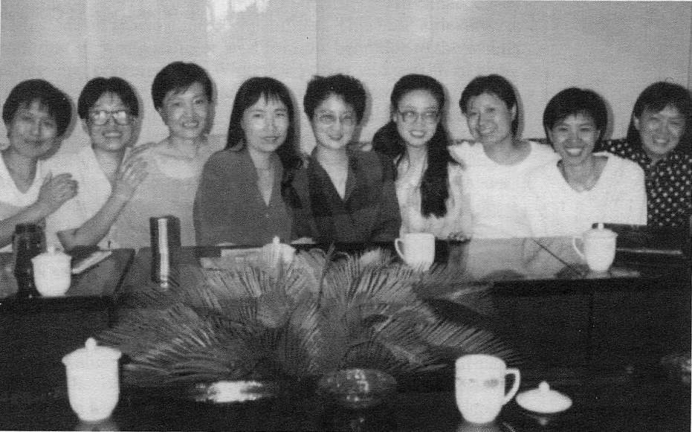
December 1997 workshop. (From right) Prof. Qiang Haiyen, vice-dean of the graduate school in education, Shaanxi Normal University; Prof. Li Xiaojiang, feminist scholar, Prof. Wong Shuland, Shaanxi Normal University; Prof. Ping-Chun Hsian, Canadian coordinator.
Credit: Ping-Chun Hsiung.

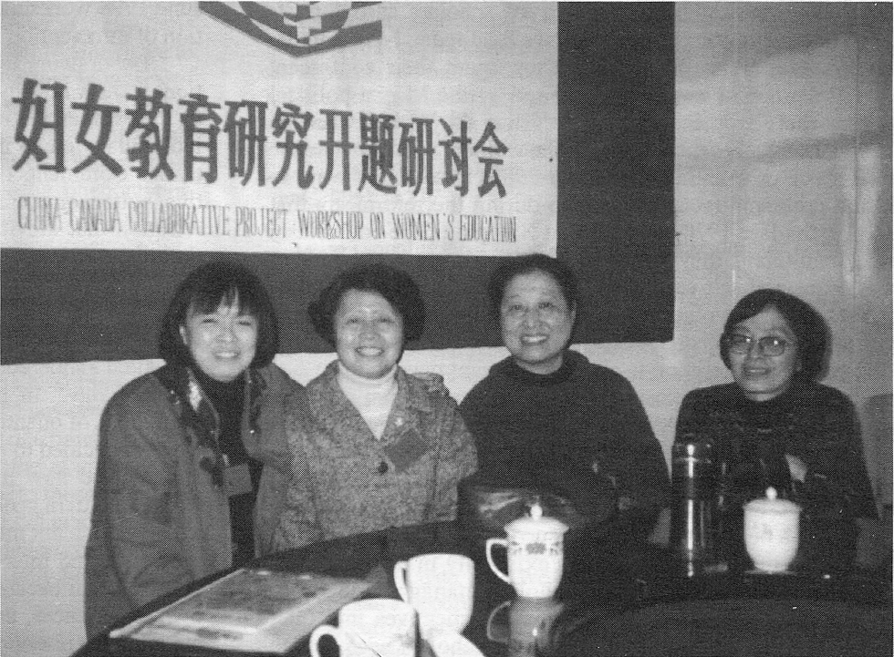
June 1998 workshop. Group photo taken before a presentation. Credit: Ping-Chun Hsiung.

