In Press: Attention, Perception & Psychophysics
Running Head: EXPRESSIVE PROFILES

Emotional Expression on a Profile: Feature Height, Mouth Angle And Tilt
Shaaista Bhasin, John M. Kennedy & Matthias Niemeier
University of Toronto Scarborough

Running Head: EXPRESSIVE PROFILES

Corresponding author: John M. Kennedy
Address: Department of Psychology,
University of Toronto,
1265 Military Trail, Toronto, ON,
Canada, M1C 1A4
Email: kennedy@utsc.utoronto.ca
Tel: 416-287-7435 Fax: 416-287-7676
Abstract
Profiles may vary in expression with changes in the height of the profile’s features, the mouth’s angle at the profile contour and head tilt. Three experiments varied these factors. Features low on the profile, with mouths at an obtuse angle to the profile line and head tilted 15° forehead-forward, appear especially sad. High features with acute mouth angles suit forward, upright and backward head tilts. Feature height, mouth angle and head tilt on a profile are physical variables that can specify postures such as downcast heads and turned-down mouths and thereby psychological factors. We point out alternative accounts of the height and tilt effects.

Emotional Expression on a Profile: Feature Height, Mouth Angle And Head Tilt
Emotion is a psychological matter made known through expressive physical features as arbitrary as a white flag and as species-specific as a smile (Darwin, 1872). Faces are especially significant for showing emotions, and their physical features are widely researched (Duclos et al., 1989; Tracy & Robins, 2004). Testing drawings with elliptical faces, Todorovic (2008) and Chan et al. (2007) found that higher features were judged happier than lower features (Figure 1). Height may also affect expression of profiles of faces (Figure 2). Feature height on a face per se has no obvious theoretical link with emotion. Perhaps the effect could be mediated by inferred head tilt, or inferred mouth angle. Profiles could be used to test such expressive variables and their interaction. Here, we find low features, with mouths at an obtuse angle to the profile line and a head tilted forehead-forward, appear especially sad. Also, we show that several head tilts -- forward, upright and back -- fit happier or neutral expressions. We inquire about the psychological significance of these physical variables.
There has been this effect, that feature height on a face influences its inferred
emotional expression. Now, it is unlikely that the effect was due to feature height
per se, because there is no theoretical reason that. Alternatively the effect might
be mediated by mouth angle or inferred head tilt....

-------- --------------
Insert Figs 1-3 about here
--------- -----------------

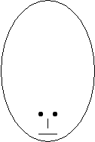
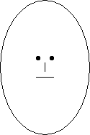
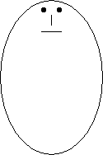

Figure 1. Front facing elliptical faces used by Chan et al. (2007), following Todorovic (2008).

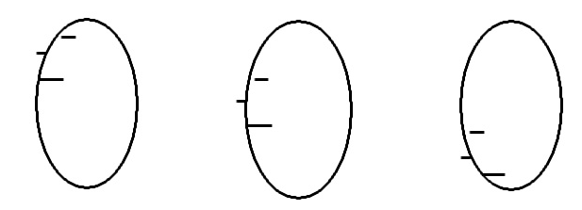

Figure 2. Elliptical face profiles used in Experiment 1.

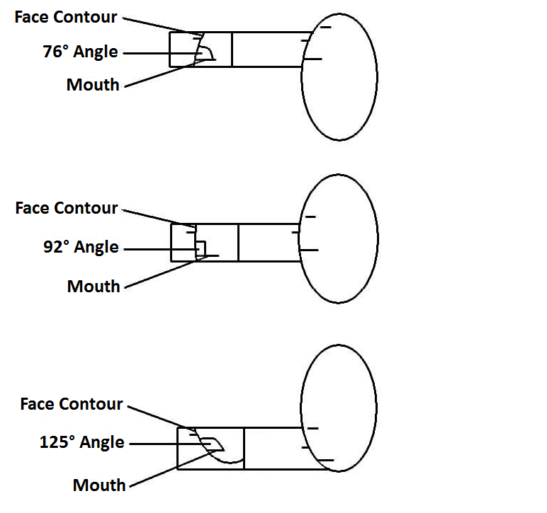

Figure 3. Elliptical faces with labels for the mouth, the face contour and the upper angle between the mouth and face contour.
In Figure 3, height is related to mouth angle. Lowering the features on the profile changes the mouth angle from 76° to 92° to 125° with respect to the tangent at the profile (measuring the upper angle at the intersection with the profile). The mouth angles are not symmetrical with respect to 90° because the eyes and nose occupy space between the mouth and the top of the ellipse. On rectangles (Figure 4), the mouth angle remains 90° as the features change height.
------ ------------
Insert Figs 4 and 5 about here
--- -----------------

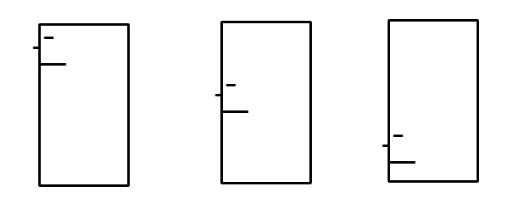

Figure 4. Rectangular face profiles used in Experiments 1 and 2.
The physical variables manipulated here are straightforward, but they could have several psychological implications. At the outset let us consider one that we will test and find wanting – perception and projection — and others such as head tilt and mouth angle will be discussed more positively later. As a face, an ellipse may appear more 3-D than a rectangle, with implications for 2-D features in Figure 2 (Lyons et al., 2000). Curves fit an egg-like head – an ellipsoid – projected from a point source, and straight lines a flatter form such as a brick. That is, in linear perspective a 3-D distal ellipsoid projects a 2-D ellipse (Figure 5). Above the equator, horizontal lines of latitude on the ellipsoid project lines concave downwards on the ellipse. They are concave upwards below the equator. Straight lines above the 2-D ellipse’s equator would be projections from lines concave upwards, like a smile, on the ellipsoid. Below the equator, they would be projections from lines concave downwards, like a sad mouth. Lines on flat distal forms project true forms in the rectangle – straight distal lines project as straight lines. The rectangle’s straight vertical sides fit the straight sides of a cylinder, but its straight horizontals suggest a brick rather than a cylinder’s convex curved top and bottom.
Does height’s expressiveness rely on 2-D curves suggesting ellipsoids? Alternatively, features low and high on ellipses may imply expressive postures such as a downcast or erect head, and rectangles a fixed upright posture. In either case, rectangles would not change expression with feature height. Another possibility is that just as a smile is species-specific, features high on a head are positive and low features are negative per se. In this case, the rectangles would differ in expression.
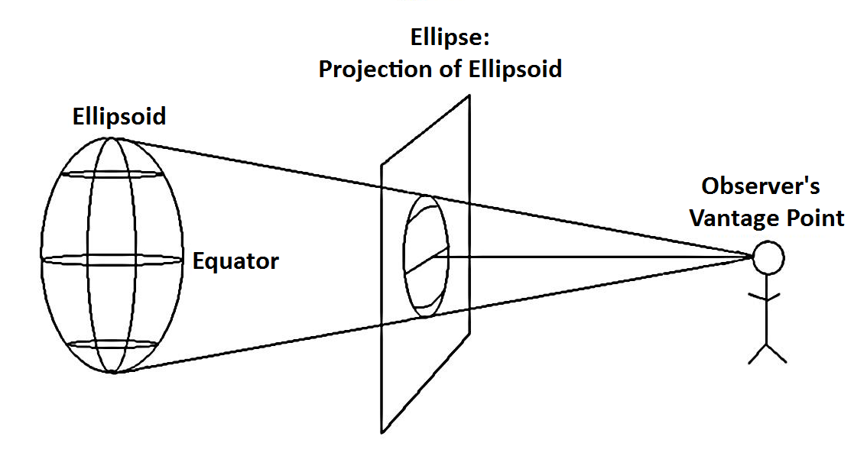

Figure 5. An ellipsoid is projected on a 2-D flat surface as an ellipse. The observer’s vantage point is at the equator of both figures. Horizontal lines above and below the equator project as curves (concave down and up respectively). At the same locations, straight lines on the 2-D ellipse are projections of curves (concave up and down respectively) on the ellipsoid.

In Experiment 1, expressive effects of feature height (high, middle, low) and the shape of the face (ellipses and rectangles) were tested. In addition, participants were asked which appeared more 3-D, the ellipse or the rectangle.

Experiment 1
Method
Participants
As in all experiments here, the participants (here, N=24, mean age = 19, SD = 1.43; 19 females, 17 with corrected-to-normal vision) were enrolled in an introductory psychology course at the University of Toronto Scarborough, received a course credit for their participation and were naïve about the purpose of the experiment.
Stimuli
Six face stimuli were presented on paper. The ellipses were 4cm in height and 2.4cm in width, shaped as in Figure 2. The rectangles were 4.4cm in height and 2.4cm in width, shaped as in Figure 4. The facial features were short straight horizontal lines for the mouth (6mm long), the nose (2mm) and the left eye (4mm) on the left side of the ellipse and rectangle. The nose was on the outside of both shapes and the other two features on the inside, high, middle and low on the ellipses and rectangles. The distance between the top of the ellipse and the high mouth was 1.5cm, 2.5cm from the middle mouth and 3.7cm from the low mouth. The mouth angles to the contour’s tangent were 76°, 92° and 125°. For the rectangle, the corresponding distances were 1.1, 2.4 and 3.9cm, and all the mouth angles were 90°.
Procedure
Participants, tested individually, were shown two faces, one ellipse and one rectangle, on each page and three pages in total. The ellipse and rectangle on each page had features at the same facial height (high, middle or low). On page one and three, either the ellipse or the rectangle was at the top, with the opposite shape at the top on page two. There were twelve orders in total, and two participants were exposed to each order, with a total of 24 participants. Participants judged expressions on a scale from 1 to 7, ‘1’ (Very Sad), ‘2’ (Sad), ‘3’ (Slightly sad), ‘4’ (Neutral), ‘5’ (Slightly Happy), ‘6’ (Happy) and ‘7’ (‘Very Happy’). The rating scales were presented as horizontal lines to the right of each stimulus, and judgments were made by checking a number.
Results
On a Friedman test for height, averaging across shape (ellipse and rectangle), the main effect was significant (χ² = 39.9, p < 0.001). Wilcoxon Signed Ranks tests found differences between all heights (high versus middle: Z = - 2.68, p = 0.007; high versus low: Z = -4.21, p < 0.001; low versus middle: Z = -4.22, p < 0.001). Another Wilcoxon Signed Ranks test, averaging across height, found a main effect for shape (Z = -3.28, p = 0.001). A Friedman test for the shape by height interaction found it significant (χ² = 34.16, p < 0.001). Furthermore, all participants judged the ellipses more 3-dimensional than rectangles (p < .001, binomial). The mean rating for the difference in apparent depth was considerable, 3.3 on a 5 point scale (SD = 1.23).
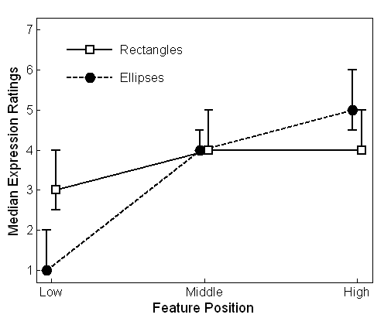

Figure 6. Median expression ratings for rectangles and ellipses with features at the low, middle and high positions in Experiment 1. Error bars indicate first and third quartiles. Only one error bar is given when the other equals the mass of the results.
Discussion
Low features elicit sad ratings -- rectangles had median 3 (slightly sad), and ellipses 1 (“very sad”). Rectangles are judged less 3-D than ellipses, which could explain the relatively small range of ratings for the rectangles on the projection hypothesis. Or, it may be primarily mouth angle that drives the range of expression in the ellipse. A change by 33° from 125° to 92° may be related to an increase in median rating of 3, and the further change of only 16° to 76° may be related to a correspondingly small rating increase of 1. The noticeably-obtuse mouth-angle gets the very sad ratings.
Unlike rectangles and ellipses, triangular and trapezoidal stimuli allow height and mouth angle to be varied separately. In these figures, would mouth angle and height act additively – wide-ranging when consistent, and neutral when inconsistent? Or would one dominate? Would straight-sided figures continue to produce ratings close to neutral, because curves suggest projection from 3-D convex surfaces?
Experiment 2
Experiment 2 used triangles, trapezoids and rectangles to vary mouth angle and feature height independently. Apex-up triangles in Figure 7 have acute mouth angles (70°), and apex-down triangles have obtuse mouth angles (110°). Opposite each apex is a horizontal line, completing the image of a face. Trapezoids based on similar horizontal lines have mouth angles of 85° (narrow top) and 95° (wide top). If height effects depend on projection from 2-D figures with curved sides, Experiment 2’s stimuli would be neutral in expression. Alternatively, expression might depend on mouth-angle and height.
------- ---------------------
Insert Figure 7 about here
--------- -------------------
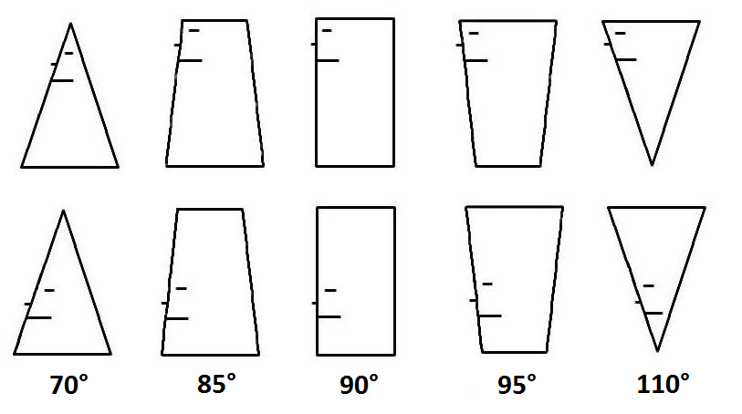

Figure 7. Faces used in Experiment 2, with mouth-angles 70° to 110°.

Method
Participants
Twelve undergraduates (mean age = 19 years, SD = 1.8; 11 females, 6 with corrected-to-normal vision) were tested.
Stimuli
All 10 stimuli (Figure 7) were 5cm in height. Intermediate features were not used since expressive effects likely appear most clearly in comparisons of high and low features, and the ratings for centered features were intermediate for both shapes in Experiment 1. The distance between the high mouth on the apex-up triangle and the apex tip was 1.5cm, and 2.9cm for low features. Avoiding crowding at the apex, the corresponding distances for the apex down triangle were 0.9cm and 2.9cm. The stimuli were presented to participants in random orders with the proviso that a stimulus with features located high was always followed by one with features low. Other details were as in Experiment 1.
Procedure
One stimulus was presented per page. Also, participants first underwent a familiarization trial in which they viewed all the stimuli without recording a response and then they re-examined the stimuli to judge the expression on each face. This was to boost sensitivity, dilute order effects and to encourage subjects to see each stimulus as a face.
Results
On a nonparametric Friedman test for height, averaging across angles (70° to 110°), the main effect was significant (χ² = 5.333, p = 0.021). Also, a nonparametric Wilcoxon Signed Ranks test for height, averaging across angles, found a main effect (Z = -2.049, p = 0.04). A Wilcoxon Signed Ranks test of the shape by height interaction found it significant (Z = -3.07, p = 0.002).
----------- -----------------
Insert Figure 8 about here
--------- -------------------
On a Friedman test, averaging across height, the main effect for angle was significant (χ² = 18.48, p = 0.001), the most acute mouth angles being happier and the most obtuse sadder than intermediates. To identify the source of this significant effect, we conducted 10 additional Wilcoxon Signed Ranks tests. One test was significant after Holm correction for multiple testing (70°vs. 110°: Z = -2.938, p = 0.003). Six other tests showed trends in keeping with this significant value (70° vs. 85°: Z = -1.975, p = 0.048; 70° vs. 90°: Z = -2.157, p = 0.031; 70° vs. 95°: Z = -2.203, p = 0.028; 110° vs. 85°: Z = -2.679, p =0.007; 110° vs. 90°: Z = -2.691, p = 0.007; 110° vs. 95°: Z = -2.043, p = 0.041), though they were not significant by the Holm criterion. With this as a caution, we will treat the uncorrected values as likely to be reliable.
Of note, both the low-featured 70° and 110° stimuli stood out. Paired-sample t-tests found significant pairwise comparisons for the 70° mouth-angle with low features versus all other angles with low features (p < 0.001), as well as the 110° mouth-angle with low features versus all other profiles (p < 0.001). However, we found no significant pairwise comparisons between the high-featured profiles.
In sum, if features are at the bottom, there is a large range of ratings from happy (the median for acute mouth angles is 5.5, meaning an equal number of ratings 5 and below and 6 and above) to sad (obtuse mouth angles rated 1). High features are somewhat happy or neutral. 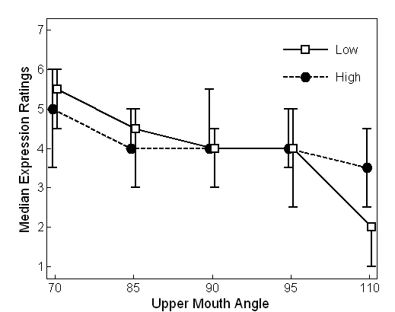

Figure 8. Median expression ratings in Experiment 2. The solid line with white squares is for low features and the dashed line with black circles is for high features. Error bars indicate first and third quartile values.
Discussion
The rectangle’s median judgment (4) was consistent with Experiment 1’s results (3 to 4). In addition, the straight-sided figures offered wide-ranging expressions (range 3.5), so we can safely conclude 2-D curves suggesting projections from curved surfaces are not crucial. The projection hypothesis we entertained used linear perspective and a point source, but the hypothesis could be broadened to include parallel projection, with triangles as projections of cones, trapezoids projections of truncated cones, and rectangles projections of cylinders. The conclusion in either case is that projection cannot explain the considerable range of the low-featured compared to the high-featured faces since they share the same forms. One possible factor is that low–featured faces show primarily a face and a head, and high-featured faces the body carrying the head. Predominance of the face and head could emphasize expression. Further, large, low mouth-angles were especially sad but angle and height are not additive since the largest and smallest ratings are given to the low-featured faces. Could head posture be at work, with distinctive effects for low features? This is tested in Experiment 3.
Experiment 3
Profiles in the obtuse-mouth-angle figures in Experiment 2 lean as if the head is downcast. The profiles with acute mouth angles are upward-oriented, as if the head is elevated and assured. Ellipses in Experiment 1 all have vertical axes, but features high and low on them may imply a head tilted up and down respectively, so implicit postural variables could contribute to their expression. Making the implied posture explicit, Experiment 3 used ellipses with head forehead forward (-15°), upright and forehead back (+15°).
In Experiments 1 and 2, the mouth line is horizontal, but keeping it horizontal in Experiment 3 would confound increasing mouth angles with increasing tilt. The mouth-line must tilt with the head. This means features presented low (mouth angle 125°) and high (mouth angle 76°) in the ellipse confound feature height and mouth angle, as in Experiment 1. However, the purpose of the experiment is to determine the effect of tilt. Hence our question can be, for a given arrangement of features, is an upright head happier than one tilted forward? Is a head tilted back happier still? The experiment can determine the effect of tilt for two arrangements of features: high features with an acute mouth-angle (high & acute), and low features with an obtuse mouth-angle (low & obtuse).
Method
Participants
Twenty undergraduates (mean age = 20.5 years, SD = 2.7, 14 females, 13 with corrected-to-normal vision) were tested.
Stimuli
All 6 ellipses (Figure 9) were Experiment 1’s figures, features high and low, in three tilts -- -15°, 0° and +15°.
----------- -------------------
Insert Fig 9 about here
---------- --------------------
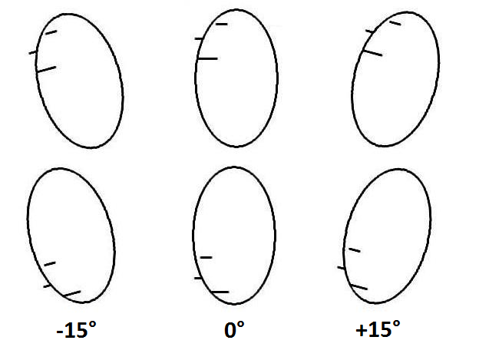

Figure 9. Figures used in Experiment 3, heads tilted forehead forward (-15°), upright (0°) and back (+15°).

Procedure
One stimulus was presented per page, for rating as before. The stimuli were presented to participants in random orders with the proviso that a stimulus with features located high was always followed by one with features low and no two stimuli with the same head tilt were presented in succession. Other details were as in Experiment 1.

Results
Low & obtuse features were especially sad, with -15° head tilt saddest. A nonparametric Wilcoxon Signed Ranks test for feature arrangement (height/mouth angle), averaging across tilt (-15°, 0° and +15°), found low & obtuse sadder (Z = -3.83, p < 0.001). A Friedman test, averaging across feature-arrangement, found the main effect for tilt significant (χ² = 8.71, p = 0.013), but on a Wilcoxon Signed Ranks test, averaging across height, tilt was significant only for +15° (median 5) versus -15° (median 3), and 0° (also median 3) (Z = -2.79, p = 0.05 and Z = -2.09, p = 0.37, respectively). A Friedman test for the height by tilt interaction was significant (χ² = 12.79, p = 0.002). The -15° tilt with features low & obtuse was notably sadder than its high & acute counterpart (median 1, 4 rating steps from features high & acute, the largest range of the tilt pairs).
------------------ ------------------
Insert Figure 10 about here
--------------- ---------------------

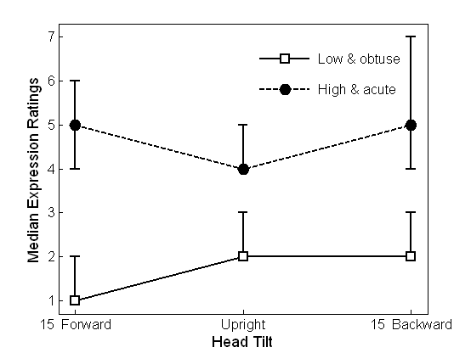

Figure 10. Median expression ratings in Experiment 3. The solid line with white squares is for low & obtuse features and the dashed lines with black circles is for high & acute features. Error bars indicate first and third quartile values.
Discussion
Head tilt had only modest effects. Within each of the two arrangements of features, the range of ratings as tilt varied was 1 step. Since explicit postures had modest effects, it is unlikely that Experiment 1’s height effects are due to implied posture, and the two experiments are commensurate since both upright ellipses were rated within 1 rating step of Experiment 1’s ratings. The low & obtuse forward-tilted profile was indeed sad (median 1). A bowed head may increase the sadness indicated by other features. It could directly express sadness or it may in addition suggest submission or concern about showing the emotion. In contrast, tilts forward and back made no difference to the happier features (medians 5 in both cases). Head down may reinforce sadness, but be neutral about happiness. With an acute mouth angle suggesting a positive or neutral emotion, a forehead-forward head can be dominant, looking down at other people. The same head tilted back can seem proud, and held upright neutral. All three tilts are consistent with an acute mouth-angle and an expression that is not sad.
General Discussion
Physical heights, angles and tilts need to be interpreted and, in principle, inducing psychology from geometry – working backwards from proximal to distal stimuli -- is not straightforward. Many roads can lead to Rome. The facts to be explained are that low features allow wide ranging expressions, mouth angle matters and only some tilts are distinctive.
The clearest finding here is one with several possible interpretations. Particularly sad ratings and happy ratings are given to low features. In Experiment 1, ellipses with low features and a mouth-angle of 125° had the lowest possible median rating (1). In Experiment 2, triangles with low features and a mouth-angle of 110° had a median rating of 2. In Experiment 3, an ellipse with a tilt of -15° and a mouth angle of 125° had the lowest median (1). The same mouth angle but with the two other tilts garnered median ratings of 2. High features are relatively happy in Experiment 1, but only median 5 for ellipses and 4 (neutral) for rectangles. In Experiment 2 high features are given a smaller range (1.5) than low features (3.5), low features appearing at the happy and sad ends of the scale. In Experiment 3, high features were rated only 4 or 5.
Physically, the asymmetry of high and low features may be partly due to the room at the bottom of a profile to move the mouth to an extreme. At the top of a profile, other features fill the space between the mouth and the top of the head. Psychologically, the emphasis on the face in low featured stimuli, rather than a head plus its supporting body, could enhance expressiveness. Projection and posture insofar as it is indicated by the tilt of the ellipse are not crucial, since projection cannot explain differences in ratings for similar forms in Experiment 2, and posture only had modest effects in Experiment 3. Social factors are worth considering as in expressions such as “Yesterday I was up, but I’m feeling quite low today.” (Lakoff & Johnson, 1980; Winner,1982). Social factors could be tested in experiments with speakers of a language that does not have these idioms.
Mouth angle, implicated in the ellipses of Experiments 1 and 3, has clear effects at the 70° and 110° extremes in Experiment 2. In the intermediate 85° to 95° range in Experiment 2 it is neutral, and normal faces likely have a range of mouth-angles reflecting neutral moods. The mouth line was horizontal in Experiments 1 and 2. Fuller effects can be anticipated for departures from horizontal. Mouth angle seems our most unambiguous, direct variable. Corners of mouths curl up in smiles and turn down in pouts.
Head tilt had modest effects across the 30° range tested, but Experiment 3 revealed the interesting possibility that a downcast head tilt is distinctive for sad features, but several head tilts are consistent with happier or more neutral features. Like height and like shape in Experiment 2, tilt has physical limits. Increasing the height of the features at the top of an ellipse creates crowding problems and suggests heads and bodies rather than just heads and faces, and another limit is set by the need for a chin below the mouthline. Exaggerating the sloping sides of triangles to increase mouth angle would create flat-headed figures not particularly facelike. Tilting a head too far may make it look asleep. Further, comparing the effects of each variable creates apples vs. oranges problems. Of more interest may be interactions, such as the distinctiveness of forward head tilt for sad features.
Since working backwards from proximal to distal stimuli often involves several options, we used the phrase “posture insofar as it is indicated by the tilt of the ellipse.” The proximal stimulus is often different from the distal stimulus, so manipulating head tilt by manipulating ellipse tilt does not necessarily affect the inferred head tilt. Head tilt might be inferred from the geometrical relations between mouth and face profile, for example. Indeed, many features could indicate head tilt and mood e.g. explicit eye postures showing we have levelled our gaze at the audience, possibly assertively, or we are looking down our noses at them, perhaps as if superior, or we are looking up at them, maybe as if submissively. Therefore inferred head tilt should not be excluded as an explanatory variable for the inferred emotional expression of a face. The role of head tilt is an open issue.
In Experiment 2, in addition to height, mouth-angle and tilt, the baseline could matter – figures with large bases might be taken by observers as offering physical stability, and hence confidence (Kennedy, 1982). Evidently, geometrical variables indicate expression by specifying psychologically-relevant factors, but the factors to be disentangled are many.
Inversion of photographs of faces hinders perception of expression, and Chan et al. (2007) found the same hindrance for the Figure 1 ellipses. The reader may wish to invert the figures here. The expressive differences vanish. Hence, the expressive differences here are allied with standard face-perception effects.
In conclusion, as in the Todorovic (2008) effect with face-frontal stimuli, expression in simple profiles based on ellipses, triangles and quadrilaterals varies intriguingly with height of facial features, posture and mouth angle. Low facial features, forehead-forward with obtuse mouth angles are especially sad. The height effects could be due curving mouths, a distinctive head posture and social connections with “low.”.

References
Chan, H., Haji, B., Press, D., Ilie, G., Juricevic, I. & Kennedy, J. (2007, September). Perspective
influences the perception of expression in schematic faces. Paper presented at the
Ebbinghaus Empire Colloquium series, University of Toronto, Canada.
Darwin, Charles. (1872). The expression of the emotions in man and animals. London: John
Murray.
Duclos, D., Laird, J., Schneider, E., Sexter, M., Stern, L. & Lighten, O. (1989). Emotion specific
effects of facial expressions and head-tilts on emotional experience. Journal of Personality
and Social Psychology, 57, 100-108.
Kennedy, J. M. (1982). Metaphor in pictures. Perception, 11, 589-605.
Lakoff, G. & Johnson, M. (1980). The metaphorical structure of the human conceptual system.
Cognitive Science, 4, 195-208.
Lyons, M.J., Campbell, R., Plante, A.., Coleman, M., Kamachi, M. and Akamatsu, S. (2000).
The Noh mask effect: vertical viewpoint dependence of facial expression perception.
Proceedings: Biological Sciences, 267(1459), 2239-2245.
Todorovic, D. (2008, August). Perception of emotional expression of faces is affected by the
vertical placement of inner facial features [Abstract]. Paper presented at the European
Conference on Visual Perception, Utrecht, Netherlands.
Tracy, J. & Robins, R. (2004). Show your pride: Evidence for a discrete emotion expression.
Psychological Science, 15(3): 194-197.
Winner, E. (1982). Invented worlds. Cambridge: Harvard University Press.

Figure Captions
Figure 1. Front facing elliptical faces used by Chan et al. (2007), following Todorovic (2008).
Figure 2. Elliptical face profiles used in Experiment 1.
Figure 3. Elliptical faces with labels for the mouth, the face contour and the upper angle between the mouth and face contour.
Figure 4. Rectangular face profiles used in Experiments 1 and 2.
Figure 5. An ellipsoid is projected on a 2-dimensional flat surface as an ellipse. The observer’s vantage point is at the equator of both figures. Horizontal lines above and below the equator would project as curves (concave down and up respectively). At the same locations, straight lines on the 2-dimensional ellipse would be projections of curves (concave up and down respectively) on the ellipsoid.
Figure 6. Median expression ratings for rectangles and ellipses with features at the low, middle and high positions in Experiment 1. Error bars indicate first and third quartiles.
Figure 7. Faces used in Experiment 2, with mouth-angles 70° to 110°.
Figure 8. Median expression ratings for faces with mouth-angles varying from 70° to 110° and features positioned high and low in Experiment 2. Error bars indicate first and third quartiles.
Figure 9. Figures used in Experiment 3, heads tilted forehead forward (-15°), upright (0°) and back (+15°).
Figure 10. Median expression ratings for heads tilted forward, upright and back and features positioned high and low in Experiment 3. Error bars indicate first and third quartiles.
Acknowledgments
1. We thank our reviewers, Dejan Todorovic in particular. He introduced us to his stimuli and their effects in discussions at UTSC in 2005. This research was supported by NSERC, Canada, and a Fellowship at Wissenschaftskolleg zu Berlin.

