Chapter 1: Stats Starts Here



- Why am I here?
- Am I going to come out alive?
  - yes!
- What can I hope to learn?
  - how to understand the numbers that make our world
  - how to organize things to make decisions about our world.
Things vary:

- people are different
- can't see everything or measure it all
- what we can measure might be inaccurate.

How do we make sense of an imperfect picture of an imperfect world?

Chapter 2: Data

Airlines monitored for safety and customer service. For each flight, carriers must report:
- flight number
- type of aircraft
- number of passengers
- how late the flight was (0=on time)
- any mechanical problems.

Who, what, why, where, when, how?

- who: the individual cases (flights)
- what: the variables (as above):
  - categorical: flight number, type of aircraft, mechanical problems
  - quantitative: number of passengers, lateness (minutes).
- why: why these variables (help to assess safety and customer service)
- when: don't know
- where: worldwide
- how: from pilot's log

Identifier variables:
- identify individual cases
  - flight number

Chapter 3: Displaying and describing categorical data

In 1991 and again in 2001, a poll was taken of 1015 adults about their opinions on working parents. The question was “considering the needs of adults and children, what do you see as the ideal family in today's society?”

The results:

 | 1991 | 2001
Both work full time | 142 | 131
One works full time, other part time | 274 | 244
One works, other works at home | 152 | 173
One works, other stays at home for kids | 396 | 416
No opinion | 51 | 51

The 1991 data, bar chart:

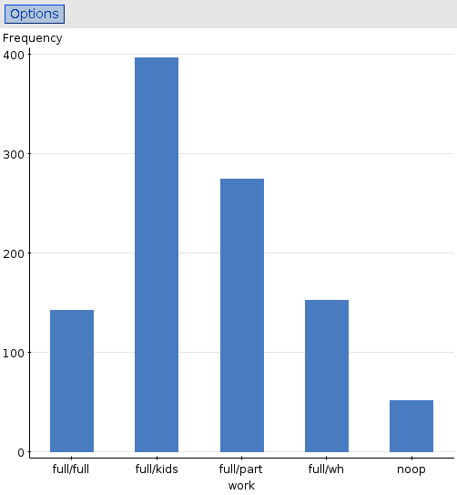

- more people think that having one parent stay home with kids is ideal
- but all four options chosen by reasonable number of people
- StatCrunch: graphics, bar plot, with summary
2001 data, pie chart
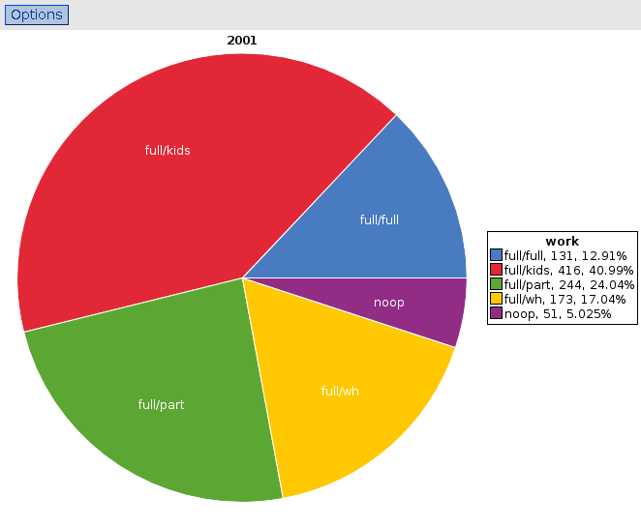

- Almost half of all people think that one parent ideally would stay at home with kids
- about a quarter of all people think that one parent working part time is ideal
- about equal numbers think that having both parents work full time or having one parent work at home ideal
- StatCrunch: graphics, pie chart, with summary.

- Bar charts

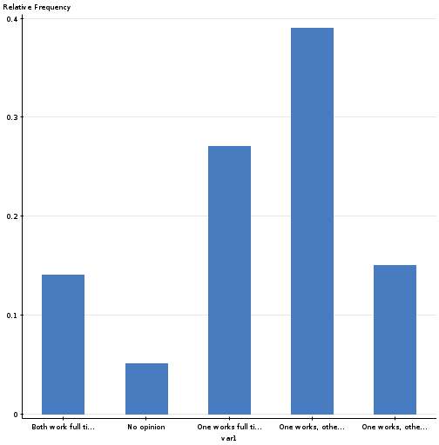
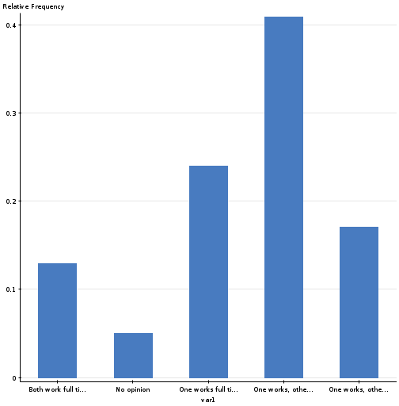

1991 2001

Hard to see much difference.

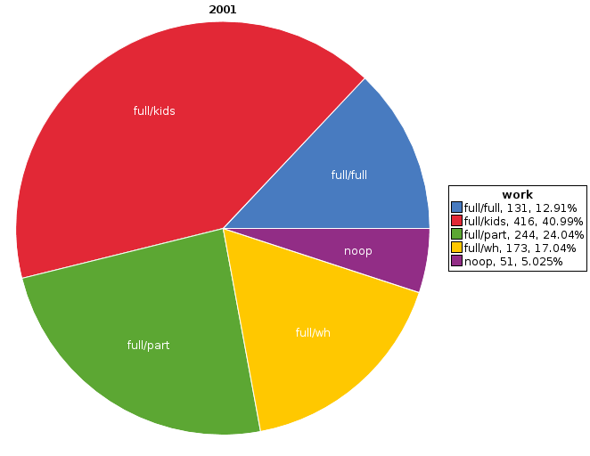
Pie charts

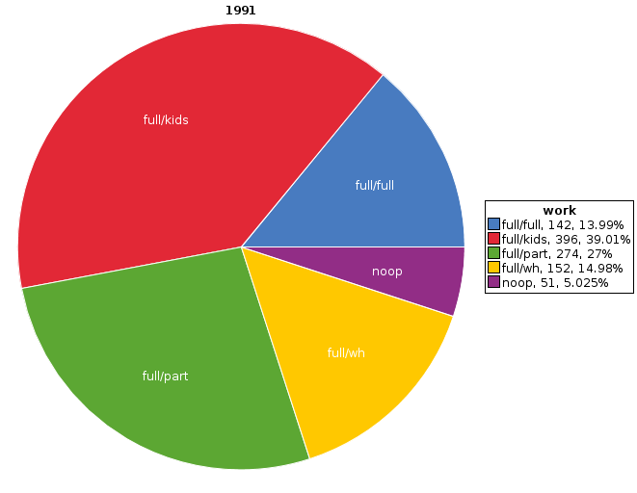

Again, not much difference apparent. Better: make bar chart for each year, but put bars side by side:
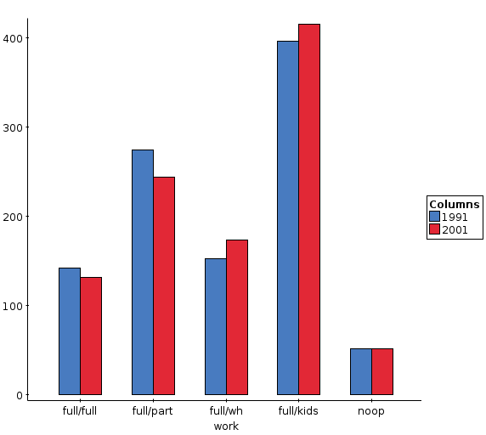
Side by side bar chart

- Slightly more had one parent at home, slightly fewer had both parents working outside the home. But differences are small.
- StatCrunch: Graphics, Chart, Columns.
Contingency tables: two (or more) categorical variables

recall surveys on attitudes to child care, above:

 | 1991 | 2001
Both work full time | 142 | 131
One works full time, other part time | 274 | 244
One works, other works at home | 152 | 173
One works, other stays at home for kids | 396 | 416
No opinion | 51 | 51
Total | 1015 | 1015
Reading a contingency table

- Both surveys had same number of people, so can just compare numbers.
- University records applications to professional schools:

 | Accepted | Rejected | Total
Males | 490 | 210 | 700
Females | 280 | 220 | 500
Total | 770 | 430 | 1200

- 280 of the applicants were females who were accepted.
- How many of the applicants were males who were rejected?
  - 210
- How many females applied altogether?
  - 500

Percentage of total

 | Accepted | Rejected | Total
Males | 490 | 210 | 700
Females | 280 | 220 | 500
Total | 770 | 430 | 1200

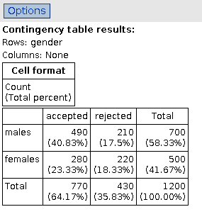
- More males than females applied (and more people accepted than not), so difficult to compare numbers.
- Compute percentages. One way: percent of total (divide everything by 1200).
- joint distribution.
- Stat, Tables, Contingency, With Summary.
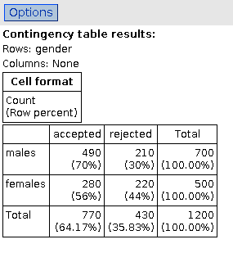
Conditional distribution

- Joint distribution is “out of everything”.
- Doesn't answer question “are more males than females accepted”?
- For that: out of males, what % accepted – row percents.
- See males and females both add up to 100%.
- 70% of male applicants accepted, but only 56% of female applicants.
- Discrimination?
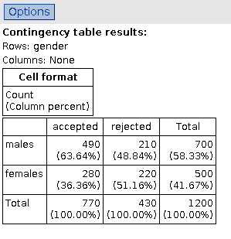
Column percents

look like this:

- 63% of people accepted were males.
- 51% of people rejected were females.
- Doesn't answer our question.
Deciding between row and column percents

- Look for words “out of” in what you want to know: “out of females, what % accepted”.
- Look for an “outcome”. In this case, gender is fixed (unless your name is Jenna Talackova!) but acceptance or rejection in columns was outcome. So need row percents. (Ie. thing that is not outcome.)
- Whichever you use, getting conditional distribution. “If I look at females, what % are accepted” = conditional distribution of acceptance for females.
Another example: airline punctuality

 | America West | Alaska | Total
On time | 6438 | 3274 | 9712
Delayed | 787 | 501 | 1288
Total | 7225 | 3775 | 11000

- what is the outcome?
  - on-time / delayed
- do we want row or column percents?
  - column
- which airline is more punctual (StatCrunch)?
Three categorical variables and Simpson's paradox

Professional schools example: also recorded acceptance and rejection separately for law school and business school:

Law | accepted | rejected | total
males | 10 | 90 | 100
females | 100 | 200 | 300
total | 110 | 290 | 400

Business | accepted | rejected | total
males | 480 | 120 | 600
females | 180 | 20 | 200
total | 660 | 140 | 800

What would be appropriate percents to find here, and what do we conclude?
Professional schools
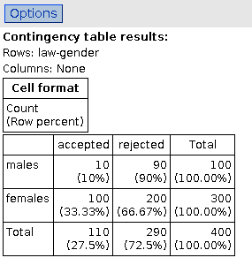
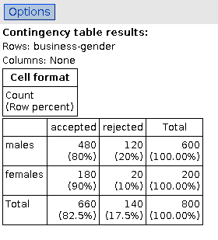

 | Male % accepted | Female % accepted
Overall | 70 | 56
Law school | 10 | 33
Business school | 80 | 90
- how is that possible???

Why we get this answer

- Look at where males tend to apply
  - is it easy to be accepted there?
    - business school; easy
- Look at where females tend to apply
  - is it easy to be accepted there?
    - law school; difficult

Acceptance depends mainly on where you apply, not on whether you are male or female.

In fact, females have larger acceptance rate, other things being equal.

(Original comparison of overall acceptance rates is apples vs. oranges.)

(Actually, the airline example also contains a Simpson's paradox; the extra variable there is “airport”. America West flies mainly into Phoenix, easy to be on time, and Alaska mostly into Seattle and San Francisco, hard to be on time.) GOTO page 28
Chapter 4: Displaying and summarizing quantitative data

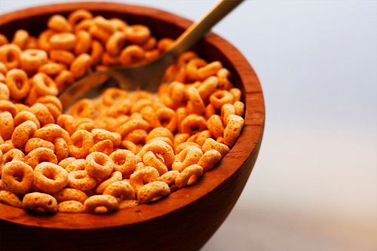
The breakfast cereal data

Study collected data on nutritional content per serving (and other things) of 77 different breakfast cereals, so that different cereals can be compared.

Mostly quantitative variables.
Histogram for calories per serving
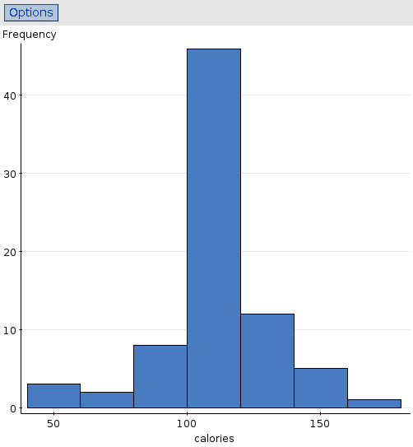

- most cereals have between 100 and 120 calories/serving.
- A few have a lot more or a lot less, but only a few.
- Shape symmetric: falls away from peak about same both sides.
Cereal calories stemplot
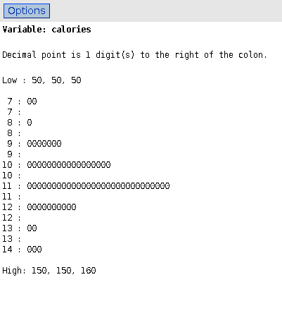

- same shape (turned on side)
- unusual values listed at top and bottom
- smallest value actually on plot is 70, largest 140.
- All leaves are 0:
  - actually only measured to nearest 10
  - couldn't see from histogram.

- Calories “almost” categorical (small number of possible values), so could also draw bar chart.
Bar chart of calories (treated as categorical):
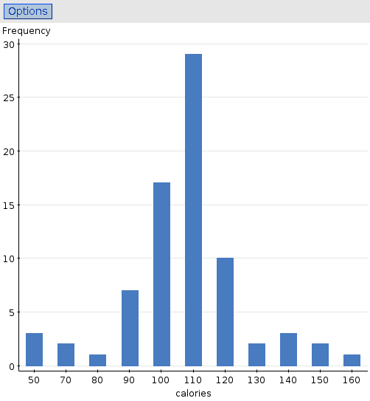
- again shows large number of values between 100 and 120, and few extremely high and low values.

Cereal potassium data histogram:
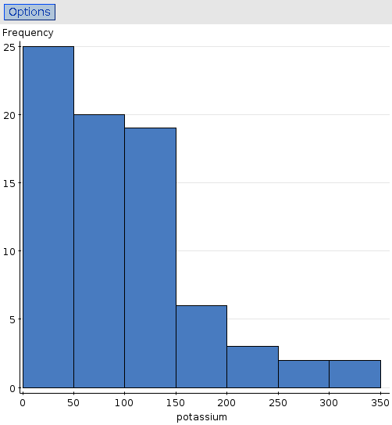
- Peak on left with long straggle of values to right
- Has right-skewed shape.
- Unlike calories, which was symmetric.

- Distribution of values with long straggle (tail) to left would be left-skewed.
Potassium stem-and-leaf:

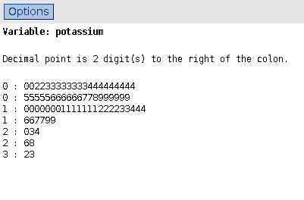
- Right-skewed shape shows up as long straggle at bottom.
- Value on end of 1st line is 40
- Highest value (end of last line) 330.

The mean and median (measures of “centre”)

- mean: “average”, add up values and divide by how many
- median: sort values into order, pick out middle one (or mean of 2 middle ones)

data: 8, 12, 7, 5, 4

- mean (8+12+7+5+4)/5=7.2
- median: in order 4, 5, 7, 8, 12, so median=7
  - with values 4, 5, 7, 8, 9, 12, median would be (7+8)/2=7.5.
- with n values, median is (n+1)/2-th value
  - n=5, median=6/2=3
  - n=6, median=7/2=3.5

Mean and median from cereal data:
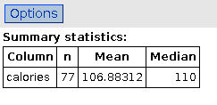
- Calories: median a little bigger than mean, but close together given nature of data

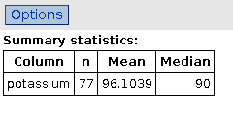
- Potassium: mean bigger than median, because distribution right-skewed.

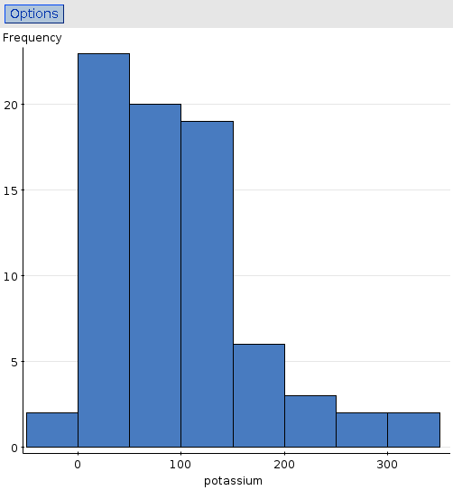

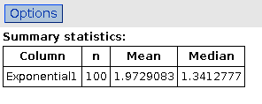
Another example:
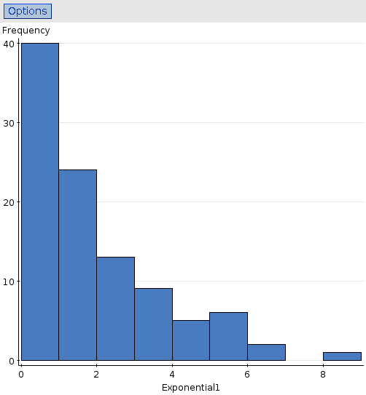

- Very right-skewed
- Mean much bigger than median
- Lower limit zero
With a lower or upper limit, there is “only one way” for a variable to go, especially if a lot of values close to the limit.

In the situations below, is there an upper or lower limit on the values of the variable? Which way would you expect the variable to be skewed?

- waiting time to be served at a bank
  - lower limit 0, skewed to right
- number of employees in companies based in Scarborough
  - lower limit 0, skewed to right
- scores on an easy quiz (marked out of 10)
  - upper limit 10, skewed to left
  - a really hard quiz might be skewed to the right.

Spread: interquartile range

- 1st quartile Q₁ has ¼ of data values below it and ¾ above
- 3rd quartile Q₃ has ¾ of data values below it and ¼ above
- Find a quartile by taking lower (upper) half of data, and finding median of that half.
- Interquartile range is IQR=Q₃-Q₁. Larger = more spread out.

Example: 3, 5, 7, 7, 8
- lower half 3, 5, 7 (include middle), so Q₁=5
- upper half 7, 7, 8 so Q₃= 7
- IQR=7-5=2
- IQR not affected by extremely high or low values, like median.
Standard deviation (SD): another measure of spread
Illustrate with example. Data as above, mean 6:
Data | Minus mean | Squared
3 | -3 | 9
5 | -1 | 1
7 | 1 | 1
7 | 1 | 1
8 | 2 | 4
Total | 0 | 15

So variance is 15/(5-1)=3.75
and therefore SD is = 1.94.
Fire up StatCrunch and enter these numbers into a column:

1, 2, 3, 4, 5.

- Find the mean and median. Are they the same? Would you expect them to be?
  - yes
- Replace the number 5 with 10, and find the mean and median again. Are they still the same? If not, which is bigger?
  - no; mean is bigger
- Now replace the 10 with 20. What has happened now? Do you think the mean or median is the better choice for the “centre”?
  - mean is bigger still; median is better choice for centre

Optional extra: repeat for IQR and standard deviation.
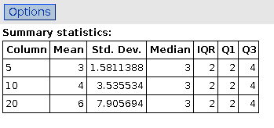

Chapter 5: understanding and comparing data

Data 10, 11, 14, 15, 17, 19, 21, 28, 35:

- find median
  - 17, Q1= median of 10,11,14,15, 17 ie. 14
  - Q3=median of 17, 19, 21, 28, 35 ie. 21
- find Q₁ and Q₃

- find interquartile range
  - 21-14=7
- find 5-number summary min, Q₁, median, Q₃, max.
  - 10, 14, 17, 21, 35

Boxplot (numbers from example above)
- box goes down the page, with scale on left.
- centre of box at median (17)
- top of box at (21) Q₃
- bottom of box at (14) Q₁
- calculate R=1.5 x IQR: 1.5(21-14)=10.5
  - upper fence at Q₃+R 21+10.5=31.5
  - lower fence at Q₁-R 14-10.5=3.5
- draw lines connecting box to most extreme value within fences
- plot values outside fences individually. These are suspected outliers and deserve to be investigated.

StatCrunch boxplot (select “use fences to identify outliers”):

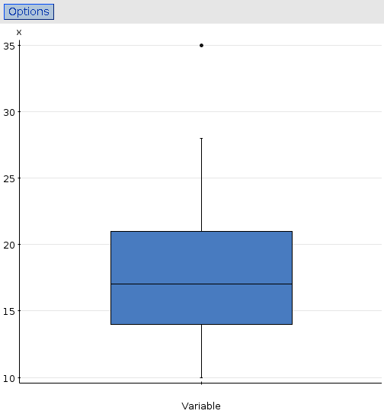
Comparing distributions with boxplots

Cereals classified by shelf where found in grocery store:
- 1=top shelf
- 2=middle shelf
- 3=bottom shelf
Want to compare sugar/serving for shelves.

How about a histogram for each shelf, put results side by side?

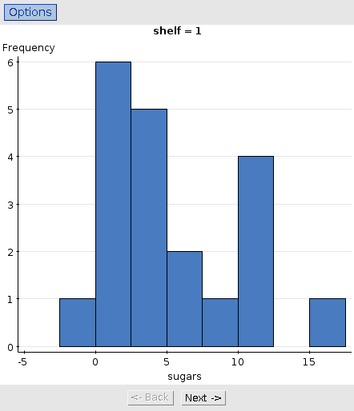
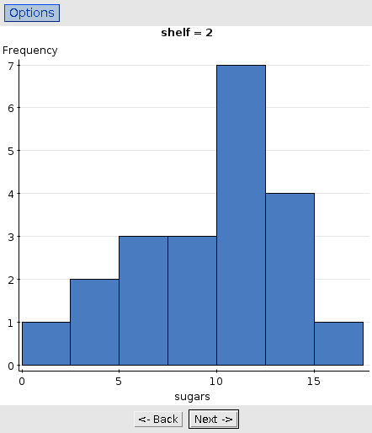
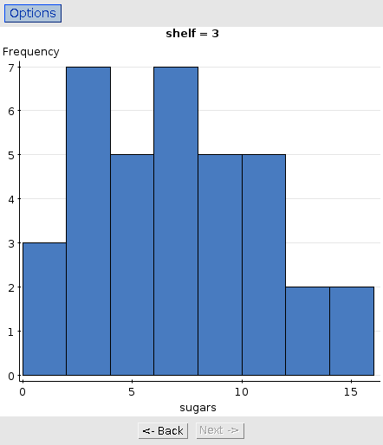

- so where are the most sugary cereals?
- maybe on shelf 2? Hard to decide.
- how about side-by-side boxplots?
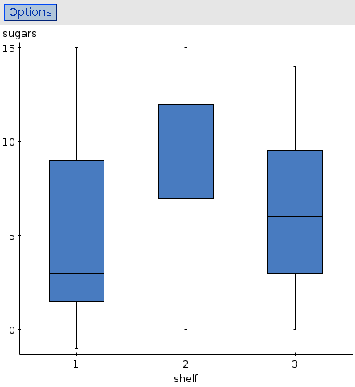

Median definitely highest for shelf 2, lowest for shelf 1.
- Easier to see than on histograms.
- Bonus: shelf 1 sugar right-skewed, shelf 2 sugar left-skewed.
  - shelf 1 boxplot has longer whisker above,
  - shelf 2 boxplot has longer whisker below.

- where did median go for shelf 2 sugar?

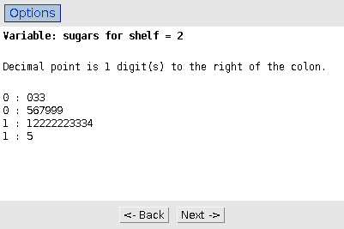
… and why?

- Look at stemplot for shelf 2 sugar
- a lot of the cereals had sugars exactly 12.
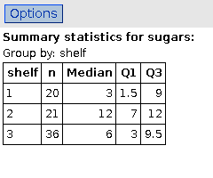
- so Q3 and median for shelf 2 sugars are the same.
- 21 cereals so median 11th and Q3 16th smallest. (Or 6th and 11th largest.)

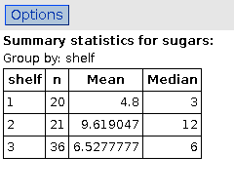
- do the means tell the same story as the medians?
- does the skewness show up here as well?
yes: compare means and medians
Data file “audio.dat” contains lengths (seconds) of audio files sampled from an iPod.
Histogram and boxplot:
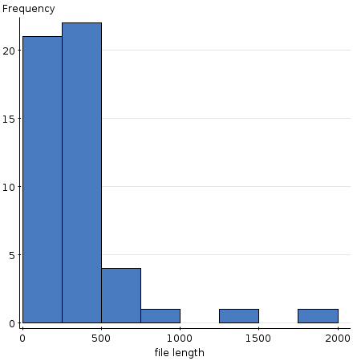
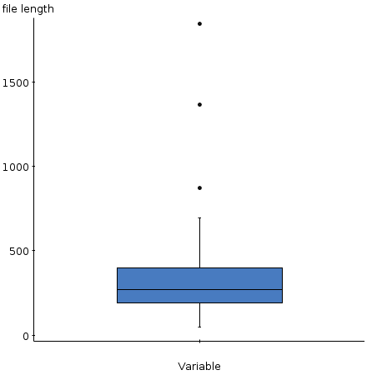
- at least 2 (maybe 3) outliers. Are they reasonable track lengths? yes, 1800 seconds is only half an hour (eg. symphony)
Which summary do you prefer:
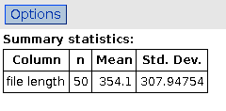
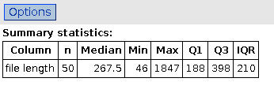

Why?

don't use mean and SD (skewed shape), use median etc. instead.

(mean and SD will be messed up by skewness/outliers.)

Chapter 6: The standard deviation as a ruler and the normal model
Which is the better exam score?
- 67 on an exam with mean 50 and SD 10
- 62 on an exam with mean 40 and SD 12?

Is it fair to say:
- 67 is better because 67 > 62?
- 62 is better because it is 22 marks above the mean and 67 is only 17 marks above the mean?
Key: z-scores.

Return to the cereal potassium data. Look at StatCrunch report “location and spread under linear transformation”.

Summary:
- if you multiply/divide all data values by a constant, all measures of centre and spread multiplied/divided by that constant.
- if you add/subtract constant to all data values, measures of centre add/subtract that constant, but measures of spread unchanged.

When you calculate a z-score as

using the mean and SD of x, what are the mean and SD of z?

- First off, suppose x has mean 10 and SD 3.
- Then x-10 has mean 10-10=0 and SD 3.
- and z=(x-10)/3 has mean 0/3=0 and SD 3/3=1.
- this actually works no matter what mean and SD x has.
- Try it with x having mean -5 and SD 10, say.

No matter what mean and SD x has, z has mean 0, SD 1.

- Calculating a z-score sometimes called “standardizing”. Above says why.
- Gives a basis for comparison for things with different means and sds.
Those exam scores above:

Which is the better exam score?
- 67 on an exam with mean 50 and SD 10
- 62 on an exam with mean 40 and SD 12?

Turn them into z-scores:
- 67 becomes (67-50)/10=1.70
- 62 becomes (62-40)/12=1.83

so the 62 is a (slightly) better performance, relative to the mean and SD.

Density curves and the normal model

How big might a z-score typically be?
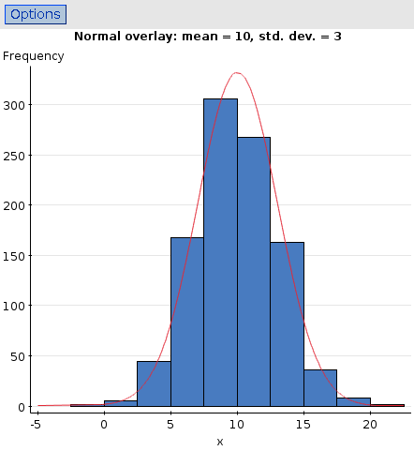
To answer that, need mathematical model to describe what's going on.

Here's one: often run into data with symmetric distribution and no outliers, like this:

Red curve is normal distribution model. Not a perfect match, but pretty close.
Mean and standard deviation on a normal distribution
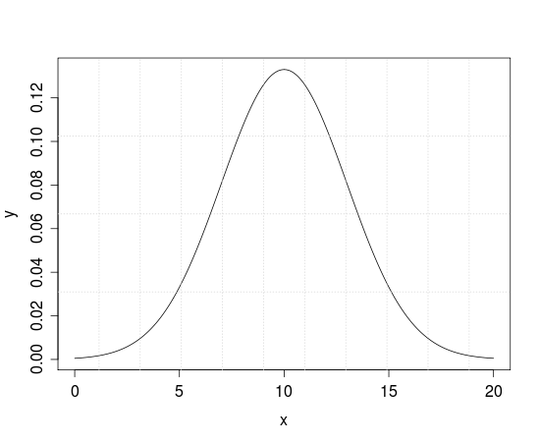
- Mean (and median) at peak (10)
- for SD: look at where density function stops curving down and starts curving out. These are “shoulders”: at 7 and 13.
- Distance from mean to a shoulder is the SD: 13-10=10-7=3.
- So mean is 10 and SD is 3.
Z values and Table Z

How much of a normal distribution is less than a value, more than a value, between two values?

Use Table Z, pages 1047-8 in text:
- first calculate z
- then look up z in table, which gives you fraction less.

Roma tomatoes have weights that have a normal distribution shape with mean 74 grams and SD 2.5 grams. What proportion of these tomatoes will weigh less than 70 grams?
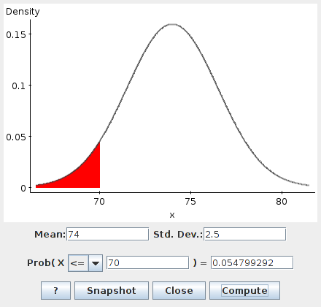
z=(70-74)/2.5=-1.60;
look up -1.60 in table Z to get 0.0548.

What proportion of the Roma tomatoes in the previous question will weigh more than 80 grams? (Mean 74, SD 2.5.)
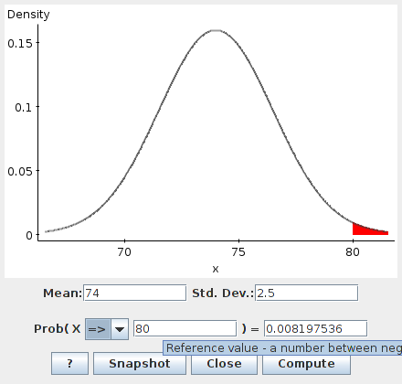
- z=(80-74)/2.5=2.40
- Table: 0.9918 less
- so 1-0.9918=0.0082 more.

What proportion of the Roma tomatoes of the previous two questions will weigh between 70 and 80 grams? (There are two ways to do this, both of which use the previous work.)

Way 1 (easier to understand)
- 0.0548 less than 70
- 0.0082 more than 80
- everything else between: 1-0.0548-0.0082=0.9370.

Way 2 (easier to do)
- 70 as z-score is -1.60, table gives 0.0548.
- 80 as z-score is 2.40, table gives 0.9918.
- Subtract: 0.9918-0.0548=0.9370.
What if z has 2 decimal places?

Example using Roma tomatoes again (mean 74, SD 2.5): proportion less than 77.4 grams?
- z=(77.4-74)/2.5=1.36
- use column of table according to 2nd place, so z=1.36 gives 0.9131 (answer).

Getting values from proportions

- Use Table Z backwards to get z that goes with proportion less
- Turn z back into original scale by using x=mean + SD * z.
- Why? z=(x-mean)/SD, solve for x

At-term newborn babies in Canada have weights that follow a normal distribution, with mean 3500 grams and SD 500 grams. (The mean is a little less than 8 pounds.)

- A baby is defined as being “high birth weight” if it is in the top 2% of birth weights. What weight would make a baby “high birth weight”?
  - 2% more = 98% less = 0.9800 less
  - z=2.05 (closest)
  - weight = 3500 + 500*2.05 = 4525 grams (or more)
- A baby is defined as being “very low birth weight” if it is in the bottom 0.1% of birth weights. What weight would make a baby “very low birth weight”?
  - 0.1% less = 0.0010 less
  - z = -3.09 (I picked the middle one)
  - weight = 3500 + 500*(-3.09) = 1955 grams (or less)

How do we see whether a normal distribution is a good fit to data?

Return to the cereal potassium data.
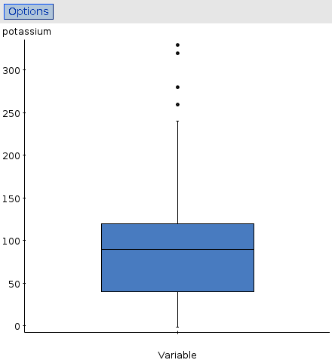
Histogram and boxplot:

- distribution skewed right.
- look also at normal probability plot (QQ plot):
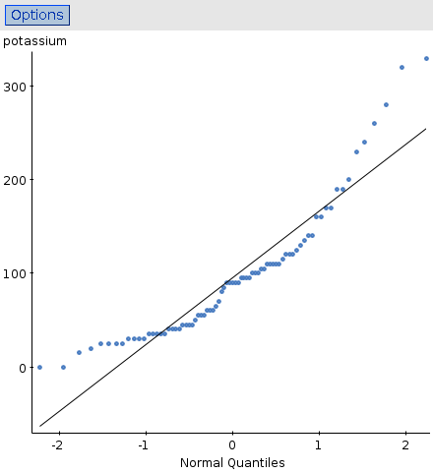
- if normal distribution OK, blue dots more or less follow central line (straight)
- Curve or other systematic deviation from line = not normal
- Here, not normal.
- low values too bunched together, high values too spread out: skewed to right.
Actual normal data:
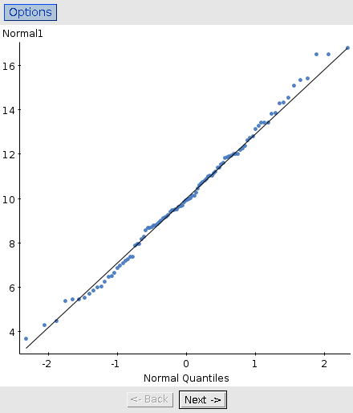
- not perfectly straight
- but no obvious outliers or curve
- normal distribution ok for these data.
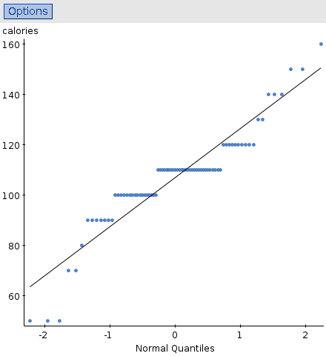
Cereal calorie data:

- horizontal blue dots: calories only measured to nearest 10
- high values a little too high
- low values too low
- symmetric, but too many outliers for normal.

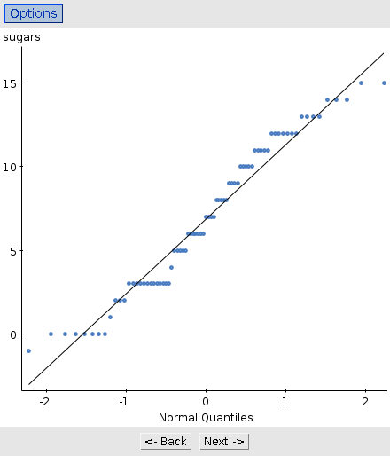
Cereal sugars:

- a lot of identical values (like calories)
- otherwise reasonably close to line
- normal probably not too bad.
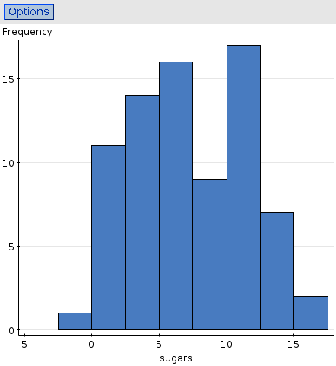
Cereal sugars histogram:

- histogram has a “hole” between 7.5 and 10
- otherwise, not too far from normal.
68-95-99.7 rule

Sometimes can get a rough idea of normal proportions like this.
- about 68% of a normal distribution between mean +/- SD
- about 95% of a normal distribution between mean +/- 2 SD
- about 99.7% of a normal distribution between mean +/- 3 SD

Recall weight of Roma tomatoes: mean 74, SD 2.5 (grams)
- what weights will about 95% of them be between?
  - 95% is 2xSD so between 74-2(2.5)=69 and 74+2(2.5)=79
- about what fraction of the weights will be between 71.5 and 76.5 grams?
  - z for 76.5 = (76.5-74)/2.5=1 and z for 71.5 = -1, so the fraction is 68%.
Variations
Again using mean 74, SD 2.5:
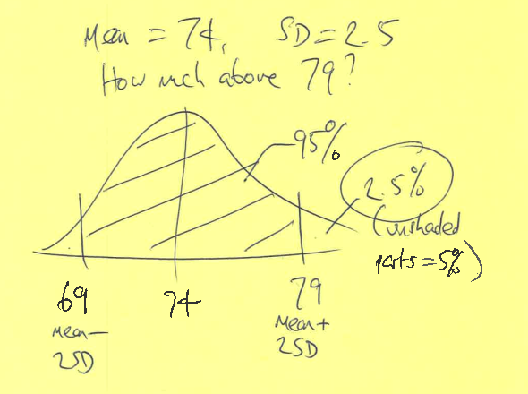
- about what fraction of weights will be more than 79 grams?
  - 2.5%

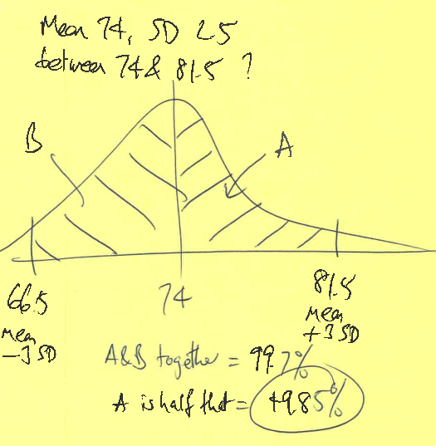
- about what fraction will be between 74 and 81.5 grams?
  - 49.85%

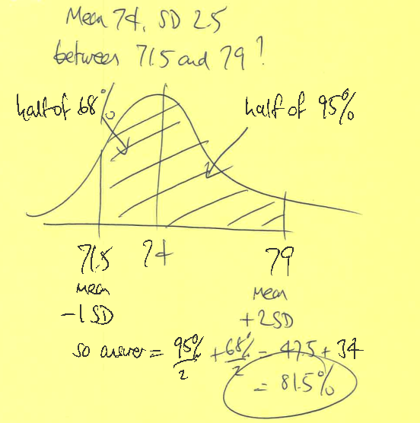
- about what fraction will be between 71.5 and 79 grams?
  - 81.5%

When you don't have a normal table

Proportion of standard normal distribution less than z is approximately , 0.99 for 2.2<z<2.6, 1 beyond.
(this for z positive – if z<0, draw a picture and flip it around).

Roma tomatoes: mean 74, SD 2.5; proportion less than 77.4 gives z=1.36. Proportion less approximately
0.5+(1.36)(4.4-1.36)/10=0.9134
Compare correct answer 0.9131. (Usually accurate to 2 decimals.)

Proportion less than 70: gives z=-1.60. Draw picture. Same as proportion more than 1.60. Proportion less than 1.60 approx 0.5+1.60(4.4-1.60)/10=0.9480.
Proportion more than 1.60 = proportion less than -1.60
= 1-0.9480=0.0520 (compare exact 0.0548: 0.05 is correct).

Chapter 7: Scatterplots, association and correlation

- Previously, single variables on their own.
- Or one or more categorical variables.
- Now look at two quantitative variables.
- First tool: scatterplot.
  - Plot values of two quantitative variables against each other.

The airport in Oakland, California recorded the number of passengers departing in each month from 1990 to 2006. Scatterplot of passengers against time:

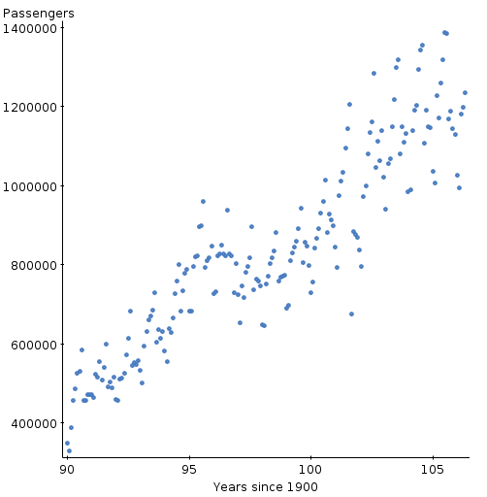

Talking about association

- Direction
  - Upward trend (positive), downward trend (negative)
- Form
  - Straight line, curve
- Strength
  - Strong (clear) relationship, moderate, weak

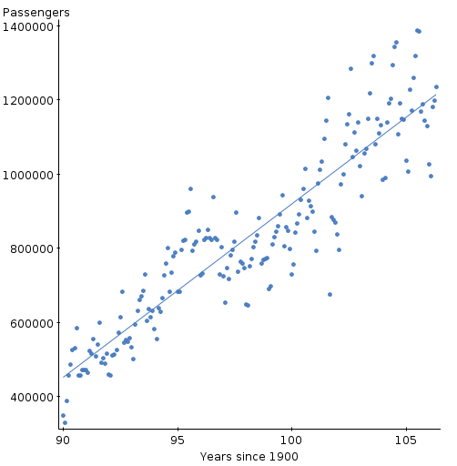
With line:

- upward trend
- close to straight line (not obviously curved)
- fairly strong (could be closer to line, but not much)

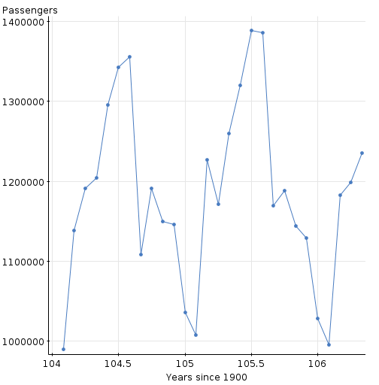
Now look at month-by-month for 2004-2006 (months joined by lines):

- what is happening? Why?
  - seasonal trend: low in winter, high in summer, mixed up with overall increase
- why didn't we see it before?
  - hard to see this detail over 15 years

Correlation

- If the association is a line, can calculate a number to describe how near a line the points are: correlation (coefficient).
- Number between -1 and 1:
  - 1 means perfect positive (uphill) association
  - 0 means no (linear) association at all
  - -1 means perfect negative (downhill) association
  - in between means in between

Some correlations
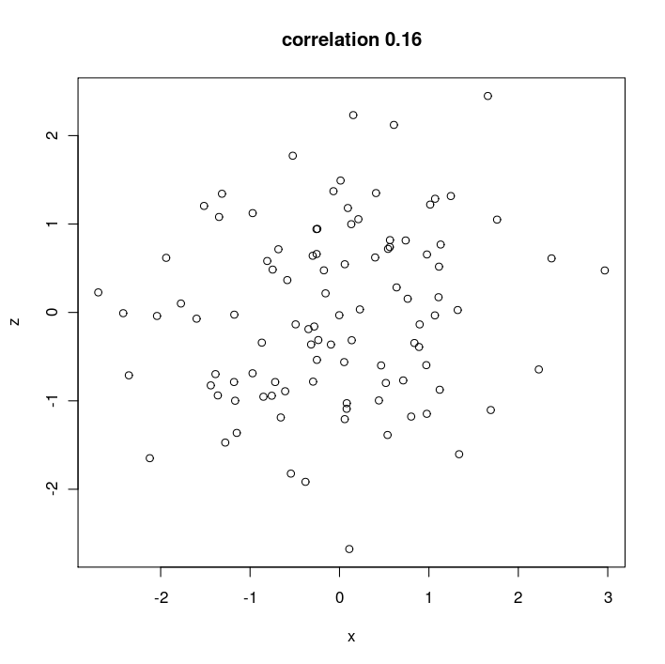

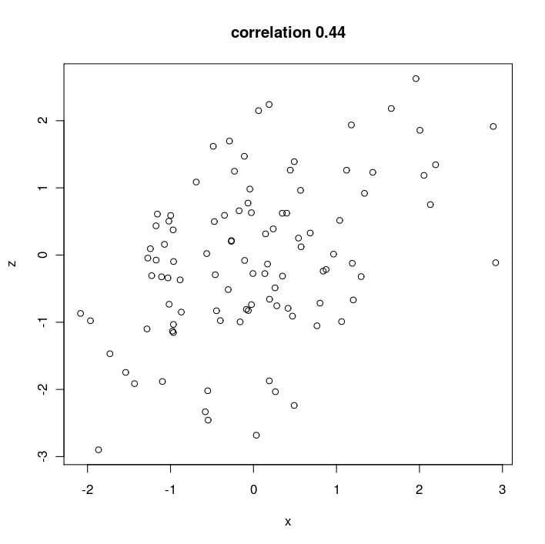

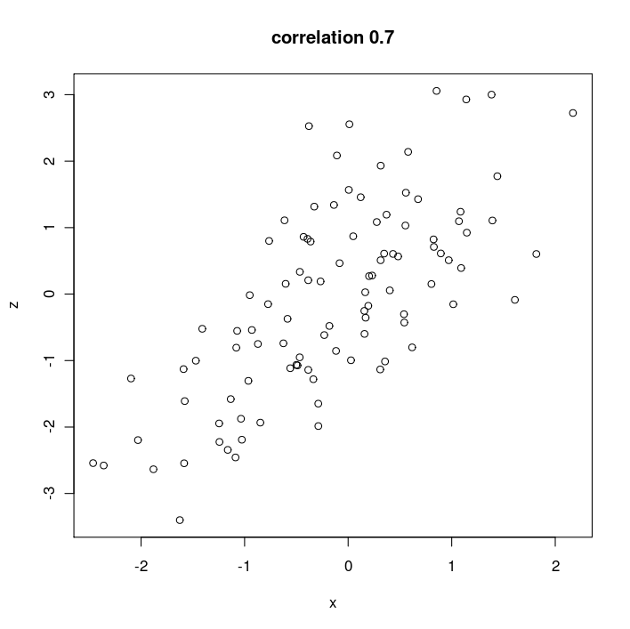
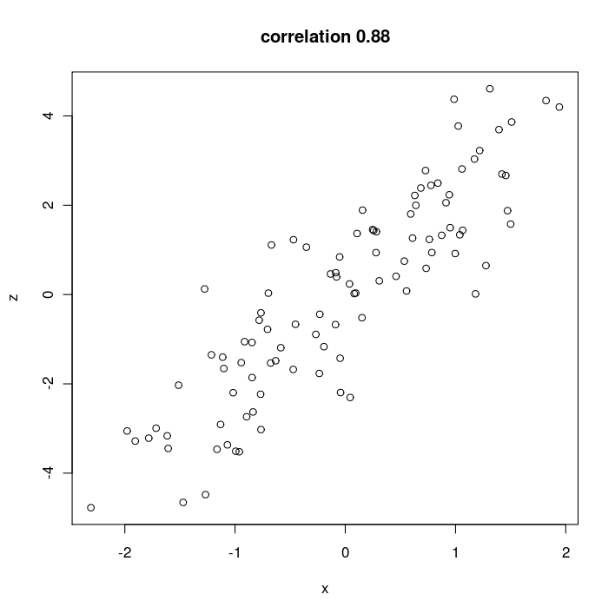
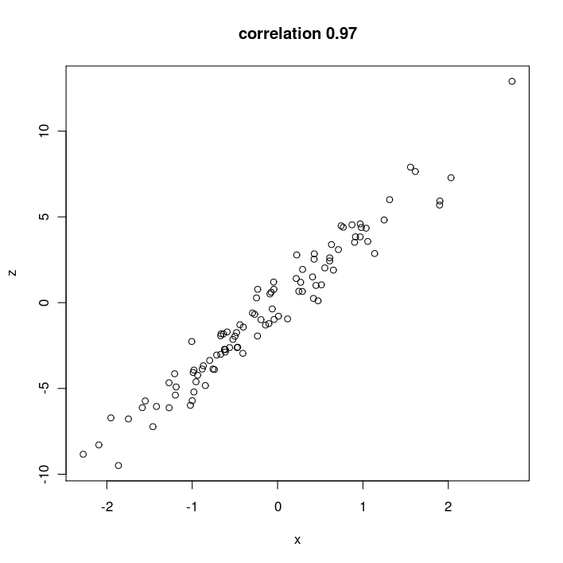
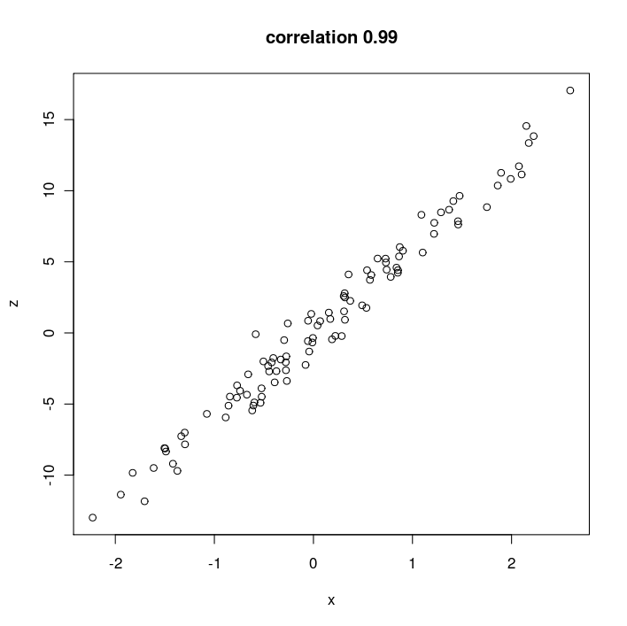
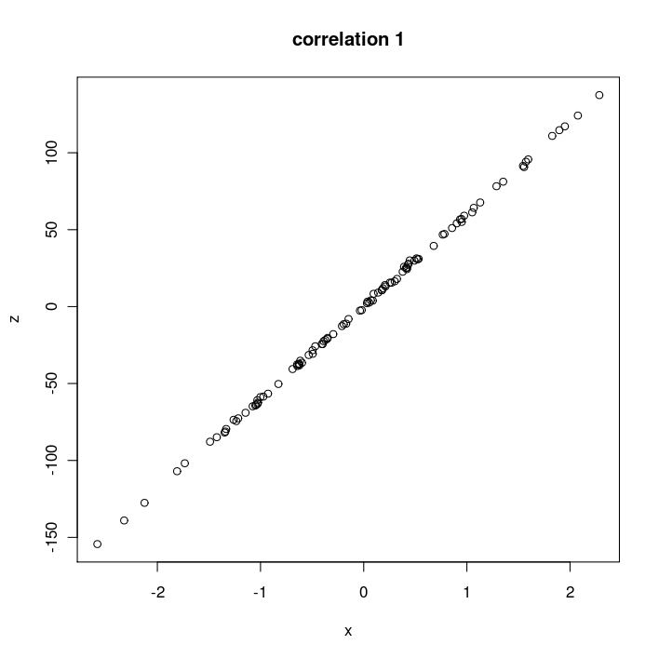
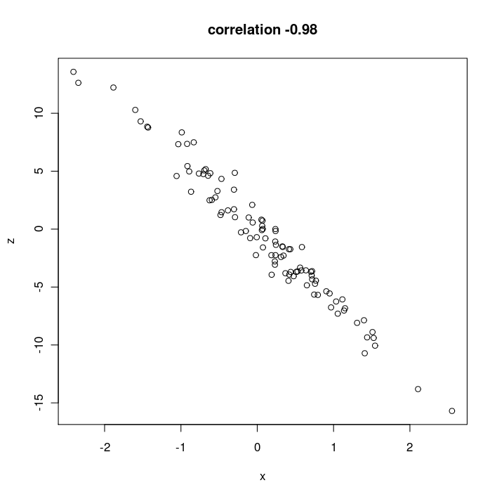
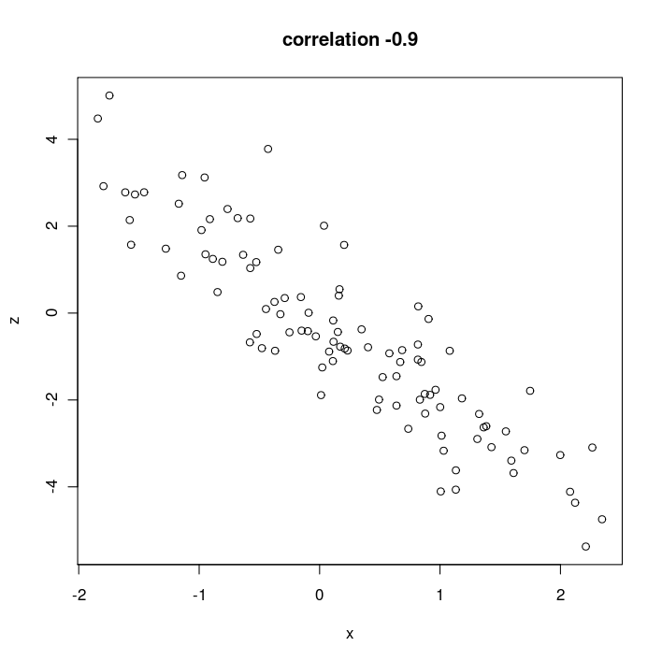
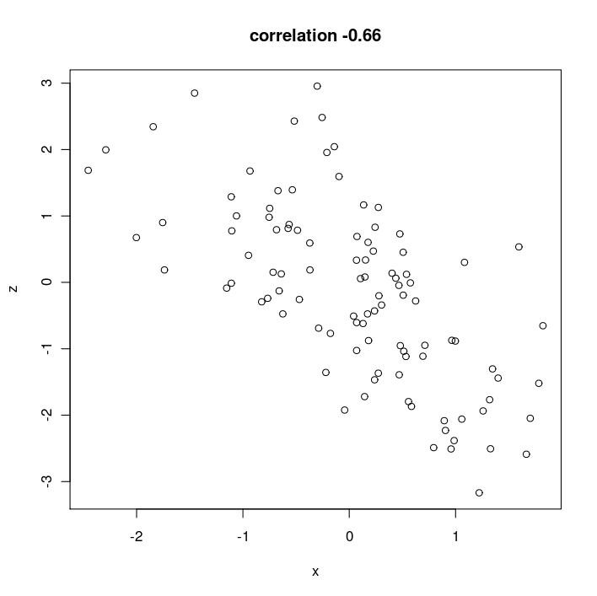
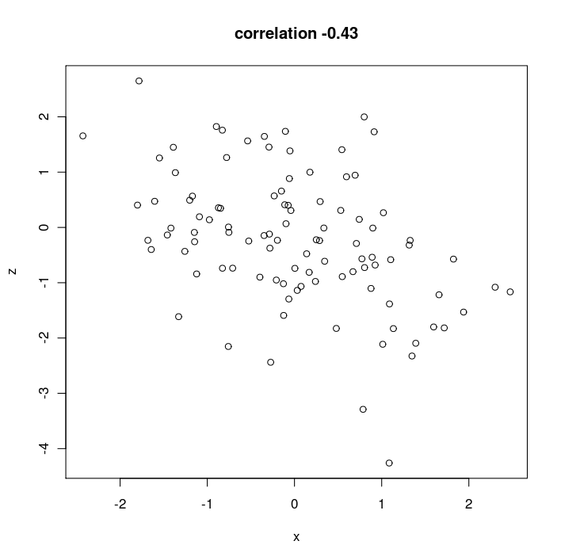
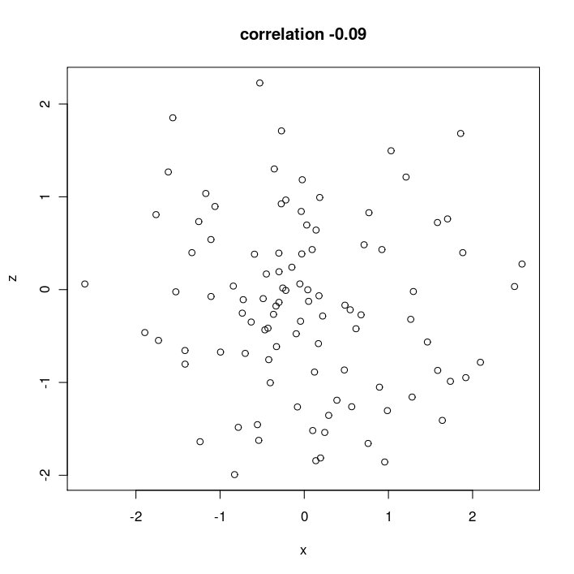
Scatterplot of marijuana use vs. other drug use:
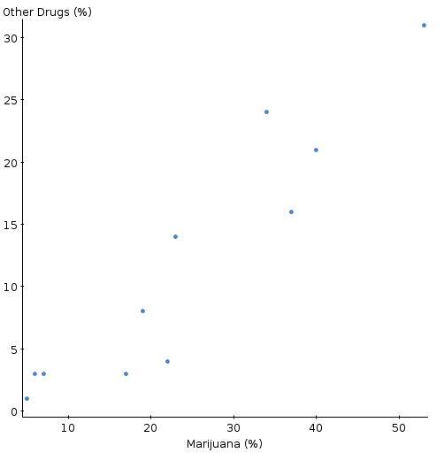
- Describe what you see on the scatterplot (form, direction, strength).
  - upward trend, fairly strong, linear
- Does it make sense to find a correlation here?
  - yes, because trend looks linear.
- Can you conclude that marijuana is a “gateway drug”: marijuana use leads to use of other drugs? Why or why not?
  - no, correlation does not show cause and effect.
(My data set: “drug abuse”.)
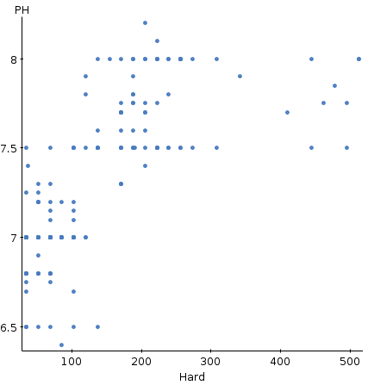
In a study of streams in the Adirondack mountains, the following association was found between the pH of the water and its hardness:

- Describe the relationship.
  - positive association, but not a straight line.
- Is it appropriate to use the correlation to summarize the relationship? Explain.
  - no, because correlation only useful in linear relationships.

Response and explanatory variables

- When you calculate a correlation, it doesn't matter which variable is x and which is y.
- Sometimes one variable is an “outcome” or response, and the other explains the outcome, an explanatory variable.
  - In that case, call the response y and plot it on the vertical axis of a scatterplot.
Chapter 8: Linear regression – finding the best line

In math, straight line relationship looks like

where x and y are variables, and a and b are numbers that describe what kind of straight line you have.
- a = “intercept”: value of y when x=0
- b = “slope”: if you increase x by 1, how much do you increase y by?
  - slope=2: increasing x by 1 increases y by 2
  - slope=-3: increasing x by 1 decreases y by 3
  - slope could be negative, if line goes downhill.

If you know the intercept and slope, you know the straight line.
So aim: find intercept and slope of line that “best” describes data.
Straight line only model: won't be perfectly accurate. But may be useful.
Residuals

Go back to drug abuse data set.
Let y=other drug use, x=marijuana use. Let be predicted other drug use.
Suppose model is .
For England, x=40, y=21, is prediction.
England's actual drug use was 21, higher than predicted by the model:

Idea: want “best” line to pass close to all the data, so want all residuals close to 0.
So decide how good a line is by working out all the residuals, square and add up. (Like variance). Best line is one with sum of squared residuals smallest. (could try a bunch of candidate lines, work out all the residuals for each one, add up and compare. But can do better.)
How to find the least squares line

- find means and Sds of both variables: and correlation r between them
- slope =
- intercept =
Drug abuse example
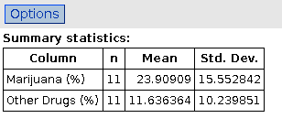
StatCrunch says ----------------->

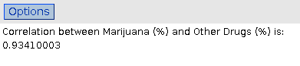

- Calculate the slope and intercept of the least-squares regression line. (Answers: slope 0.615, intercept -3.068.)
  - slope=(0.934)(10.240)/(15.553)=0.615
  - intercept=11.64-(0.615)(23.91)=-3.068
- Predict “other drug use” for England (x=40), which was actually 21. How close is the regression line?

  - regression line is
  - prediction is -3.068+0.615(40)=21.53
  - actual value 21
  - residual = 21-21.53=-0.53

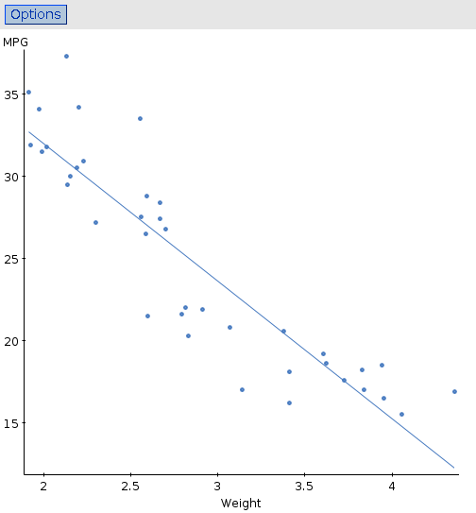
Car data
- data on number of car models. Here predict gas mileage (miles per US gallon) from the weight of the car – expect heavier cars to have a worse (lower) mpg.
- first: scatterplot. Is association straight?
  - apparently
- correlation of -0.903 is pretty good.
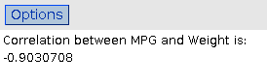

Regression for predicting MPG from weight
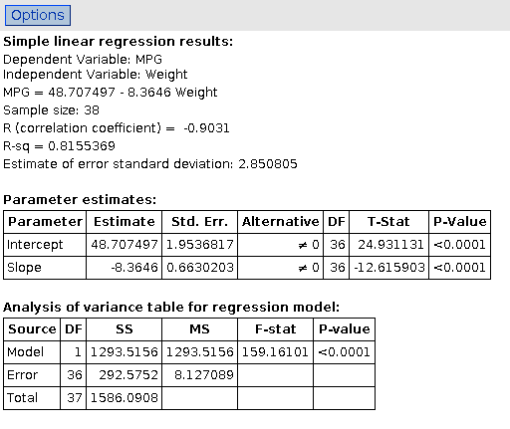
- R-squared: 82% (high): most of reason mpg varies is because it depends on weight.
- Intercept 48.7, slope -8.4.
- Predicted MPG for car weight 2.5 tons?
  - 48.7+(2.5)(-8.4)=27.7
- Predicted MPG for car weight 6 tons?
  - 48.7+(6)(-8.4)=-1.7
  - nonsense!
  - predicting beyond data: extrapolation (bad)
Checking residual plot
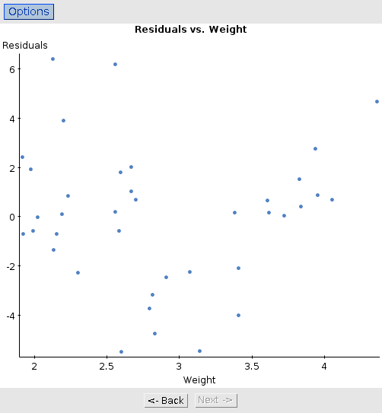
- down-and-up pattern
- residuals for weights around 3 tons are negative
- those for low & high weights mostly positive
- residual plot shows curve: actual relationship is curved, not linear.
- So predictions we made not completely trustworthy.
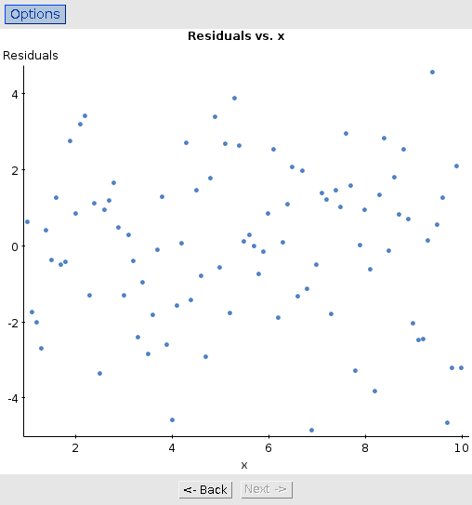
Random rubbish

- This residual plot has no pattern whatever.
- The regression it came from has no problems.
Doing regression
- start with a scatterplot
- if it does not look like a straight line relationship, stop (see Chapter 10).
- otherwise, can calculate correlation and also intercept and slope of regression line
- check whether regression is OK by looking at plot of residuals against anything relevant
  - if not OK, do not use regression.
- Aim: want regression for which line OK, confirmed by looking at scatterplot and residual plot(s). Otherwise, cannot say anything useful.

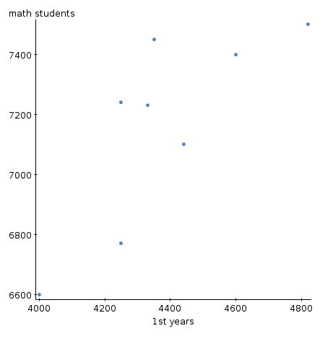
At a certain university, for each of several years, the total number of first years is recorded, and also the number of students taking “elementary math courses”. A scatterplot looks like this:

- Would you say that as the number of 1st years increases, the number of math students increases too?
- Would you consider fitting a regression line here?

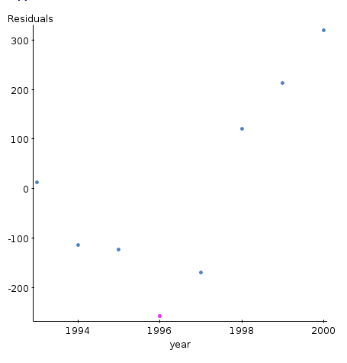
- For the same data, a regression is done to predict the number of math students from the number of 1st years. The residuals are saved.
  - There is a third column in the data set, the year in which the students were counted. A plot of residuals against year looks like this:

- Does this suggest that the regression was satisfactory, or not? If not, why not?

Correlation and causation

- high correlation between #sodas sold in year and #divorces, years 1950-2010. Does that mean that having more sodas makes you more likely to divorce?
- observe that smokers have higher blood pressure on average than non-smokers. Smoking causes higher blood pressure?
- high correlation between #teachers and #bars for cities in California. Teaching drives you to drink?
- high correlation between amount of daily walking and quality of health for men aged over 65. Explanation?
- positive relationship between #ski accidents and waiting time for ski lift for each day during one winter at ski resort. Having to wait a long time makes people impatient?

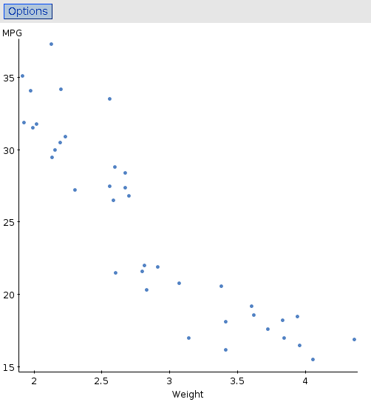
Chapter 9: Regression Wisdom

- If a car is heavier, what effect does that have on gas mileage?
- Data for 38 cars from magazine survey.
- Direction, strength, form?
Do the regression for predicting MPG from weight:

- high R-squared
- strongly negative correlation and slope.
- Next stage: plot the residuals. I also got a scatterplot with fitted line on it.
The residual plot:

- Doesn't look completely random, but a bit curved.
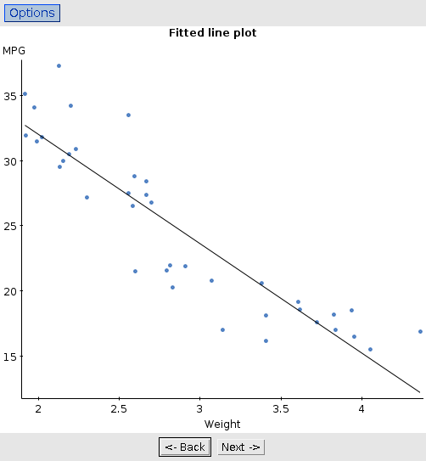
Look at scatterplot with fitted line:
- Looking more carefully, the curve does show up.
- See how to fix this in chapter 10.

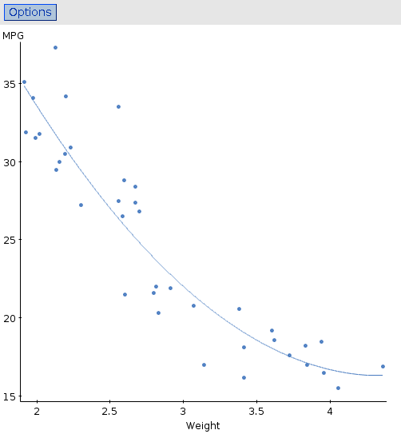
Scatterplot with fitted curve

- curve does seem to go through points better
- as weight increases, MPG does not decrease so fast.

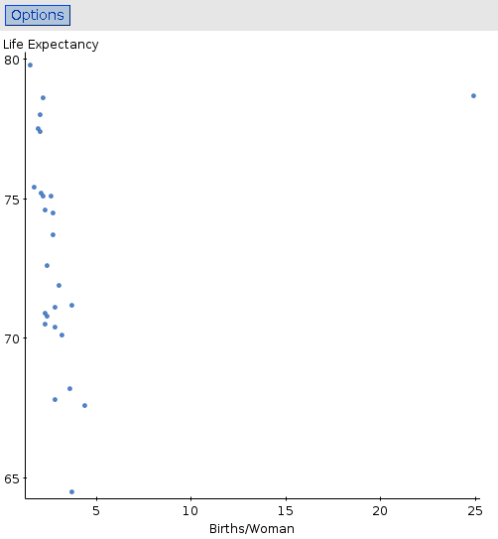
Life expectancy 2004

How does the life expectancy for a woman depend on number of children that woman has? Data for 26 countries (“life expectancy 2004”). Scatterplot:

- as births/woman increases, life expectancy decreases.
- Huge outlier top right.
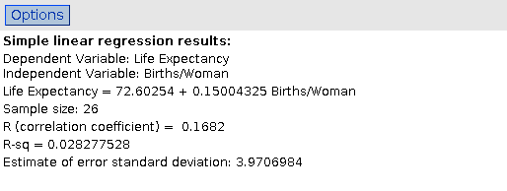
Regression with and without the outlier:

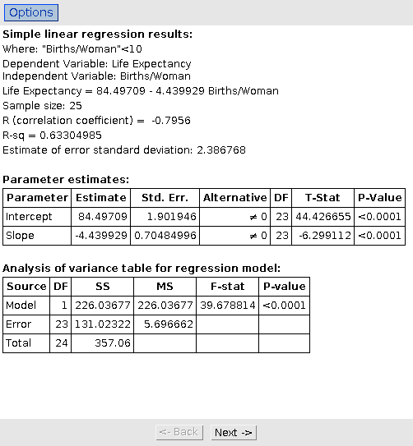
- Completely different!
- What has changed?
- The outlier is influential because it has unusual value for explanatory variable.
Do we trust the regression without the outlier?
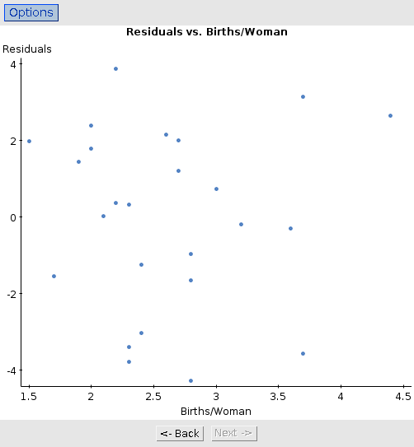
Residual plot:

Is it a random scatter of points?
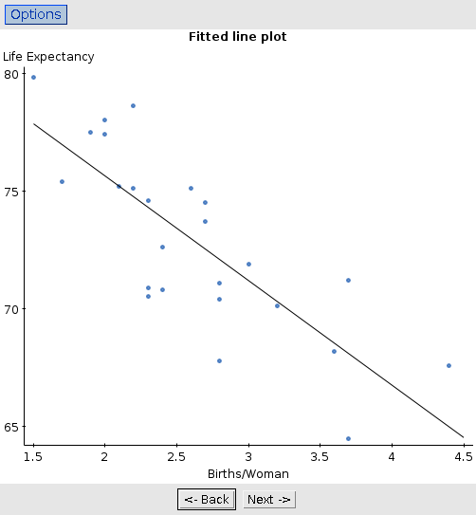
Fitted line plot:

- Direction, form, strength?
- Outlier was Costa Rica, with life expectancy 78.7 and births/woman 24.9.
- What do you think Costa Rica's births/woman should have been?
- What do you think happened to Costa Rica's data?

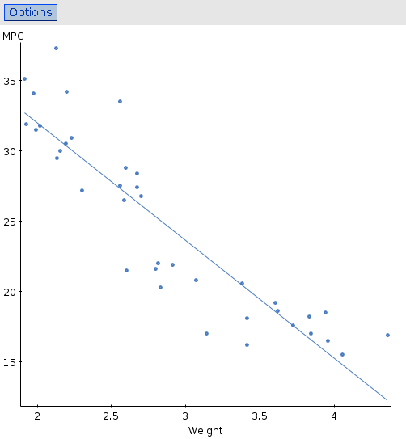
Correlation with subsets of data

Return to cars MPG/weight:

- cars seem to divide into “good” gas mileage (above 25) and “bad” (below).
- What is correlation between MPG and weight for just the “good” cars, or just the “bad” cars? How does that compare to correlation for all cars?
Correlations:
- correlation for just part of the data is lower (closer to 0) than for all the data.
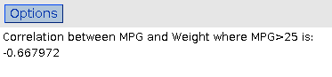
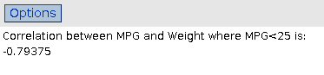
- look at the data for just the low-MPG cars (in scatterplot above). How would you describe that MPG-weight relationship? Do the answers to the right surprise you?

Called the restricted-range problem: when one of the variables is restricted (you only look at some of the values), the correlation can be surprisingly low.
Scatter plot showing separate regression lines for each group
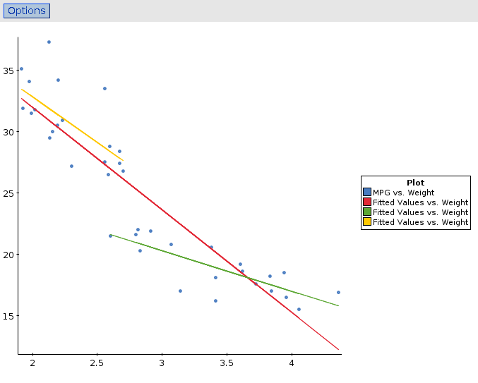
- the regression lines are quite different, which would make you expect to see a higher correlation within each group.
  - but you don't!

Chapter 10: Re-expressing data – Get it Straight!

- Take a simple function of the data (the response, in regression) to achieve:
  - make the distribution more symmetric
  - make spreads of several groups more similar
  - make a scatterplot more linear
  - make spread in a scatterplot same all the way along

Stemplot and boxplot of cereal potassium data. What would you like to fix?
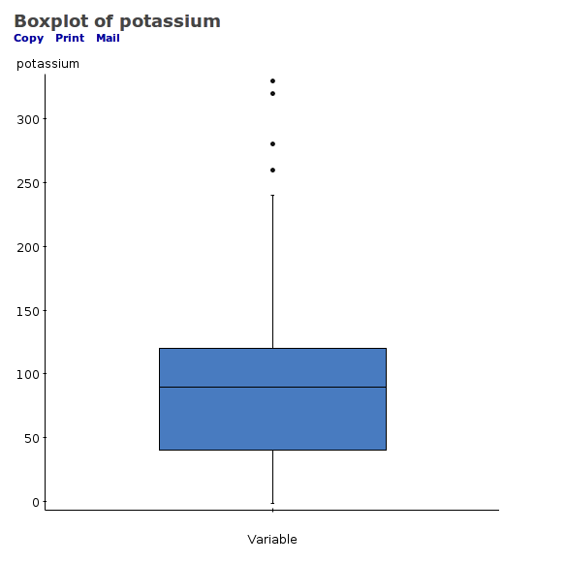
Variable: potassium
Decimal point is 2 digit(s) to the right of the colon.
0 : 002233333333444444444
0 : 55555666666778999999
1 : 00000001111111222233444
1 : 667799
2 : 034
2 : 68
3 : 23

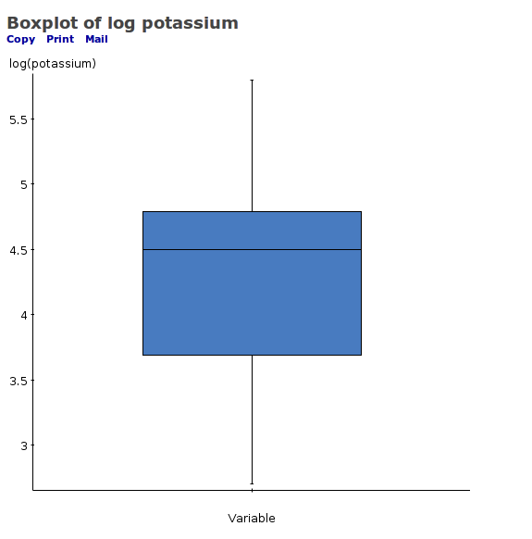
Try log of potassium:
Variable: log(potassium)
Decimal point is at the colon.
2 : 7
3 : 022224444
3 : 66666777788889
4 : 0001112244
4 : 5555566666667777777788889999
5 : 11112234
5 : 56688

What about boxplots of potassium by shelf?

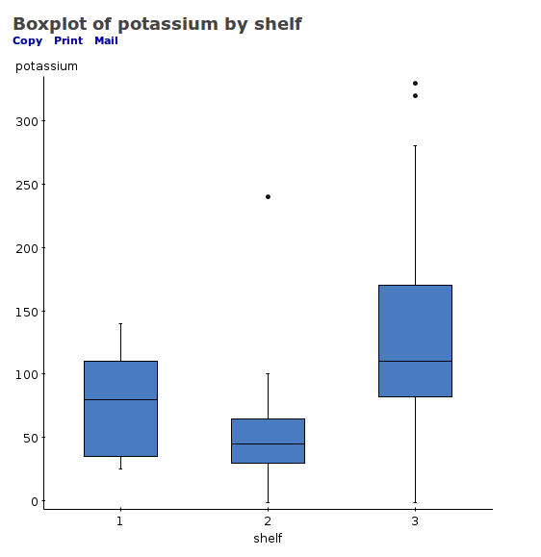
How does spread compare as centre gets larger?

Try using log of potassium values:
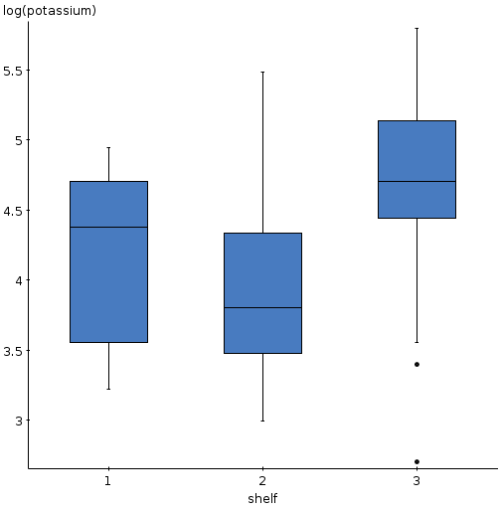

Spreads are more equal now, less dependent on centre.

Ladder of powers

Power | Name | Notes
2 | Square of values | Left skewed
1 | Unchanged data
0.5 | Square root | Counts
0 | Logarithm | % change matters
-0.5 | -1/square root | Rare
-1 | -1/data | Ratio “wrong way up”

Cereal potassium data: log was good, but can we do better? Look at boxplots:
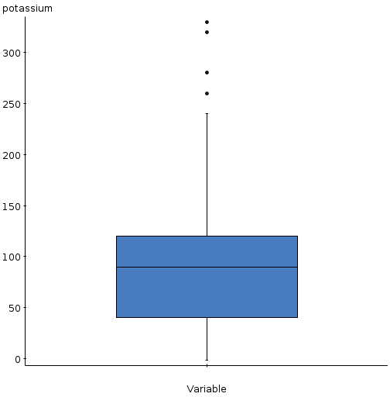
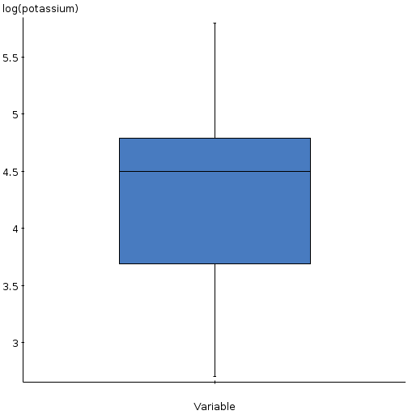

original data (1) log (0)
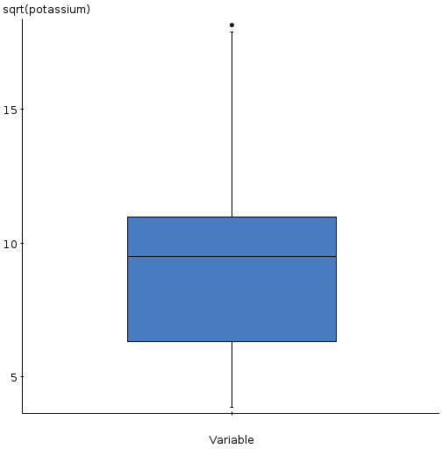
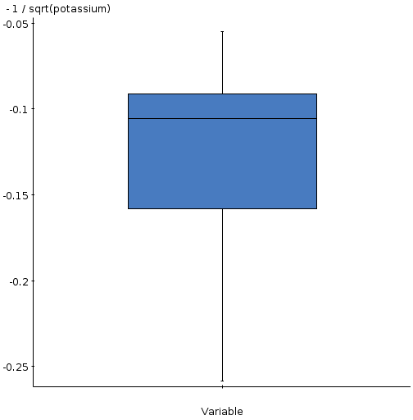

square root (0.5) -1/sqrt (-0.5)
Where on the ladder of powers should we be to
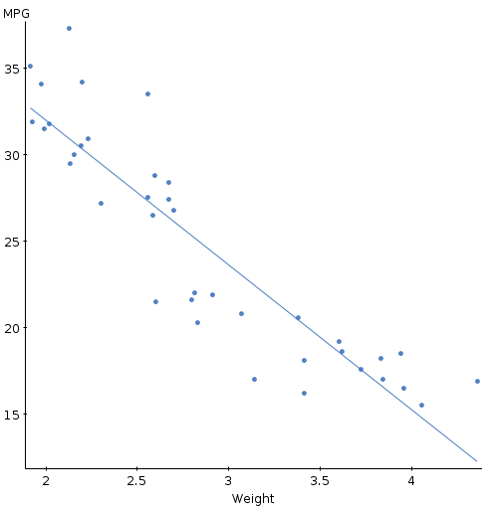
make the shape symmetric?

(Graph belongs on next page.)
power 1
Previously saw regression of car mpg vs weight:

- Relationship looks curved (shows up on residual plot). Also logically mpg cannot go below zero.

- Try log of mpg.
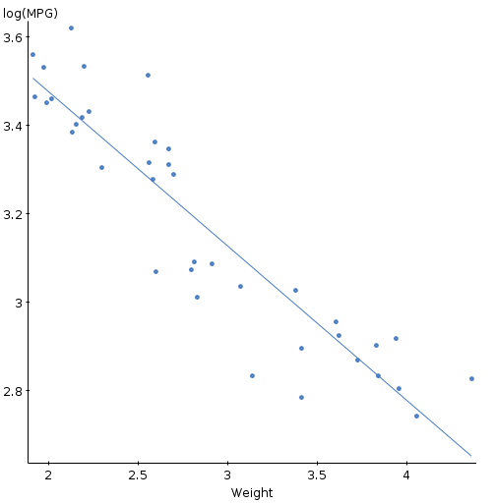
log (power 0)

- Still curved (also on residual plot). Must go further. Try -1 power (negative reciprocal).
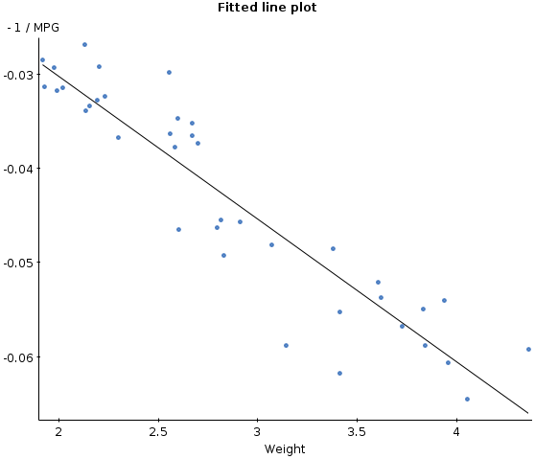

Which would you choose? Why?
power -1: straightest
- The original regression equation is
=48.7 - 8.365 Weight
For a car of weight 6 tons, what is predicted mpg? Does this make sense?
  - prediction is negative, which makes no sense (MPG cannot be negative).

- Using the -1 power, fit again to get
= 0 – 0.015 Weight
What is predicted mpg for car of weight 6 tons? Does this make some kind of sense?
- predicted -1/mpg=0-(0.015)(6)=-0.090
- ie. -mpg=-1/0.090 or mpg=1/0.090=11.1
- this looks reasonable from original scatter plot. The re-expression makes sense here.

Chapter 11: Understanding Randomness

- What does “random” mean?
- These games are random:
  - toss a fair coin, win if you get a head.
  - roll a fair six-sided die: win if you roll a 6.
  - play roulette at a casino: win if “red” comes up.
- In short term, unpredictable
- In long run, predictable:
  - coin: should win about ½ of the time.
  - die: should win about 1/6 of the time.
  - roulette: 18 of 38 numbers are red, so should win 18/38 of the time.
- Computer random numbers generated by non-random method (!) but look just like random numbers.
Random digit tables

- Easiest way to do simulation is with computer (eg. StatCrunch).
- Otherwise, can use tables of random digits 0-9: equally likely to be each digit, but next digit unpredictable, eg:
24655 67663 61607 42295
  - 14635 62038 40528 12195
  - 85757 38452 76349 78850
Simulation: the dice game of 21

- Played with ordinary 6-sided die
- Each player keeps rolling die, totalling up spots, until:
  - the player decides to stop
  - the player's score goes over 21, in which case the player loses.
- Player with highest score of 21 or less is winner.

Suppose you are playing one opponent, who scores 18. How likely are you to win? (Strategy: keep rolling until you win or go over 21.) Use random number table to simulate games.

Use table thus: random digit of 1—6 is die roll, 7—9 and 0 ignored.
24655 67663 61607 42295
  - 14635 62038 40528 12195
  - 85757 38452 76349 78850

- Trial 1: 2, total 2; 4, total 6; 6, total 12; 5, total 17; 5, total 22. Lose.
- Trial 2: 6, total 6; 7, ignore; 6, total 12; 6, total 18; 3, total 21. Win.
- Trial 3: 6, total 6; 2, total 7; 6, total 13; 0, 7 ignore; 4, total 17; 2, total 19. Win.

And so on. Here, won in 2 out of 3 simulations, but would do many more to get accurate view of how likely we are to win. I did 1000 simulations, and found the second player to have about a 72% chance of winning.
Here's a bigger table, all done by simulation:
First player scores | Second player wins
15 | 100%
16 | 95%
17 | 86%
18 | 72%
19 | 52%
20 | 29%
21 | 0%

A more interesting question is when the first player should stop. If she stops once she gets to 16, she cannot go over 21, but she is very likely to lose. If she aims for 20, she is likely to win if she gets 20 (or 21), but she is very likely to go over 21 trying.

(What looks like a good target for the first player to aim for?)
First player strategy

- Several strategies for 1st player: “stop at 16 or more”, “stop at 17 or more”,..., “stop at 20 or more”, “stop only at 21”.
- Do simulations of entire game, using each of these strategies for 1st player and “win or bust” strategy for 2nd. See how often each player wins. (2nd player automatically wins if first player goes over 21.)
- My results:
1st player's strategy | 1st player wins | 2nd player wins
Stop at 16 or more | 29% | 71%
Stop at 17 or more | 39% | 61%
Stop at 18 or more | 48% | 52%
Stop at 19 or more | 50% | 50%
Stop at 20 or more | 45% | 55%
Stop only at 21 | 29% | 71%

A simulation is not the answer

- Because it's based on random numbers (and random numbers can be weird), a simulation won't be completely accurate.
- Later, see it's possible to get exact answers in some cases, or to use approximations that are more accurate than simulation.
- Simulation is cheap and (fairly) easy, so do lots of trials.
- With lots of trials, answers from simulation will be accurate enough to give a good idea.

The birthday month problem

Ask people one by one which month their birthday is in. How many people might you have to ask to find two people with their birthday in the same month?
To simulate:
- arrange the months in a column
- sample, say, 20 months with replacement (2 people can have birthday in same month)
- count down columns until you find a repeated month.

Do by hand in StatCrunch.
- sample a bunch of months with replacement
- see how many simulated “people” are needed until a month appears for the second time
Summary of birthday-month results (from R)

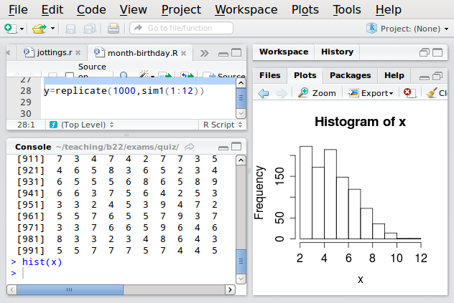
- Having to ask a lot of people is possible but unlikely
- Distribution is skewed to right
- Most of the time, we will only have to ask 2 or 3 or 4 people (surprising?)
- Our 9 people in class was unusually high.

Chapter 12: Sample surveys

See this kind of thing all the time:
  - a survey asking “if there were a provincial election tomorrow, which party would you vote for?”
  - with results based on responses from maybe 1000 people, claimed to be accurate “to within 3 percentage points 19 times out of 20”.

How is that done, and why?

What would happen if we tried to survey everybody?
Examine a part of the whole

- Population = everyone we want to investigate.
- Need to use a sample that represents population (is like it in all important ways).
- Imagine radio call-in poll about highway tolls. What kind of people might call in? Is that likely to be a representative sample?
- A sample that over-represents or under-represents some part of population called biased. Conclusions from biased sample cannot be trusted.
How might we select a representative sample?

- Carefully select individuals to match the population in every way we can think of:
  - Males and females
  - the right mix of ages
  - right number of people living in each city/rural area
  - right mix of political opinions
  - etc, etc.
  - Difficult to do.
  - Might miss important way of matching population.
- Select individuals at random.
  - Easy to do
  - Approximately represents population in all ways, including ones you didn't think of.

Why does randomization work?

- Short term unpredictable, long term predictable
- Cannot predict which individuals are going to end up in sample
- With a large sample, sample will have approximately right proportion of males/females, urban/rural, old/young, etc., and anything else we didn't think of.

Do you have enough noodles in your soup?
- stir soup, take (random) sample. Does that have enough noodles?
- doesn't matter how much soup you're cooking, as long as you stir it (population size doesn't matter)
- the bigger your sample of soup, the better your estimate of how much noodles it has.
- but if you sample too much soup, none left for your guests!
Three keys for sampling:

- Examine a part of the whole (sample)
- Randomize (to obtain the sample)
- It's the sample size (that is important).
Populations and parameters, samples and statistics

- Suppose we want to know what proportion of the population of the GTA are in favour of highway tolls.
- This is the population parameter. What we want, but unknown (except by asking everybody). Notation .
- Take a sample, calculate proportion in favour in your sample. Sample statistic. Easy to figure out, but not the thing we want. Notation .
- Hope that sample statistic close to population parameter. If sample drawn using randomization, can work out how close (later).
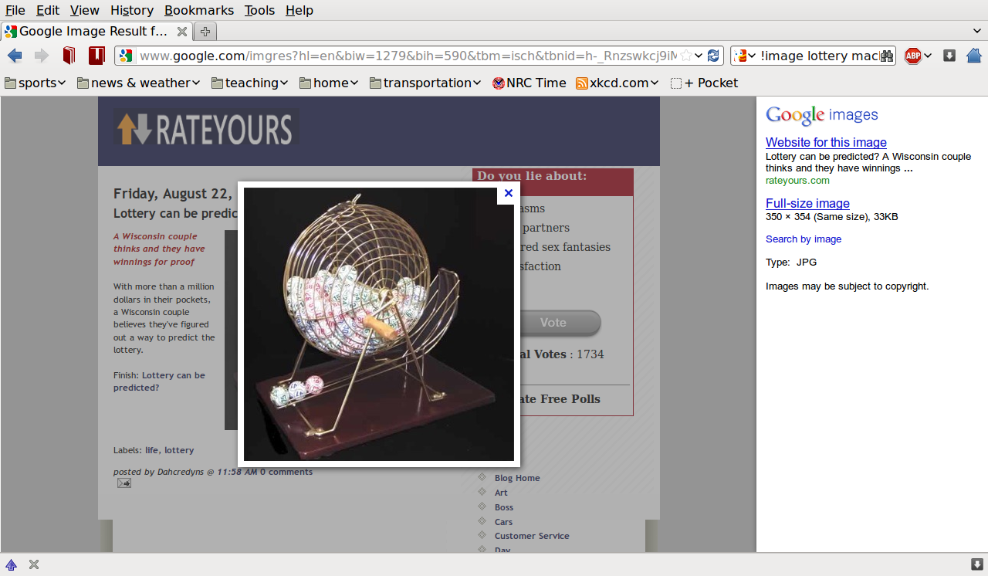
How can we draw a sample?
- Simple random sample: put names of all members of population in “hat”, shake, and draw out one by one without looking.
- Every member of population equally likely to be selected, independently of who else in sample.
- Every possible sample equally likely.

Have to make a list of whole population (sampling frame).

Drawing a simple random sample using random digit table

Suppose we have a population of 80 students, numbered 01—80, want a simple random sample of 6 of them. Use these random digits: 43623 33434 94776 15780 95603 64962 46971 95188.

43, 62, 33, 34 all ok
34 is a repeat: reject
94, 77 too big, reject
61, 57: ok

so sample is students numbered 43, 62, 33, 34, 61, 57.

Stratified sampling

- Population is in groups that could be quite different from each other (in terms of what's being measured)
- Take a simple random sample from each group, and combine to make overall sample.
- Why is this good?
  - Fair representation of all parts of population.
  - Therefore sample statistic should be closer to population parameter.

Example of stratified sampling

Back to population of 100 students. 60 of them female, 40 male. Suppose issue is “do you plan to try belly-dancing in next year?” None of males will, but 50% of females will (thus 30% of whole population). Sample of size 10.

With simple random sample, might get a lot of females and over-estimate interest in belly-dancing. Eg. 8 females and 2 males, what is sample proportion likely to be?

Or might have 2 females and 8 males. What is sample proportion likely to be?

In stratified sample, guaranteed to have 6 females and 4 males in sample. So sample proportion should be close to 30%.
Drawing a stratified sample

Population of 100 students: 01-60 female, 61-99 and 00 male.
Use random digits: 18406 28903 75909 66389 28937 46983 49652 37406 .

Draw stratified sample of 6 females and 4 males.

18, 40 females (2 so far)
62, 89 male (2 so far)
03 female (3 so far)
75, 90 male (now 4 males, don't sample any more)
96, 63, 89 reject (would be more males)
28 (4th female), 93, 74, 69, 83 (reject)
49, …, 23 (last 2 females).

Cluster and multistage sampling

How would you randomly sample 100 words from the textbook?

- simple random sampling: number every single word (!) and then sample from them.
- easier: randomly sample 10 pages first, then randomly sample 10 words on each page. Why is that easier to do?
- not same as simple random sampling: if you select a particular page, other words on the same page more likely to be in sample.
- Called cluster sampling.

Multistage sampling

- Often hierarchy of clusters eg. chapter – section – sentence – word, and could choose:
  - chapters
  - section within chosen chapter
  - sentence within chosen section
  - word within chosen sentence

Called multistage sampling. At each stage, choice made by simple random sampling.

Choose cluster/multistage sampling for convenience, choose stratified sampling for accuracy.
Things that can go wrong with sample surveys

- not getting Who you want (nonresponse)
  - call back later
- getting the question(s) right
  - avoid favouring a certain answer in way question is asked.
- not giving choices for answer (ie. getting open-ended response)
  - eg. use strongly agree – strongly disagree
- sampling volunteers
  - don't rely on people who choose to respond, eg. callers to radio show
- sampling badly but conveniently
  - see above
- undercoverage
  - not being able to sample certain parts of population.
Chapter 13: Experiments and Observational Studies

How do you find out if exercise helps insomnia?

- look at a bunch of people, find out if they exercise and how much, ask them to rate their insomnia.
- Suppose the people who exercise more suffer less from insomnia. Can you conclude that people who suffer from insomnia should be recommended to exercise?
  - maybe: but this is only an association, not cause and effect.

- This kind of study called observational study.
- Assesses association but not cause and effect (like correlation).
- Why not?
  - detects association but not its reason.
Observational studies

- Commonly used
- May help identify variables that have an effect
  - but may not identify the most important ones.
- Retrospective study “looking back”, like one above:
  - measure exercise and insomnia from historical records.
- Prospective study “looking forward”:
  - identify subjects in advance, collect data as events happen.
- Are data from the past even accurate?
- Which is better, retrospective or prospective?
  - prospective: usually less confounding and bias. Outcome needs to be a common one. Takes a long time.
  - retrospective: easier to obtain enough data for rare events. Takes less time to do. More concerns about bias/confounding.
Experiments

How do we establish cause and effect?
- need to randomly choose some subjects and instruct them to exercise
- the other subjects are instructed not to exercise
- assess insomnia for all subjects.

Why is this better? How does it level out effects of other variables?
- choosing two groups at random means that the groups should start out relatively equal in terms of anything that might matter
- if the groups end up unequal in terms of insomnia, then evidence that exercise made a difference.
Terminology

- People/animals/whatever participating in experiment called experimental units / subjects.
- Experimenter has at least one explanatory variable, a factor, to manipulate.
- At least one response variable measured.
- Specific values chosen for factor called levels.
- Combination of manipulated levels of factors called treatment.

Variation of exercise/insomnia experiment: add diet

- three kinds of exercise: none, moderate, strenuous
- two different diets: fruit/veg, “normal”
- factors are:
  - exercise, with 3 levels
  - diet, with 2 levels
- 3 x 2 = 6 treatments (6 combinations of 2 factors)
- divide subjects into 6 groups at random.
Principles of experimental design

- Control
- control experimental factors by design
- control all other variables by randomization
- Randomize
- “control what you can, randomize the rest”
- Replicate
- get many measurements of response for each treatment.
- Blocking
- divide experimental units into groups of similar ones and sample appropriately (compare stratified sampling)

Blocking

Suppose you have 8 six-year-old girls and 2 ten-year-old girls who want to play soccer. How would you divide them into two teams?

- idea 1: use randomization to decide who goes on which team.
  - but: what if the two older girls end up on same team? Is that fair?
- idea 2: block A: the ten-year-old girls. Block B: the six-year-old girls. Choose at random one girl from block A and four from block B for each team.
- If some experimental units are different from rest, arrange in blocks so that units within block similar, in different blocks different. Then share out units from different blocks among different treatments.
How do we know a treatment is effective?

- If the treatments are equally good, will the means for each treatment be exactly the same? Why or why not?
  - no, because of random assignment of subjects to treatments.
- If the mean for treatment 1 a lot bigger than mean for treatment 2, is that evidence of a difference between treatments? Why?
  - the treatment groups should be about the same, so a big difference is most likely due to the treatment(s).
- How big is “big”?
  - Suppose two treatments are equally good. How big a difference in treatment means might we see, just by chance (due to randomization)?
    - simulation: 2 treatments, both mean 20, SD 5, 10 subjects for each. How far apart could the means be?
      - mean difference could be eg. 3 or 4, but bigger difference points to an effect of treatment.
  - What does it mean if we see a difference bigger than that in our actual experiment?
    - it is probably the treatment that is making the difference.
Placebos

- A placebo is a “fake” treatment designed to look like a real one.
- Why is that important?
  - Known that receiving any treatment will cause a subject to improve.
  - Want to show that the “real” treatment is not just effective, but better than a placebo. Then have evidence that the treatment is worth knowing about.
- Can also use current standard treatment to compare with.
- Subjects getting placebo/standard treatment called control group.

Blinding

- Suppose you participate in an experiment to see if a new herbal remedy for common cold really works.
- If you knew that you got the placebo, would that influence your recovery?
- If you knew that you got the herbal remedy, would that influence your recovery?
- Best if:
  - you don't know what you're getting
  - the experimenter doesn't know what you're getting
- so as not to bias results.
- In practice, design placebo to look just like herbal remedy, and label with eg. reference number so that no-one knows until after data analyzed which is which.
The best experiments

are:
- randomized
- comparative
- double-blind
- placebo-controlled.

More factors

Recall (revised) insomnia experiment:
- three kinds of exercise: none, moderate, strenuous
- two different diets: fruit/veg, “normal”
- have subjects on all 6 combos of exercise/diet
- analysis tells us whether either (or both) of these variables have an effect on insomnia.

Suppose:
- group 1: all the subjects on no exercise were also on normal diet
- group 2: all the subjects on moderate/strenuous exercise were on the fruit/veg diet.
If group 2 comes out better, cannot tell whether exercise or diet deserve credit: exercise, diet confounded.
Ethical experiments

Idea of imposing treatments on subjects might be questionable:
- what if study effects of smoking on lung disease?
- would have to prevent some subjects from smoking, and make some subjects smoke for duration of study (!!!)
There are some known unhealthy/dangerous things you cannot ask subjects to do. Also,
- giving a placebo when a best proven treatment is available is not ethical.
- subjects who receive placebo must not be subject to serious harm by so doing.
See Declaration of Helsinki, which governs experiments on human subjects:
www.wma.net/en/30publications/10policies/b3/index.html

Chapter 14: From randomness to probability

To start chapter 11, thought about randomness:
- These games are random:
  - toss a fair coin, win if you get a head.
  - roll a fair six-sided die: win if you roll a 6.
  - play roulette at a casino: win if “red” comes up.
  - go into Tim Horton's, win if they have your favourite donut.
- In short term, unpredictable
- In long run, predictable:
  - coin: should win about ½ of the time.
  - die: should win about 1/6 of the time.
  - roulette: 18 of 38 numbers are red, so should win 18/38 of the time.
  - Tim Horton's?
Empirical probability

- Observe your game many times. (Reality/thought).
- Long-run fraction of times you win: probability of winning.
- Each single play you win or not, but probability guides actions.

Game: roll a (fair) die, win $3 if you roll a 6, lose $1 otherwise.
- prob. of winning 1/6 (prob. of losing 5/6)
- play game 6 times, expect to win once, lose 5 times
- total winnings 1 x $3 plus 5 x -$1, total -$2.
- on average expect to lose
- but: unpredictable in short term, might be lucky enough to win (eg if roll 6 first time).
Terminology

- collection of all things that can happen to you: sample space.
  - toss a coin once, sample space is?
  - roll a die once, sample space is?
- one of things in sample space called outcome.
  - one possible outcome of tossing a coin is a Head.
- one or more outcomes together called event.
  - roll a die, “even number of spots” an event, consisting of outcomes 2, 4, 6.
- each time we observe random event called trial.
  - rolling die to see how many spots come up is a trial.

Law of Large Numbers

- how do we know that the relative frequency of some outcome actually will settle down to one value?
- Law of Large Numbers (mathematical fact): relative frequency of some outcome has a limit as number of trials becomes large
- Or, with many trials, the relative frequency and probability will be approximately equal.

Look at my StatCrunch report “Law of Large Numbers for Probability”.
Empirical probability of a Head getting close to 0.5
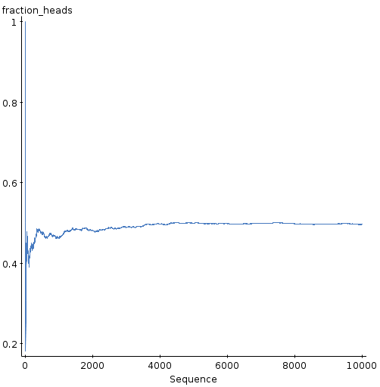
- Toss a coin 10,000 times
- Keep track of proportion of heads so far.
- That proportion appears to be getting closer to 0.5 as #tosses gets bigger.
“Law” of averages

- toss a coin, get 5 heads in a row: “due” a tail?
- play casino game, lose 6 times in a row. “Due” a win?
- NO!
- that would require coin/casino to remember previous results!
- you have the same chance of winning every time, independently of what happened before.
- How does that square with law of large numbers?
  - law of large numbers says nothing about short-term.
  - short-term unpredictable, long-term predictable
  - if a short run of coin-tosses has a lot of heads, the long run that follows will have about 50% heads. The overall average dominated by long run, so will be about 50% heads also.
Theoretical probability

- Sometimes can argue (in a mathematical model) what probabilities should be:
  - toss a coin: two faces of a coin are just the same, so coin should be equally likely to land heads or tails, eg. P(H)=1/2.
  - roll a die: in theory it is a perfect cube, so each of the 6 faces equally likely to be uppermost: eg. P(6)=1/6.
  - more generally, any time you have equally likely outcomes, prob. of event A is

  - example on next page
Rolling red and green dice and getting 10 spots total
- Sample space, red die first:
  - S={(1,1),(1,2),...,(1,6),(2,1),...,(6,6)}
  - all 36 possibilities equally likely.
- Which of those possibilities add up to 10?
- How many of them are there?
- So what is (theoretical) probability of total of 10?
Personal (subjective) probability

- What is probability that it will rain tomorrow? How does weather forecaster get “40%”?
- Forecaster uses experience to say that in “similar situations” in past, it's rained about 40% of the time.
- Personal probabilities not based on long-run behaviour or equally likely events. So treat with caution.
Probability rules
- A probability must be between 0 and 1 (inclusive).
- Probability of the whole sample space is 1.
- Addition rule: If events A and B have no outcomes in common (disjoint), prob. of either A or B is P(A)+P(B).

Roll a fair die once.
- S={1,2,3,4,5,6}, equally likely, so each prob is 1/6. Why would any other value be wrong?
  - 1/6+1/6+...+1/6=1 (“something must happen”)
- Let A be event “5 spots or more”, A={5,6}, and B be event “2 spots or fewer”, B={1,2}. What is prob that either A or B happens?
  - 2+2=4 ways to win, so P(either A or B) = 2/6+2/6=4/6

- Let A be event “5 spots or more”={5,6} as above, and C be event “even number of spots”={2,4,6}. Can you use the addition rule to find the prob of “either A or C”? What happens if you do? What is the correct answer?

try: P(either A or C) =? 2/6+3/6=5/6
But: “either A or C” means 2 or 4 or 5 or 6: P(either A or C)=4/6??
The outcome 6 belongs to both events: we counted it twice.
Events A and C are not disjoint.Addition rule is wrong, right answer is 4/6 (addition rule only applies to disjoint events).

Probability of “not A”

To get the probability of an event A not occurring, written , use rule .

- for our A={5,6} above, .
- Does this make sense?
  - outcomes in “not A” are {1,2,3,4}
  - P(not A)=4/6 (confirms above)
General addition rule

- When two events A and B not disjoint (have outcomes in common), how to find P(either A or B or both)?
- found above that 1st addition rule gives answer that is too big. Fix up:
  - P(A or B or both)=P(A)+P(B)-P(both A and B)
- above: events A={5,6}, C=even number={2,4,6}
- what is P(both A and C)? (Which outcomes make this happen?)
- Find P(A or B or both).
  - event “A or C or both” = {2,4,5,6} so P(A or C or both) =4/6
  - by rule: P(A or C or both)=P(A)+P(C)-P(both A and C)
  - = 2/6 + 3/6- 1/6 = 4/6 (A and C both happen if you roll a 6)
Note that if the two events are disjoint, P(A and B)=0

Chapter 15: Probability Rules

Law | acc. | rej. | total |  | Business | acc. | rej. | total
males | 10 | 90 | 100 |  | males | 480 | 120 | 600
females | 100 | 200 | 300 |  | females | 180 | 20 | 200
total | 110 | 290 | 400 |  | total | 660 | 140 | 800

- How likely is an applicant to law school to be accepted overall?
  - 110/400=0.275
- How likely is a female applicant to law school to be accepted?
  - 100/300=0.333

Second answer is conditional probability: we know the applicant is female, so only look at females.

Notation:
  - let F be event that applicant female
  - let C be event that applicant accepted
  - we found P(C|F): accepted given female (0.333)

Not the same as P(F|C): now I know the applcant was accepted.
P(F|C)=100/110

How to find a conditional probability

- try with above example:
  - Want P(C|F)
  - P(both C and F)=100/400 (both female and accepted)
  - P(F)=300/400
  - so P(C|F)=.
400's cancel out and answer is 100/300.

General multiplication rule

Or turn around:

Prob that law school applicant is both male and rejected? Let A=male, B=rejected. Then
- P(A) = 100/400
- P(B|A) = 90/100
- so P(both A and B)=
- also see from table: out of 400 applicants, 90 of them were males who were rejected.

Another example

Law | acc. | rej. | total |  | Business | acc. | rej. | total
males | 10 | 90 | 100 |  | males | 480 | 120 | 600
females | 100 | 200 | 300 |  | females | 180 | 20 | 200
total | 110 | 290 | 400 |  | total | 660 | 140 | 800

- Randomly select two male applicants to law school. What is probability that they are both rejected?
  - R1 event “1st one rejected”
  - R2 event “2nd one rejected”
  - P(R1 and R2)=P(R1) x P(R2|R1)=90/100 x 89/99
  - (we know the first male applicant was rejected)

… and another:

Law | acc. | rej. | total |  | Business | acc. | rej. | total
males | 10 | 90 | 100 |  | males | 480 | 120 | 600
females | 100 | 200 | 300 |  | females | 180 | 20 | 200
total | 110 | 290 | 400 |  | total | 660 | 140 | 800

I changed the question below to something easier:

- For a randomly chosen applicant to business school, what is probability that that person is either male or accepted? How does that relate to the probability of being female and rejected?

define M=male, A=accepted
want P(M or A or both)=P(M)+P(A)-P(M and A)
=(600/800)+(660/800)-(480/800)=780/800
Only way this can fail is to choose a rejected female, prob=20/800=1-780/800.
Independence and disjointness

- If two events A, B are disjoint, they can't both happen.
- Suppose A happens, then P(B|A) must be 0, whatever P(B) is.

- Suppose now C and D are independent events.
- Then P(D|C) equals P(D): knowing about C makes no difference.
- Some examples on next page.
Examples of independence and disjointness

Suppose you are selected to take part in an opinion poll. Which of the following are independent, disjoint, or neither?

- A=your telephone number is randomly selected; B=you are not home when they call.
  - independent because of random selection. (Being in the poll has nothing to do with your being home).
- A=as selected subject, you complete the interview; B=as selected subject, you refuse to cooperate.
  - disjoint because can't both happen.
- A=you are not home when they call at 11:00am; B=you are employed full time outside the home.
  - knowing whether a person works outside the home has an impact on whether they will be home at 11am (if they do work full outside the home, they cannot be home at 11am).
  - Not independent.

Turning conditional probabilities around

Suppose a restaurant has two (human) dishwashers. Alma washes 70% of the dishes, and breaks (on average) 1% of those. Kai washes 30% of the dishes, and breaks 3% of those. You are in the restaurant and hear a dish break at the sink. What is the probability that it was Kai?

Define some symbols, and figure out what we know. Let K be the event that Kai is washing dishes, and let B be event that a dish breaks.

Then, if Kai is washing, , and if Alma is washing (Kai is not washing), Also, and

What we want: know that a dish breaks, so want P(K|B). Not same as P(B|K).
… continued

Know: , , ,
Want: P(K|B).

Now: so
And: so

Then:
But don't know P(B).
Idea: when B happens, either K happens or it does not, so

Also, P(K and B)=P(B and K), so finally

Even though Kai washes less than half of the dishes, when a dish breaks, it is more likely than not that Kai broke it.

Or: do much more easily using contingency table.
The dishwashing example, the easy (easier) way:

Suppose a restaurant has two (human) dishwashers. Alma washes 70% of the dishes, and breaks (on average) 1% of those. Kai washes 30% of the dishes, and breaks 3% of those. You are in the restaurant and hear a dish break at the sink. What is the probability that it was Kai?

Pretend there are 1000 dishes. Then Alma washes 700, and breaks 7 (700(0.01)) . Kai washes 300, and breaks 9 (300(0.03)). Make a table:

 | Breaks | Does not break | Total
Alma | 7 | 700-7=693 | 700
Kai | 9 | 300-9=291 | 300
Total | 16 |  | 1000

16 dishes were broken, 9 by Kai, so P(Kai|dish broke)=9/16.
Another one:

Three different airlines A, B, C operate night flights from LA to NY. On their night flights, airline A takes off late 40% of the time, B 50%, and C 70%. My travel agent books me on a night flight from LA to NY at random (equal prob. for the three airlines).
- what is prob. that I'm on airline A and late taking off?
  - 40/300
- What is probability that I'm late taking off?
  - 160/300
- I was late taking off. What is the prob. that I was booked on airline A?
  - 40/160
Make a table, pretending there are 300 flights altogether:
 | Late taking off | On time | Total
Airline A | 40 | 60 | 100
Airline B | 50 | 50 | 100
Airline C | 70 | 30 | 100
Total | 160 | 140 | 300
“At least one”

Suppose I buy a lottery ticket each week for 3 weeks. Each ticket has probability 0.1 of winning a prize each week, independently of other weeks. What is the probability that I win at least one prize?

How does that probability change if I buy one ticket a week for 26 weeks?

What if my winning chances are 0.05 for the first week, 0.10 for the second, 0.15 for the third week?

Idea: work out chances of not winning at all.
This is (1-0.1)x(1-0.1)x(1-0.1)=0.9^3=0.73.
So P(win at least once)=1-0.73=0.27
Over 26 weeks, should have higher chance of winning at least once: P(no wins)=(1-0.1)^26=0.06, so P(at least one win)=1-0.06=0.94.
Last one: P(no wins)=(1-0.05)x(1-0.10)x(1-0.15)=0.73;P(at least one win)=1-0.73=0.27.
Binge drinking

44% of university students engage in binge drinking, 37% drink moderately, and 19% don't drink at all. Among binge drinkers, 17% have been involved in an alcohol-related car accident, among moderate drinkers, 9% have, and among non-drinkers, 0% have.

If a student has a car accident, what is the probability that they were a binge drinker?
- in 1st col of table: 7.48/10.81

Make a table. Pretend 100 students altogether:

 | Alcohol-related accident | Not | Total
Binge drinker | 7.48 | 36.52 | 44
Moderate | 3.33 | 33.67 | 37
Non-drinker | 0 | 19 | 19
Total | 10.81 | 89.19 | 100
Chapter 16: random variables

Sometimes events have numbers attached to them:

- count how many heads in 3 coin-tosses
- total number of spots when you roll 2 dice
- the most cards of the same suit in 13 cards from a deck
- how much you might claim in a year on a car insurance policy

These numbers called random variables.
Probability distributions

Each value of a random variable is an event, so each value has probability. List of values and probabilities called probability model.

Tossing 3 coins:
# heads | 0 | 1 | 2 | 3
Prob.

Rolling two dice:
Spots | 2 | 3 | 4 | 5 | 6 | 7 | 8 | 9 | 10 | 11 | 12
Prob.

Combining values of random variable:

3 coins:
# heads | 0 | 1 | 2 | 3
Prob.

- How likely are we to get two or more heads?
  - add up probs: 3/8+1/8=4/8=1/2
- How likely to get at least one head?
  - P(no heads)=1/8, so P(at least one)=1-1/8=7/8
    - or: P(1 or 2 or 3)=3/8+3/8+1/8=7/8
- What do all the probabilities add up to? Does this make sense?
  - 1, because one of those numbers of heads must happen.

The mean of a random variable

Here's a random variable, called X:

Value of X | 2 | 3 | 4 | 5
Probability | 0.1 | 0.2 | 0.4 | 0.3

- Mean not (2+3+4+5)/4=3.5 because 4 and 5 more likely than 2 or 3.
- Have to account for more likely values when adding up:
  - times by probability:
  - 2(0.1)+3(0.2)+4(0.4)+5(0.3)=0.2+0.6+1.6+1.5=3.9.
  - (Weighted average, weights sum to 1.)
- Median is value of X where summed-up probabilities first pass 0.5: 3 too small (total 0.1+0.2=0.3), 4 is right (0.1+0.2+0.4=0.7), so median 4.
- Mean a little smaller than median: left-skewed.
SD of a random variable

Another probability distribution:

Value of Y | 3 | 4 | 5
Probability | 0.1 | 0.8 | 0.1

- Mean is 4: why?
- Procedure:
  - subtract mean from each possible value
  - square
  - times each result by its probability
  - add up: gives variance; square root to get SD
- Here: variance
- SD=small since Y most likely 4.
Linear changes to a random variable

- What does it mean to add a to a random variable? Multiply it by b?
  - Take all the values and change them, while leaving the probabilities alone.
  - Here's Y, with mean 4 and SD 0.45:
Value of Y | 3 | 4 | 5
Probability | 0.1 | 0.8 | 0.1
2Y looks like this. Check that mean now 8, SD 0.9.
Value of Y | 6 | 8 | 10
Probability | 0.1 | 0.8 | 0.1
and Y+3 as below. Check that mean now 7, SD 0.45.
Value of Y | 6 | 7 | 8
Probability | 0.1 | 0.8 | 0.1

Summary

- If you add a constant to a random variable, what happens to its mean? SD?
  - Mean of (X+a) = mean of X plus a
  - SD of (X+a) = SD of X
- If you multiply a random variable by a constant, what happens to its mean? SD?
  - Mean of bX = b times mean of X
  - SD of bX = b times SD of X.

Two (or more) random variables

Suppose X is #heads when tossing a coin 5 times, and Y is #spots when rolling a die once. What can we say about total “score” X+Y, which is a random variable too?
Given: X has mean 2.5, SD 1.12; Y mean 3.5, SD 1.71.
- Probability distribution of X+Y is difficult to figure out.
  - Example: P(X+Y=3)? Work out possibilities: X=2, Y=1; X=1, Y=2; X=0, Y=3. Find prob of each, add up.
- Mean of X+Y easy to figure out:
  - Mean of (X+Y) is mean of X + mean of Y.
  - here: mean total score = 2.5+3.5=6.
SD of X+Y

- If X and Y are independent:
    - variance of (X+Y) = variance of X + variance of Y.
  - two random variables are independent if knowing about one tells you about the other. Here, knowing coin toss result tells you nothing about die roll, so our X, Y independent.
  - X has SD 1.12, Y has SD 1.71.
  - In example, variance of total score = variance of X + variance of Y = = 4.18.
  - So SD of total score is = 2.04.

Odd fact: SD of X-Y is same as SD of X+Y
- above example: difference in scores, coins minus die, has mean 2.5-3.5=-1, variance , SD = 2.04.
- Suggests: will score more on die than on coins on average, but large SD says will at least sometimes score more on coins.
- How often? Easiest by simulation:
  - coin score has binomial distribution, n=5, p=0.5
  - die score has uniform distribution, a=1, b=6.
  - Compute difference.
  - results: diff greater than 0 ___ times out of 1000
- difference in scores isn't normal, but pretend it is:
  - for difference of 0, z=(0-(-1))/2.04=0.49, prob of greater than 0 is 1-0.6879=0.3121.
Continuous random variables

- So far: our random variables discrete: set of possible values, like 1,2,3,... , probability for each.
- Recall normal distribution: any decimal value possible, can't talk about probability of any one value, just eg. “less than 10”, “between 10 and 15”, “greater than 15”.
- Normal random variable example of continuous.
- Finding mean and SD of continuous random variable involves calculus :-(
- but if we are given mean/SD, work as above (example over).
Handling two normal distributions

Betty and Clara go for a swim every morning. The times it takes each of them to complete their swim have (independent) normal distributions. Betty has mean 10 minutes and SD 2 minutes, and Clara has mean 11 minutes and SD 1 minute. How likely is it that Clara will complete her swim first?

Let B be Betty's time, and C be Clara's. Then Clara will finish first if the random variable C-B is less than zero.
- What are the mean and SD of C-B?
    - mean is 11-10=1; variance is so SD = =2.24.
- Turn 0 into a suitable z-score and find the answer
  - z=(0-1)/2.24=-0.45, prob is 0.3264.
How do you find SD of sum and difference if random variables are not independent?

- In this course, you don't.
- See p. 436—437 of text for gory details.

Chapter 17: Probability Models

A certain coffee shop has a Roll Up the Rim to Win promotion. 15% of all cups win a prize:
  - How many cups are you likely to have to buy before you get your first prize?
  - How many prizes might you win if you buy 10 cups of coffee?

Reasonable to assume that each cup is a prizewinner or not, independently of other cups. Call act of rolling up the rim on one cup a “trial”.
Often encounter:
- Two possible outcomes “success” and “failure”
- Prob p of success does not change.
- Trials are independent.
Called Bernoulli trials.

Are these Bernoulli trials?
- Tossing a coin, success is “heads”.
  - everything good: independence of traials, P(H)=0.5.
- Rolling a die, success is getting a 6.
  - again, independence ok, P(6)=1/6
- Joe buys 1 lottery ticket every week for a year; success is winning a prize.
  - reasonable to believe independence and P(prize)=constant.
- A person keeps taking a driving test; success is passing.
  - hope that P(success) will increase, so not Bernoulli trials.
- Toss a coin 10 times; success is getting 2 heads in a row (eg. HTHHTTTHHH is 3 successes)
  - P(two heads) depends non whether you just had a head or a tail, so is not constant.
- Large population of people who agree or disagree with a statement; take simple random sample from population, success is “agree”.
  - because of independence between members of sample, and P(agree) changes very little (large population), Bernoulli trials are (at least approximately) OK.

Recall:

A certain coffee shop has a Roll Up the Rim to Win promotion. 15% of all cups win a prize:
  - How many cups are you likely to have to buy before you get your first prize?
  - The cup you get is randomly chosen, so independence and constant probability ok.
To win the first prize on 1st cup: prob 0.15.
On 2nd : fail then succeed: prob (1-0.15)(0.15)=0.1275
On 3rd: fail 2x then succeed: prob (1-0.15)(1-0.15)(0.15)=0.1084

More calculation:
- Prob 0.56 of finding winner within first 5 cups.
- Prob 0.09 of not finding winner within first 15 cups.
Number of trials until 1st success: use geometric model as above.
Mean number of trials to first success = 1/p, here 1/0.15 = 6.67.
Second question above:

A certain coffee shop has a Roll Up the Rim to Win promotion. 15% of all cups win a prize:
  - How many prizes might you win if you buy 10 cups of coffee?

Interested in number of successes in fixed number of trials. This different, uses binomial model:
- fixed number of trials n
- fixed prob of success p on any one trial
- variable number of successes

Here, n=10, p=0.15.

Reminder:
- Bernoulli trials
  - Two possible outcomes “success” and “failure”
  - Prob p of success does not change.
  - Trials are independent.

Interested in #trials until first success: Geometric model

Interested in #successes in fixed #trials: binomial model.
Binomial table

The link to Statistical Tables on course website includes table of binomial distribution probabilities. In here, find chance of exactly k successes in n trials with success prob p.

(n=10,p=0.15):
Prob of 0 prizes (k=0) is 0.1969, 1 prize (exactly) (k=1) is 0.3474, 2 prizes (exactly) (k=2) is 0.2759.
So chance of 2 prizes or less is 0.1969+0.3474+0.2759=0.8202.
Chance of 2 prizes or more: 1-0.1969-0.3474=0.4557.
(“Not 2 prizes or less” is 3 prizes or more.)
What if p>0.5 in binomial table?

Suppose n=8 and p=0.7. What is the probability of
  - exactly 7 successes?
  - 7 or more successes?

Idea: count failures instead of successes.
P(success)=0.7 means P(failure)=1-0.7=0.3
7 successes = 8-7=1 failure.
so look up n=8, p=0.3, k=1 prob=0.1977 which is answer we want.

7 or successes = 7, 8 successes
P(failure)=1-0.7=0.3
7, 8 successes = 1, 0 failures
prob we want is 0.1977+0.0576=0.2553.
Mean and SD of binomial distribution

- Mean of number of successes in binomial distribution = np.
- SD of number of successes = . (Derivation: math box p. 451.)

For our example, n=10, p=0.15, so
- mean = np = 1.5
- SD = = = 1.13

Could get up to 10 successes (though unlikely), so distribution of number of successes skewed to right. Also mean minus 2 SD < 0, further evidence.

Use StatCrunch to get probability histograms of binomial distributions (Stat, Calculators, Binomial):
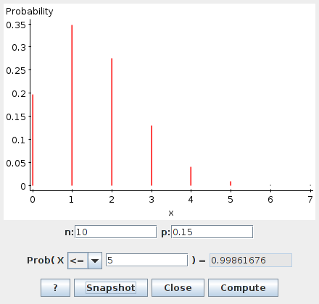
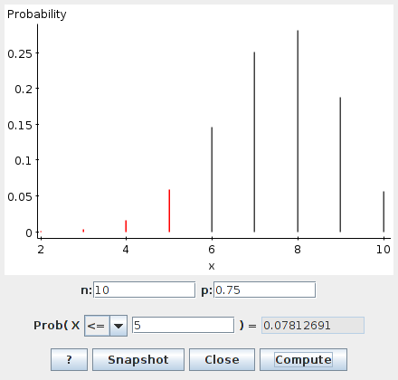
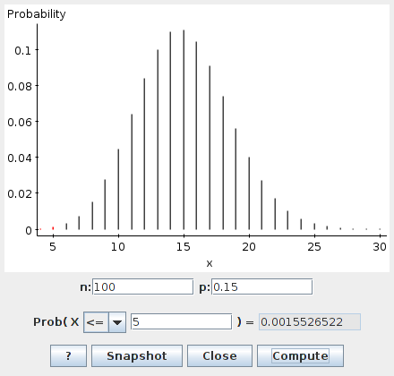
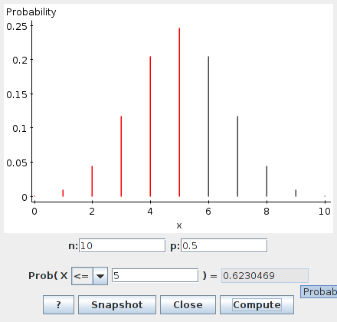

- How does the shape depend on p?
  - p<0.5, skewed right; p>0.5, skewed left; p=0.5, symmetric
- What happens to the shape as n increases?
  - shape becomes normal
- What does this suggest to do if n is too large for the tables?
If n too large for tables, try normal approximation to binomial.

Compute mean and SD of binomial, then pretend binomial actually normal:

P(10 or fewer prizes in 100 coffee cups)=?
- # prizes binomial n=100 p=0.15
- mean 100(0.15)=15, SD =3.57
- for 10 prizes, z=(10-15)/3.57=-1.40
- prob of less is 0.0808
- exact answer (StatCrunch) 0.0994

Works if n large and p not too far from 0.5:
- rule of thumb and
- can relax this a bit if p close to 0.5.
Continuity correction
Know about what this is, but won't need to do it on exam.

Problem:
- binomial distribution discrete
- normal distribution continuous

so “10 or fewer” on binomial really means “anything rounding to 10 or fewer” on normal
ie. less than 10.5:
z=(10.5-15)/3.57=-1.26, prob. 0.1038, much closer to exact answer 0.0994.
Compare “strictly less than 10 successes”:
- exact (binomial) 0.0551
- straight normal approx 0.0808 as above
- with continuity correction use 9.5: z=(9.5-15)/3.57=-1.54, prob 0.0618.
Chapter 18: Sampling Distribution Models

If you toss a fair coin 100 times, how many heads might you get?

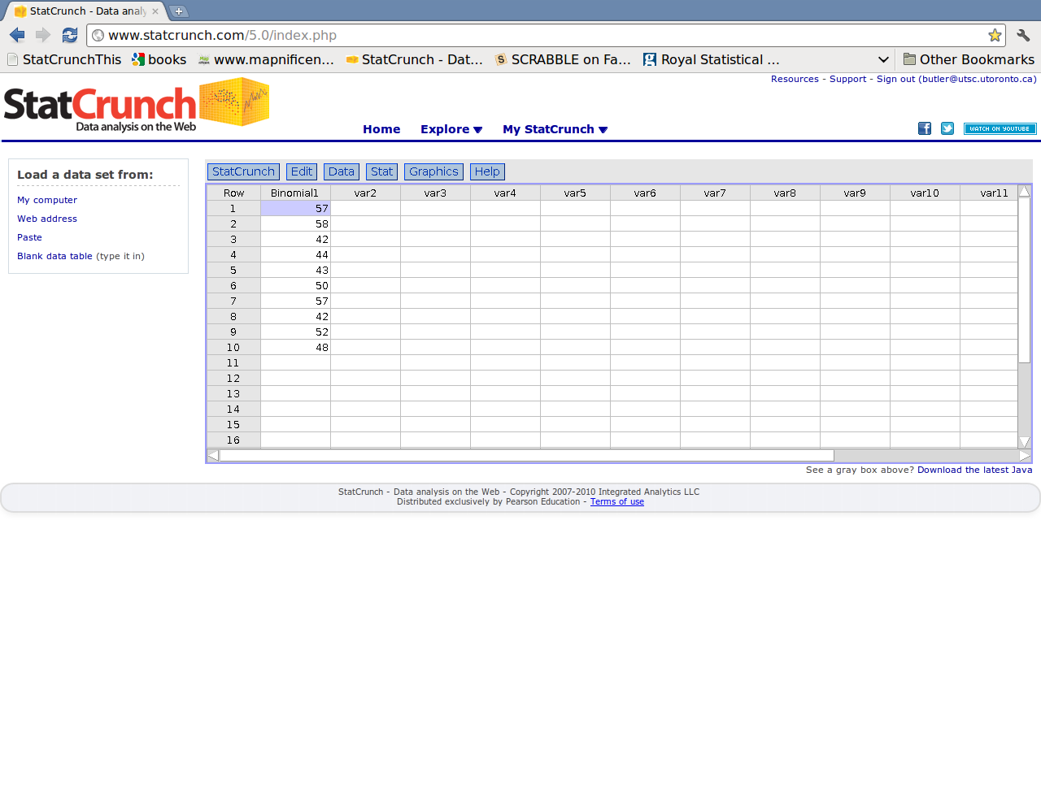
Either do it, or simulate with StatCrunch: binomial, n=100, p=0.5:

- number of heads not the same every time (sampling variability)
- usually between 40-60 heads
- usually not exactly 50 heads
- Do more simulations to get better idea.

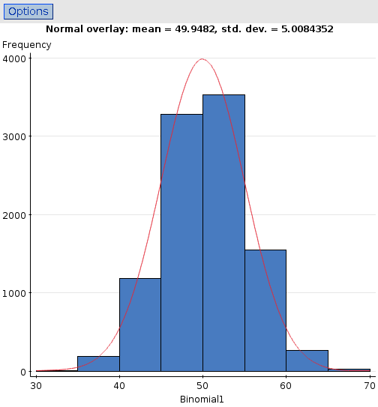
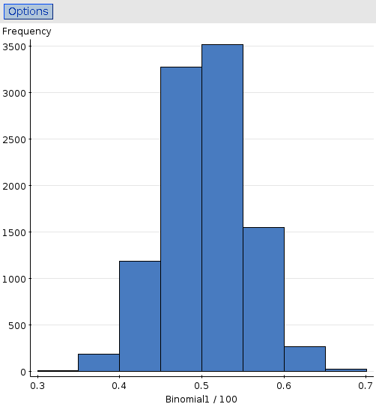
Number of heads in 100 tosses Proportion of heads

What about 1000 tosses instead of 100?
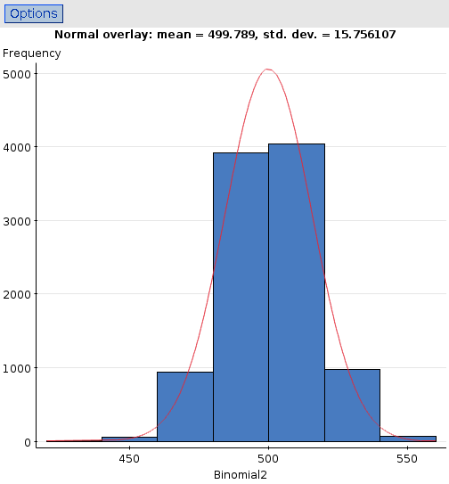
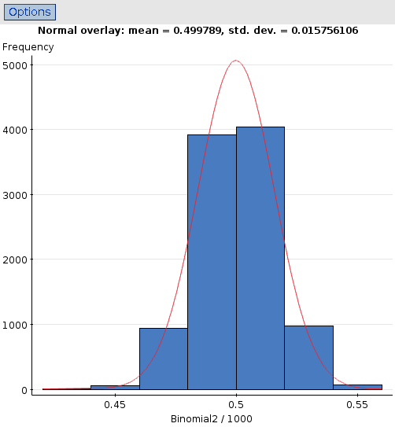
- proportion of heads likely closer to 0.5
- number of heads might be further from half #tosses
- shapes for n=100, n=1000 both normal
Exact answers:
- number of “successes” and proportion of successes both (approx) normal if np, n(1-p) both at least 10
- For number of successes:
  - mean np
  - SD
- For proportion of successes:
  - mean p
  - SD (divide values for number by n)
- Our examples:
 | n=100, p=0.5 |  | n=1000, p=0.5
 | Number | Proportion | Number | Proportion
mean | 50 | 0.5 | 500 | 0.5
SD | 5 | 0.05 | 15.81 | 0.02
- Shows sample proportion closer to its mean for larger n.
Opinion poll:
- 1000 randomly sampled Canadians, 91% believe Canada's health care system better than US's.
- How accurate is that 91%?
- Sampling variability: another sample would contain different people, so its sample proportion may not be 91%.
- Simple random sample, so #better binomial, n=1000, p=?
- Assume (for lack of better) p=0.91.
- How far from 91% might another sample proportion be?
- SD is = 0.0090.
- Based on this, how likely is a sample proportion over 95%?
  - Check: np=910, n(1-p)=90 both at least 10; normal OK.
  - z=(0.95-0.91)/0.0090=4.44; prob very close to 0.
- Most of the time, sample proportion between : 0.892 to 0.928.
- Or, sample proportion unlikely to be more than 2% away from truth, with n=1000 and p near 0.91.
Sampling distribution for sample means

Lottery:
Winnings | -1 | 2 | 10
Probability | 0.9 | 0.09 | 0.01
How much might you win per play if you play many times?

Mean winnings from 1 play is (-1)(0.9)+(2)(0.09)+(10)(0.01)=
-0.62
(population mean).

Law of large numbers: sample mean close to population mean for large enough sample. If you play 1000 times, you'll lose close to 0.62 per play.

What kind of sample means might you get for different sample sizes?
Sampling distributions of sample mean for various sample sizes
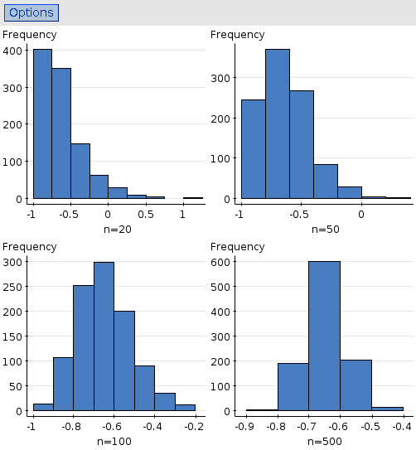
Normal quantile plots:
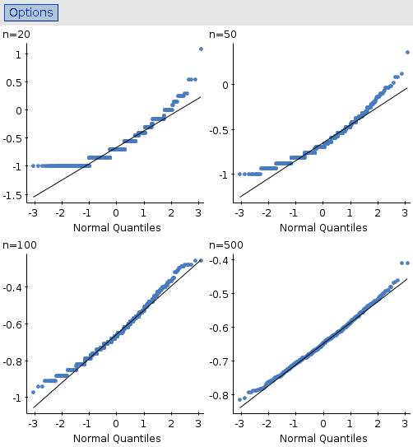

Skewed to right but progressively less so as n gets bigger: more and more normal.
Where did normal come from?
- Not the population
- Must be the large sample and fact we look at sample mean.

Remarkable fact:
- From any population, sampling distribution of sample mean is approximately normal if sample is large.
- Central Limit Theorem.

Even in our very extreme population, began to work at about n=100.
Usually ok with much smaller n (eg. n=30 often big enough).

Mean and SD of sampling distribution of sample mean

- So sampling distribution of sample mean approx normal
- What are its mean and SD?
- Population has mean , SD
- Sampling distribution of sample mean has:
  - mean ,
  - SD (see Math Box p 486-487).
- As n gets larger, variability of sample mean gets less, so closer sample mean will be to population mean (law of large numbers again).
- Use this when want to know about sample mean might be.

Calculations for sample mean:

A sample of size n=25 is drawn from a population with mean 40 and SD 10. What is prob that sample mean will be between 36 and 44? (Assume Central Limit Theorem applies.)

- Sampling dist of sample mean has mean and SD
- 36 gives , 44 gives .
- “Within 2 SDs of mean”: prob is about 95% (0.9544).
- Most of the time, sample mean between 36 and 44.
- Most of the time, sample mean no more than 4 away from population mean.

Chapter 19: Confidence intervals for proportions

Recall: Opinion poll with 1000 randomly sampled Canadians, 91% believe Canada's health care system better than US's.

Sampling distribution of sample proportion has:
- mean p (unknown)
- SD
For SD, use known n and best guess (91%) at p:
- SD approx = 0.0090.
- Sampling distribution approx normal: , About 95% of the time, sample proportion should be inside

that is, p and should be less than 0.0180 apart.

We had , so, about 95% of the time p should be between 0.91-0.0180=0.892 and 0.91+0.0180=0.928.
Confidence interval

(0.892,0.928) called 95% confidence interval for p.

What does “95% of the time” mean? In 95% of all possible samples. But different samples have different 's, and give different confidence intervals.

Eg. another sample, with n=1000, might have , giving 95% confidence interval for p of (0.870,0.910).

So our confidence in procedure rather than an individual interval.

Certainty and precision

We used 2*SE to get our 95% confidence interval. What if we use 1*SE or 3*SE?
Confidence level | Lower limit | Upper limit
68.0% | 0.901 | 0.919
95.0% | 0.892 | 0.928
99.7% | 0.883 | 0.937

- if you want a shorter interval, you have to be less confident in it.
- if you want to be more confident in your interval, it has to be longer.
- no way to get a “certainly correct” interval – unless it is so long as to be meaningless – always the chance that your statement about p will be wrong.
Getting other confidence intervals for a proportion

How would we get a 90% interval? 80%?
- Sampling distribution approximated by normal (hence 1, 2, 3)
- Interval is
- with z* from normal table is value where
  - half the leftover is below -z*
  - half the leftover above z*
  - so amount of normal curve between -z* and z* is right %.

Find z* for 90% interval:
  - leftover is 10%=0.1000
  - half that is 5%=0.0500
  - Table: z=-1.64 or -1.65 has 0.0500 less
  - z=1.64 or 1.65 has 0.0500 more (0.9500 less).
  - so z*=1.64 or 1.65.
Handy table:
Confidence level | z*
90% | 1.645
95% | 1.960
99% | 2.576

- 1.96 a “more accurate” version of 2.

Example

A city ballot includes an initiative that would allow casino gambling. A poll of 1200 randomly chosen voters finds 53% in favour, while a second poll of 400 randomly chosen voters finds 54% in favour. In each case, find a 95% confidence interval for the proportion of all voters in favour.

First poll:
= 0.028 = 0.502 to 0.558.
Second poll:
= 0.049 = 0.481 to 0.579.

(0.028 and 0.049 are margins of error for the confidence intervals)

- polls differ in % in favour (sampling variability)
- First poll allows conclusion that majority in favour
- Second poll gives less precise interval (smaller sample).

Determining sample size

Suppose we plan a survey. How big a sample?
- margin of error determines how far CI goes up and down
- desired confidence level known: know z* (eg. 1.96)
- don't have a sample yet, but might have guess at p
- know how big we'd like margin of error to be (say m)
- then can solve for n:

A study is to be carried out to estimate the proportion of all adults who have higher-than-normal levels of glucose in their blood. The aim is to have a margin of error on a 90% confidence interval of 4% (0.04). How many (randomly chosen) adults should be surveyed? A pilot study shows that the proportion is about 20%.

Use the formula. z*=1.645, m=0.04, p=0.20:
=270.60; sample 271 adults (round up).

Without a guess at p, use p=0.50 (worst case):
= 422.82; sample size should be 423.

It pays to have a guess at p!

Chapter 20: Testing Hypotheses about Proportions

A newsletter reported that 90% of adults drink milk. A survey in a certain region found that 652 of 750 randomly chosen adults (86.93%) drink milk. Is that evidence that the 90% figure is not accurate for this region?

Difference between 86.93 and 90, but might be chance.

One approach: confidence interval.
= 0.0123, so
95% CI is 0.845 to 0.893
99% CI is 0.838 to 0.901
so now what?

Better: hypothesis testing. Think about logic first by analogy.

Court of law
 |  | Decision
 |  | Not guilty | Guilty
Truth | Innocent | Correct | Serious error
Truth | Guilty | Error | Correct

- Truth (unknown)
- Decision (we hope reflects truth)
  - based on evidence: does it contradict accused being innocent?

Hypothesis testing
 |  | Decision
 |  | fail to reject H₀ | reject H₀
Truth | H₀ true | Correct | Type I error
Truth | H₀ false | Type II error | Correct

- Null hypothesis H₀ is “presumption of innocence”: some state of affairs is correct.
- Alternative hypothesis H_{A} is that H₀ is false. Need evidence (data) to be able to reject H₀ in favour of H_{A} .
- Hypotheses: ask “what do I need evidence for?” That's H_{A} .
- Milk example: trying to prove that 90% not correct for this region, so
  - H₀:
  - H_{A}:

How to assess whether we believe H₀ ?
- Assess the evidence
- Evidence is our data
- in particular: sample proportion .
- P-value: probability of as far or further from H₀ than the value observed.

In our case, H₀: and . If H₀ true, value of we might observe approx normal, mean 0.90, SD = 0.0110.
Prob of observing below 0.8693:
- = -2.79; prob (Table Z) 0.0026.
- Could have observed above 0.90 too, so P-value twice this, 0.0052.
“Beyond a reasonable doubt”

Is P-value of 0.0052 “beyond a reasonable doubt”? Says:
- a value of like the one we observed very unlikely if true
- so either:
- we observed something very unlikely
- isn't true after all.
- when P-value so small, prefer to believe (b): reject in favour of .

On the other hand, a P-value like 0.7789 not small. Says that if true, result we observed entirely possible. Have not proved that true, but cannot reject .
One-sided and two-sided tests

Our alternative was : two-sided since values of too far above or below 0.90 could make us reject . Suppose now had been 0.92. Then = 1.82. P-value is prob of above, doubled: 2(1-0.9656)=0.0688.

Might have been looking for evidence that p was smaller than 0.90, ie. . Two parts to getting P-value:
- are we on correct side? is, is not.
  - if on correct side, go to next step.
  - if not on correct side, stop and declare not rejected (as for ).
- P-value is prob of less. For that is (z=-2.79) 0.0026.

Similar idea for other kind of one-sided alternative, like :
- on correct side? is not, is.
  - if on correct side, go to next step
  - if not (), stop and declarenot rejected.
- P-value is prob of greater. For, that is (z=1.82) = 0.0344.

When doing a test:

- always state the P-value. Enables reader to draw own conclusion about truth or falsity of .
- follow up (particularly when you want to reject ) with a confidence interval. Enables reader to get idea of size of parameter (effect size) and hence whether result is important vs. statistically significant.

How small is small (for a P-value)?
- think about how plausible the alternative is
  - if alternative is implausible, need very strong evidence (very small P-value)
  - if alternative is plausible, weaker evidence (larger P-value) would do
- think about how costly or dangerous rejecting is
  - eg. if rejecting would mean rebuilding a factory
Chapter 21: More about Tests

- null hypothesis has to give a parameter value like .
- alternative has to say what you are trying to prove like .
- Kind of alternative you use depends on exactly what you want to prove:
  - is p different? (2-sided)
  - is p larger? (1-sided)
  - is p smaller? (1-sided)

Example: at a small computer peripherals company, only 60% of the hard drives produced pass all the performance tests the first time. Management recently invested a lot of resources into the production system. A sample of 100 hard drives produced recently found that 71 of them passed all the performance tests the first time. Did the investment help?

- let p = proportion of all hard drives produced recently that pass performance tests first time.
- Looking for evidence that investment helped, ie. .
- Null has to give value for p: .
- SD of = 0.0490.
- and both at least 10: normal approx OK.
- Sample gives .
- Test statistic = 2.24.
- On correct side (0.71>0.6, z>0).
- P-value for z=2.24 = prob of greater (Table Z): 0.0125.
- If p=0.60 correct, unlikely to have observed as high as
- so reject and conclude investment has helped.

Compare:
- prob of true, if observe data like this: no.
- prob of this kind of data, if true: yes, P-value.

Reason: is either true or false, so can't talk of its prob.

Previous example:
-
-
Suppose now .
Then = 0.61, with P-value 0.2709

Data not especially unlikely if true, so cannot reject .

- have not proved that correct
- have only obtained the kind of data we would have seen, if were correct
  - so justified in acting as if were correct.

Alpha

- How to decide whether P-value small enough to reject ?
- Choose (alpha) ahead of time:
  - if rejecting an important decision, choose small (0.01)
  - if seeing whether any evidence at all, larger (0.10)
  - “default” 0.05.
- Reject if P-value less than the you chose.

With in above examples:
- : P-value 0.0125: reject : investment has helped
- : P-value 0.2709: do not reject : no evidence that investment has helped.
With , even (P-value 0.0125) not strong enough evidence to conclude that investment has helped.

Tests and Cis

We do later (with inference for means).

Example of hypothesis test for proportion (ex. 20.28, edited)

A study of acid rain and trees in Hopkins Forest found that 25 of 100 (randomly selected) trees had some kind of damage from acid rain. This seems to be higher than the 15% quoted in a recent article. Is the 15% figure wrong for the Hopkins Forest? Use alpha=0.05

- Parameter:
  - p=proportion of all trees in this forest suffering acid rain damage
- Hypotheses:

- Test statistic:
  - =sqrt(0.15*0.85/100)=0.04
  - =(25/100-0.15)/0.04=2.5;
- P-value:
  - 2 x 0.0062 = 0.0124, smaller than 0.05
- Conclusion:
  - reject H0, conclude that this forest is different
- Follow up with 95% confidence interval: (0.175,0.343)

Making errors

 |  | Decision
 |  | fail to reject H₀ | reject H₀
Truth | H₀ true | Correct | Type I error
Truth | H₀ false | Type II error | Correct

- Type I error: reject when it is true
  - jury convicts innocent person
  - healthy person diagnosed with a disease
  - future patients get a useless treatment
- Type II error: fail to reject when it is false
  - jury fails to convict guilty person
  - sick person not diagnosed with disease
  - future patients do not get useful treatment

- Prob of type I error is (eg. )
- Prob of type II error called (beta)
  - eg. but need to know what p actually is to find
  - if p far from 0.3, should be easy to reject (small)
  - if p close to 0.3, could be hard to reject (large)
- Prob of not making type II error called power ().

Want to have power large enough to have decent chance to reject null if p “interestingly” different from value.

Example: suppose we have sample size 100. How likely are we to reject in favour of if p is really 0.4, using ?

Simulate. Steps:
- simulate a bunch of binomials with n=100, p=0.4
- turn each into sample proportion (divide by 100)
- calculate z for each (using )
- calculate P-value (2-sided) for each using StatCrunch function “pnorm”
- count how many of those P-values < 0.05.

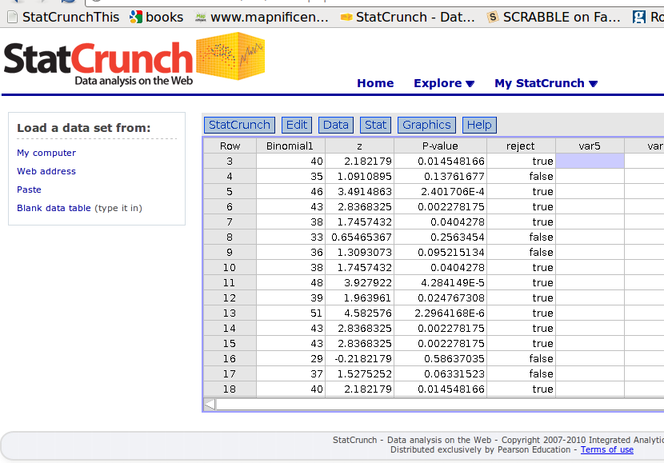
My simulation (part) above

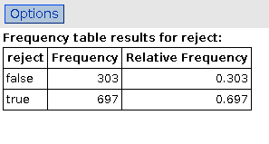
My power about 0.7. If that's
too small, larger sample size needed.
Chapter 22: Comparing Two Proportions

2006/7 homicides:
 | Shooting | Other | Total | %shooting
London | 29 | 138 | 167 | 17.37
Toronto | 72 | 82 | 154 | 46.75

- What can we say about the difference in proportion of homicides by shooting in the two cities (thinking of 2006/7 as a random sample of all years)?
- Best guess at difference is 0.4675-0.1737=0.2938.
- But how variable is that from year to year?

SE of difference in proportions

- Let be proportion of homicides by shooting in Toronto
- Let be proportion of homicides by shooting in London

- ? variance of difference is sum of variances:
- , say.
- then CI for difference in proportions is

- with our numbers
= 0.0498;

- for a 95% CI z*=1.96, so margin of error = 0.0976,
- interval is = (0.20,0.39),
- so we think % of homicides in Toronto by shooting is between 20 and 39 percentage points higher than in London.

Note:
- same idea for CI as before, estimate +/- margin of error
- margin of error is z* times SE of estimate.
- So: figure out right estimate, right SE of estimate for what you need CI of.

Hypothesis test for difference in proportions

- Null: or
- Alternative: or
  - (or or )
  - (or or )
- Now, act as if , say, so can do better for
  - estimate p as overall proportion of successes and calculate (p=”pooled”)
  - then test statistic is
  - get P-value from normal distribution as before.

On our data:

 | Shooting | Other | Total | %shooting
London | 29 | 138 | 167 | 17.37
Toronto | 72 | 82 | 154 | 46.75

- overall proportion of deaths by shooting is = 0.3146
- so = 0.0519 (not much different from D=0.0498)
- so = 5.66
- P-value=0.0000000151 (software). Conclude that shooting %'s are different.
Sample size for two proportions

- Confidence interval for difference in proportions had margin of error =0.0976. How many homicides would we need to observe in each city to get this margin down to 0.07?
- Need to know and
  - but have guesses and
- Assume number of homicides observed in each city same: let .
- Equate desired margin with formula, leaving n unknown:
- and solve for n: between 307 and 308, take 308. Need this many homicides in each city.
- If p's unknown, replace them by 0.5. In above case, would require an n of 392 in each city.
- Pays to have knowledge of ,!
- Decreasing margin of error by a little can increase sample size required by a lot. (Cutting it in half: times sample size by 4).
Power of hypothesis test

Again do by simulation. Have to know (or have guess at) both p's.

Suppose we'll do another study of % homicides by shooting for London and Toronto (using more recent data). We will look at 50 homicides for each city. How likely are we to be able to reject in favour of using , when in fact and ?

- generate a bunch of simulated homicide deaths by shooting for each city:
  - Toronto binomial
  - London binomial
  - turn each into proportions out of 50
  - calculate D for each pair of simulated death proportions
  - calculate test statistic each time
  - get P-values
  - count how many P-values are less than 0.05.
Some of my simulation:
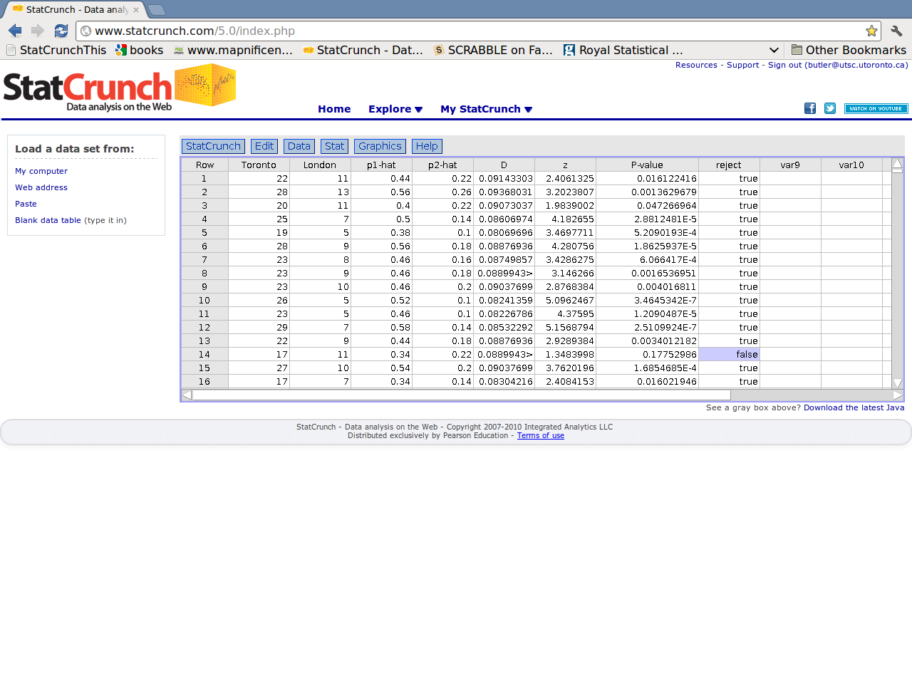
Seems unlikely that we fail to reject the null. Tabulate “reject”:
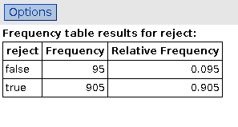
Rejected 905 times of 1000: power estimated at 0.905=90.5%. Even with small sample sizes still very likely to detect difference. True because %'s very different.
What a hypothesis test is
Black Box
Data
Hypotheses
P-value

Table of tests and confidence intervals

Inference for | SD to use (for CI if different) | P-value from | For CI use
Proportion | ; | normal
Comparing proportions | ; | normal
Mean |  | t, df n-1
Two means |  | t, df
Matched pairs | differences, as for mean.

Chapter 23: Inferences about means

“Cause of homicide death” was categorical variable. But what about eg. number of calories in a serving of yogurt? Might want to say something about mean calories/serving in all servings of a certain type of yogurt. That is quantitative variable. (exercise #36.)

Central limit theorem says:
- if you sample from a population with mean , SD , sampling distribution of approximately
  - normal
  - mean
  - SD
if sample size n is large.

All very nice, but:
- sample size may not be large
- population SD almost certainly not known
What then?
Investigate by simulation. Population normal, mean 30, SD 5, take samples of size 2. Pretend not known, so use sample SD's instead.

Look at t-sim data (on StatCrunch):
- generate normal population mean 30 SD 5
- take 1000 (“many”) samples of size 2, save in one column with column of which sample they belong to
- calculate mean of each sample
- calculate SD of each sample
- calculate z for each sample, using sample SD instead of population SD, and using correct mean 30
- calculate P-value for each z (2-sided alternative)
- for each P-value, note whether less than 0.05 (reject=true) or greater (reject=false).

- Since hypothesized mean of 30 is correct, proportion of (false)
rejections should be around 0.05 (50 out of 1000).
- How many times did we reject?

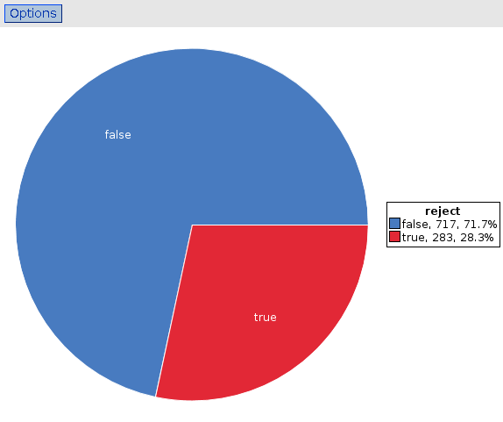

283 times, or 28.3%. Way too much!
Problem! How to fix this up?

- Issue: sample SD isn't same as population SD, might be far off if sample size small.
- Gosset (p. 620 of text) worked out what to do:
  - calculate test statistic using sample SD, call it t.
  - get P-value from table of t-distribution (Table T) with n-1 degrees of freedom.
- Example:
  - testingvs. (two-sided) and have n=10, , s=5.
  - = 3.16.
  - Look up in table with 10-1=9 df:
    - 3.16 between 2.821 and 3.250
    - so P-value between 0.01 and 0.02
    - StatCrunch gives 2 x 0.0058 = 0.0116.
  - Using , reject null;
  - conclude population mean not 30.
How does our simulation perform getting P-values from t-distribution with 1 df (sample size 2)?

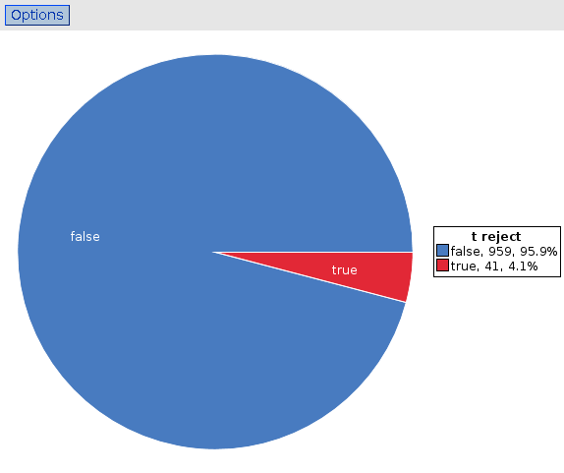

Very close to 5% (wrong) rejections of the null. Good.
When will the t-test work?

- Theory based on normal population.
- With large samples:
  - central limit theorem will work regardless of actual shape of population.
  - sample SD will be close to population SD, so not knowing won't matter much.
- with small samples:
  - no central limit theorem to help
  - sample SD might be far from population SD
  - beware of outliers/skewness
- but: in most cases, t pretty good (robust).
- Draw a picture (eg. histogram) first!

Example

A diet guide claims that the average number of calories in a serving of vanilla yogurt is 120 or less. 14 brands of vanilla yogurt are randomly sampled; the sample mean is 157.9 and the sample SD is 44.8. Do these data offer evidence that the diet guide is wrong?

Let be the mean number of calories per serving of all brands of vanilla yogurt. Testing against .

Test statistic = 3.17. P-value ?.
Data say?

Confidence interval for the population mean

Similar idea as for proportions:

- best guess at population mean is sample mean
- make interval that goes up and down depending on uncertainty in
- have to use t-distribution when using sample SD s.

So: CI is .

Yogurt data: n=14, , s=44.8. With 13 df, for 95% interval (look at bottom of Table T). Hence margin is
= 25.9 and interval (132.0, 183.8).

Know that population mean almost certainly above 120 but don't know precisely what it is. (A lot of variability in data plus small sample.)
Test vs confidence interval

Another example: data n=30, , s=10. Test vs at : gives t=2.74, P-value close to 0.01. Reject null and conclude that .

95% CI for µ: (36.3, 43.7). 35 outside this interval, once again conclude that 35 not plausible value for µ.

This works, if:
- test two-sided
- for test and confidence level match up (eg. 0.05 and 95%).

P-value close to 0.01, so 35 should be right on edge of 99% CI, and is:
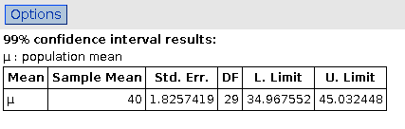
Sample size and confidence intervals

When planning a study, want to know what sample size to use. Take margin of error , say, solve for n to get

But: don't know s, and don't know what df to use for .

Use a guess at the standard deviation, and start with (infinitely large df) instead of . This will give a value of n. Use that to get df for , and repeat.
Example

In our yogurt data above, (n=14, , s=44.8), the margin of error for a 95% CI was . How big a sample would we need to reduce this margin of error to 20, if everything else stayed the same?

Step 1: don't know df, so use and calculate
= 19.28.
Now n=19 approx, so use 18 df for t: .

Recalculate:
=22.15
Round up to be safe: a sample size of 23 should do it.

We know that sample size 14 gives , so another way:

- want to multiply margin of error by = 0.77, so divide sample size by = 0.59. That is, sample size should be= 23.48, almost as above.
- Not quite same as above because we didn't adjust for change in in changing sample size.
- “Inverse square law”: eg. if you want to cut margin of error in half, have to multiply sample size by 4.

Sign Test

What if we are not sure about using the t test, maybe because our data are skewed? We might also have doubts about basing test on mean: what about median?

Say . If true, each sample value equally likely to be above or below 50. Say n=10. Then number above is binomial with n=10, p=0.5, and use this to get P-value: sign test.

Makes no assumptions about data being normal.

Example

Yogurt data are: 160, 130, 200, 170, 220, 190, 230, 80, 120, 120, 80, 100, 140, 170.
Test vs . 2 values are less than 120, 10 are greater, 2 exactly equal (throw away). On binomial with n=12, p=0.5, with X=number greater than 120:
- P(X=10) = 0.0161
- P(X=11) = 0.0029
- P(X=12) = 0.0002
Add these up to get P-value 0.0193. Again reject : the diet guide seems wrong.

P-value for sign test not as small as one for t-test (usually the case) but no assumption of (near-)normality.

Sign test not as powerful as t test if data normal, so when t test applies, should use it.

Power of t-test and sign test

Use yogurt example again.

How likely are we to reject (or ) in favour of a one-sided alternative (“greater”) if distribution of yogurt calories per serving actually normal with mean 150, SD 50 and we take samples of size 20?

Do by simulation in StatCrunch:
- generate many values from Normal(150,50) to be our population
- generate many samples of size 20 from this population, saved in one column with sample ID
- calculate mean and SD of each sample
- calculate t statistic and P-value for each sample
- count number of values over 120 in each sample, and get P-value for it
- for t test and sign test, count number of rejections and compare.
Results for t test:

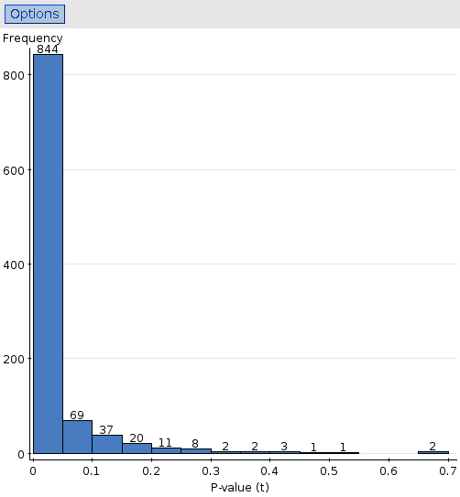

844 P-values of 1000 were less than 0.05, so power about 84%.

Results for sign test: (is this right?)

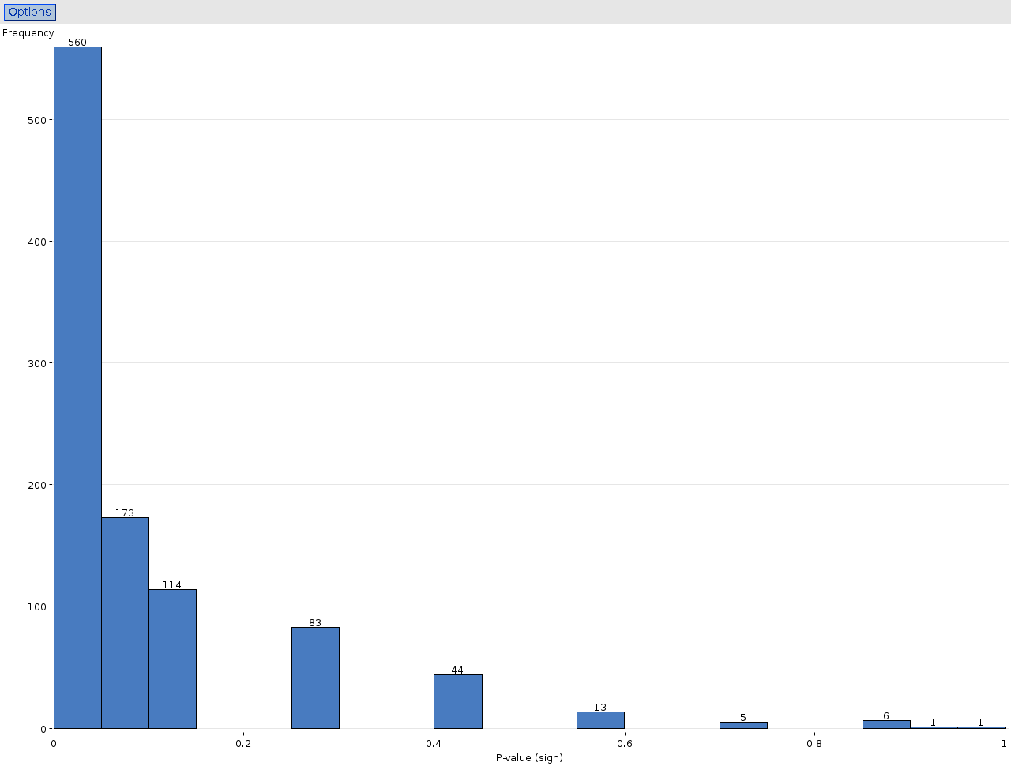
- 560+173=733 P-values less than 0.05, so power around 73%.
- Less than power of t test (84%).
- In both cases, good chance of correctly rejecting null.

Chapter 24: Comparing two means

- Seen that most useful results come from comparing two groups, eg. treatment vs control.
- How to make CI or test for difference between two means?

CI, generally, is

and here, using 1 and 2 to indicate the two samples:
,
and df for based on smaller sample (or use scary formula at bottom of p. 657).

Example

In a study to compare differences in resting pulse rates between men and women, the sample of 28 men had a mean of 72.75 and an SD of 5.37; the sample of 24 women had a mean of 72.625 and an SD of 7.70. What is a 90% confidence interval for the difference in population means? (A boxplot is shown on p. 681, suggesting not much difference.)

Based on 24-1=23 df, . Working with men minus women, the estimate for the difference in population means is = 0.075, and the standard error is = 1.871. Thus the interval is or (-3.13, 3.28). “No difference” entirely plausible.
Test to compare two means

Same story: , compare with right t distribution. The null is “no difference”: or and is for us or .
Filling in everything gives

and get P-value from t with df based on smaller sample.

Example: 50 each of males and females had to place strangely-shaped pegs into matching holes. The number of pegs placed in one minute are as shown:
 | Males | Females
Sample size | 50 | 50
Sample mean | 19.39 | 17.91
Sample SD | 2.52 | 3.39
Is there evidence that the mean number of pegs is different for males and females?

Males=1, females=2: .
= 2.52,
P-value (49 df, use 45) between 0.01 and 0.02.

At have evidence of difference in means (but not at ).
Chapter 25: Paired Samples and Blocks

What about this?

Company institutes exercise break for its workers, assess workers' satisfaction before and after implementation of exercise program.

Worker | 1 | 2 | 3 | 4 | 5 | 6 | 7 | 8 | 9 | 10
Before | 34 | 28 | 29 | 45 | 26 | 27 | 24 | 15 | 15 | 27
After | 33 | 36 | 50 | 41 | 37 | 41 | 39 | 21 | 20 | 37

Two samples of 10 workers, use methods of last chapter?

NO! the same 10 workers were assessed before and after, so don't have two separate samples (would use 10 different workers before and after). Paired data.
Analysis: a piece of cake! Add a row to table:

Worker | 1 | 2 | 3 | 4 | 5 | 6 | 7 | 8 | 9 | 10
Before | 34 | 28 | 29 | 45 | 26 | 27 | 24 | 15 | 15 | 27
After | 33 | 36 | 50 | 41 | 37 | 41 | 39 | 21 | 20 | 37
Difference | -1 | 8 | 21 | -4 | 11 | 14 | 15 | 6 | 5 | 10

- For each worker, find differences after minus before.
  - Then have one sample of differences
- Test to see whether population mean diff could be zero.
  - 10 differences have mean 8.5 and SD 7.47
  - pop mean diff; ,
  - = 3.60, 9 df, P-value < 0.005.
- Or: 95% CI for population mean diff:
  - , = 4.96 to 12.04.
- If differences not normal enough for you, do sign test on differences instead.
Matched pairs and two-sample

The design of controls and instruments has a large effect on how easy they are to use. A sample of 25 right-handed students were asked to turn a knob a fixed distance (with their right hands). There were two identical knobs, one which turned clockwise and one counterclockwise. The times for each student for the two knobs are summarized below.
 | n | Mean | SD
Clockwise | 25 | 104.12 | 15.79
C-clockwise | 25 | 117.44 | 27.26
difference | 25 | -13.32 | 22.94

Find a 95% CI to compare times. Is this matched pairs or two independent samples? Each student gave two measurements, which we can pair up by student. So Matched Pairs.

t*=2.064, so interval is , from -22.79 to -3.85.
Matched pairs and two-sample again

Physical fitness is related to personality. College faculty were divided into high-fitness and low-fitness groups. They were each given an “ego-strength” personality test, with the results summarized below:
 | n | mean | SD
High-fitness | 14 | 6.43 | 0.43
Low-fitness | 14 | 4.64 | 0.69
Differences | 14 | 1.79 | 0.73

Use a 95% CI to compare ego strengths of the high-fitness and low-fitness groups. Is this matched pairs or two independent samples? Each faculty member contributes only one measurement , so there are 28 faculty members in the study altogether. This is two independent samples.
t*=2.160; . Sq root is 0.22; CI is from 1.31 to 2.27.
When the sample sizes are different, it must be two independent samples (no way of pairing them up), but when the sample sizes are the same, it could be either.
Sample size and power

- same as for 1-sample t-test
- sample size for CI to achieve desired margin of error: guess population SD, use z* and fix up as needed.
  - in example above, to get margin of error to be 2,to give n=53.59 or 54.
  - then use t*=2.009 (50 df):
    - , n=56.30 or 57.
- power for test
  - as at end of Chapter 23:
  - simulate using null mean of 0, true mean some value of interest.

Tests and CIs

Inference for | SD to use (for CI if different) | P-value from | For CI use
Proportion | ; | normal
Comparing proportions | ; | normal
Mean |  | t, df n-1
Two means |  | t, df
Matched pairs | differences, as for mean.
We are done!

:-)

