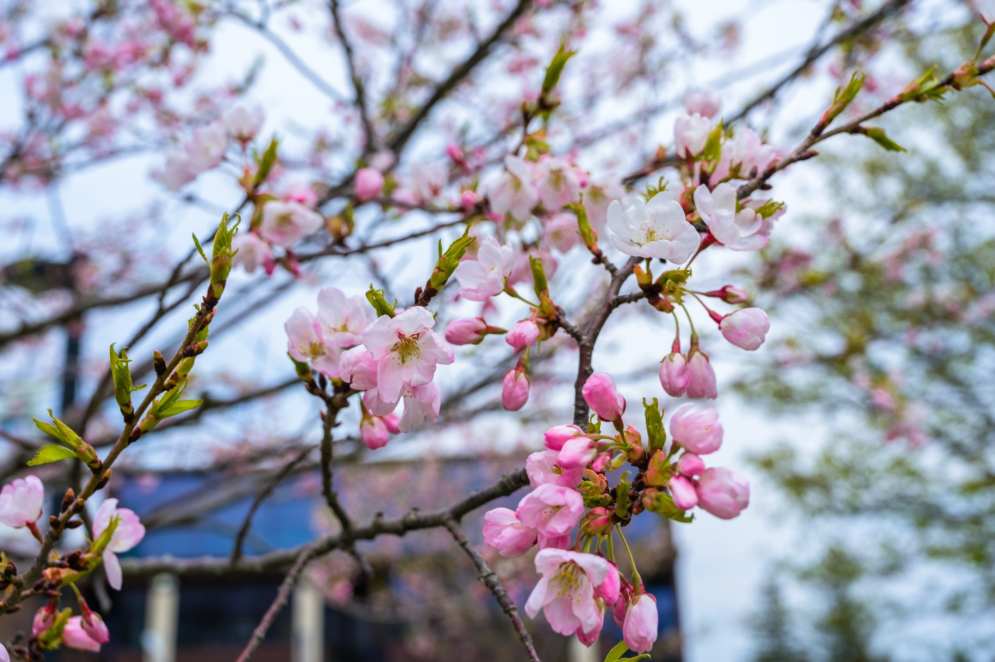

ARTS FUNDING OPPORTUNITIES | Table of Contents  Canadian Heritage  Canada Council for the Arts  Ontario Arts Council  Toronto Arts Council  Ford Foundation  City of Toronto | 2  2  6  8  9  9

Canadian Heritage
 | Canada Cultural Spaces Fund |  | Supports the improvement of physical conditions for arts, heritage culture and creative innovation. |  | Applications may be submitted at any time.
 | Local Festivals – Building Communities Through Arts and Heritage |  | Provides funding to local groups for recurring festivals that present the work of local artists; local artisans; local heritage performers or specialists; and local First Nations, Inuit, and Métis cultural carriers. |  | April 30, 2024: For festivals starting between January 1 and June 30 of the next calendar year.
 | Community Support, Multiculturalism, and Anti-Racism Initiatives Program (Events Component) |  | Provides funding to community-based events that promote intercultural or interfaith understanding, promote discussions on multiculturalism, diversity, racism and religious discrimination, or celebrate a community’s history. |  | Applications must be submitted at least 18 weeks prior to the proposed event start date.
 | Development of Official Language Communities (Strategic Fund) |  | Enhances the vitality of official language minority communities through major projects and strategic initiatives. |  | Applications may be submitted at any time during the fiscal year.
Please visit the Canadian Heritage funding page for more opportunities

Canada Council for the Arts
 | Explore and Create |  | Funds Canadian artists, artistic groups and organizations creating and disseminating innovative, vibrant and diverse art.
 | Professional Development for Artists |  | Supports the career growth of Canadian artists and artistic groups by encouraging participation in development opportunities. |  | Applications may be submitted at any time before the start of the project.
 | Research and Creation |  | Supports the initial stages of the creative process. |  | Applications may be submitted at any time before the start of the project.
 | Concept to Realization (Project Grants) |  | Supports the full creative cycle for single activities, from the initial idea through to presentation. |  | Applications may be submitted at any time before the start of the project.

 | Creating, Knowing and Sharing: The Arts and Cultures of First Nations, Inuit and Métis Peoples |  | Supports Indigenous individuals, groups, Indigenous-led arts organizations and arts/cultural sector development organizations that foster a vital and resilient Indigenous arts ecosystem.
 | Travel |  | Supports travel to events within Canada or abroad that advance professional development, enable access to new markets or build national and international presence. |  | Applications may be submitted at any time before departure.
 | Small-Scale Activities |  | Funds activities that advance artistic careers or practices. This may include acquiring materials for artistic production, engaging in development activities or benefitting from specific expertise, advice or training from a professional artist or cultural carrier. |  | Applications may be submitted at any time before the start of the project.
 | Short-Term Projects |  | Supports any combination of eligible Creating, Knowing and Sharing activities for projects lasting up to 12 months. |  | Applications due: July 17, 2024.
 | Long-Term Projects |  | Supports any combination of eligible Creating, Knowing and Sharing activities for projects lasting more than 1 year, up to 12 months. |  | Applications due: May 8, 2024.
 | Supporting Artistic Practice |  | Funds Canadian arts professionals, groups, and arts organizations who champion the Canadian arts sector, boost artist capacity to realize work and advance the conditions of creation.
 | Professional Development for Arts Professionals |  | Supports the career growth of Canadian arts professionals by encouraging knowledge-sharing and participation in a wide range of development opportunities. |  | Applications due: June 12, 2024.
 | Sector Innovation and Development |  | Supports projects by Canadian and First Nations, Inuit and Métis arts professionals, cultural connectors, groups, and organizations to grow and improve the arts sector. |  | Applications due: April 17, 2024.

 | Arts Across Canada |  | Fosters meaningful relationships and exchanges between artists and the Canadian public.
 | Travel |  | Supports participating in significant events, building a national presence and conducting research for Canadian artistic programming. |  | Applications may be submitted at any time before departure.
 | Representation and Promotion |  | Funds travel linked to promotion and the development of new markets for Canadian artists and artistic works. |  | Applications may be submitted at any time before departure.
 | Translation |  | Funds the translation of Canadian literary or dramatic works into French, English, an Indigenous (First Nations, Métis, Inuit) language, American Sign Language, Langue des signes québécoise, or any other regional Canadian or Indigenous sign language for Canadian publication or presentation. |  | Applications due: June 5, 2024.
 | Circulation and Touring |  | Supports the presentation and exhibition of performances and works by Canadian artists which build national exposure and reach Canadian audiences. |  | Applications due: June 26, 2024.
 | Public Outreach (Project Grants) |  | Supports activities of Canadian groups and organizations, as well as professionals in architecture, that contribute to the public appreciation and enjoyment of the arts. |  | Applications due: August 21, 2024.

 | Arts Abroad |  | Celebrates the creativity, innovation and excellence of Canadian artists by helping to bring Canadian works to the world.
 | Travel |  | Funds travel linked to international presentation, exhibition, artistic collaboration, networking and new market opportunities. |  | Applications may be submitted at any time before departure.
 | Representation and Promotion |  | Funds travel linked to the international promotion of Canadian artists and artistic works. |  | Applications may be submitted at any time before departure.
 | Translation |  | Funds the translation of Canadian literary or dramatic works for international presentation or publication. |  | Applications due: June 5, 2024.
 | Circulation and Touring |  | Funds exchange and networking activities for Canadian artists, arts organizations and artistic groups. |  | Applications due: June 26, 2024.
 | Residencies |  | Supports international artistic and cultural exchanges for Canadian artists, arts professionals, artistic groups and arts organizations. |  | Applications due: June 26, 2024.
 | Co-productions |  | Supports the realization of new works or exhibitions developed by Canadian artistic groups and arts organizations in partnership with foreign arts organizations. |  | Applications may be submitted at any time before the start of the project.

 | Strategic Innovation Fund |  | Supports efforts to build capacity, take risks, share knowledge, find new networks, create prototypes and scale up ambitious solutions.
 | Seed Grants |  | Provide funding to kickstart small-scale activities that explore and develop capacity, partnerships, and promising innovation ideas. |  | Applications due: July 10, 2024.
 | Digital Generator - Stream 2 |  | Funds digital capacity building for Canadian arts organizations and groups. Stream 2 supports implementing recommendations from experts/external consultants. |  | Applications may be submitted at any time before the start of the project, until September 1, 2024.
 | Cultivate Grants |  | Provide funding to implement, pilot and prototype innovation projects that address systemic issues and benefit the broader arts sector. |  | Applications due: June 19, 2024.

 | Other Strategic Funds |  | Targeted funds that respond to particular opportunities or issues in the arts sector.
 | Access Support |  | Supplementary grant for individual applicants who self-identify as Deaf, having disabilities or living with mental illness, as well as groups/ organizations that dedicate the majority of their resources to supporting these communities. Contributes to costs for projects funded through a Canada Council program (the associated grant). |  | Applications may be submitted with the associated grant application, and up to 90 days after receiving results for the latter.
 | Market Access Strategy for Official Language Minority Communities Fund |  | Supports Canadian professional artists, arts professionals, artistic groups and arts organizations self-identifying as members of an official language minority community in their province or territory. |  | Applications may be submitted at any time before the start of the project.
Please visit the Canada Council for the Arts funding page for more opportunities

Ontario Arts Council
 | Creating and Presenting |  | Funds the creation, production and presentation of artistic work through discipline-specific programs and programs created to serve specific priority groups.
 | Exhibition Assistance |  | Supports Ontario-based artists and artist collectives working in visual arts, craft and media art practices in the presentation of their artwork in a confirmed public exhibition. |  | Open from early June 2024; application deadlines vary by third-party recommender.
 | Indigenous Arts Projects |  | Supports Indigenous (First Nations, Métis, Inuit) artists to research, develop and create new work and engage with their communities. |  | Applications due: April 24, 2024 & October 16, 2024
 | Media Artists Creation Projects |  | Supports individual professional Ontario-based media artists/directors working with film, video, audio, digital, new media, video and electronic games, and virtual reality in the production and post-production phases of their projects. |  | Applications due: October 9, 2024.
 | Music Creation Projects |  | Supports Ontario-based professional artists in creating original musical works. This program supports music creators at all career stages, working in all music genres/styles. |  | Applications due: September 11, 2024.
 | Recommender Grants for Theatre Creators |  | Assists theatre creators with developing new work. |  | Open until January 10 2025; application deadlines vary by third-party recommender.
 | Recommender Grants for Writers |  | Supports Ontario writers in the creation of new work and creates or strengthens connections between Ontario writers, publishers, and literary organizations. |  | Open until January 15, 2025; application deadlines vary by third-party recommender.
 | Visual Artists Creation Projects |  | Supports professional Ontario-based visual artists to create new work. The program aims to reflect the range of artistic practices in the visual arts, and to support excellence, regional activity, diverse artists and communities. |  | Applications due: May 1, 2024.

 | Building Audiences and Markets |  | Supports a number of audience and market development projects and initiatives including outreach, touring, residencies, collaborations and travel.
 | Ontario Arts Market Development Travel Grant |  | Supports travel undertaken to promote the work of Ontario artists to presenters. Applicants may travel within Ontario, Canada or internationally to attend a single recognized arts marketplace/event to meet with arts presenters. |  | Program opens April 2024.
Please visit the Ontario Arts Council funding page for more opportunities

Toronto Arts Council

 | Black Arts Projects |  | Supports Black artists, collectives and organizations working in any discipline.
 | Black Arts Projects |  | Supports arts projects by Black artists, Black artist collectives, and Black-led, Black-focused and Black-serving organizations. |  | Applications may be submitted at any time.

 | Indigenous Arts |  | Supports Indigenous organizations, collectives and professional artists working in any discipline.
 | Indigenous Arts Projects |  | Designed to increase participation in and access to Toronto Arts Council funding by Indigenous artists, while increasing the creation and presentation of high-quality Indigenous art in the City. |  | Applications may be submitted at any time.

 | Literary |  | Supports the development of writing, reading series, festivals, performances and other literary activities in Toronto.
 | Grants to Writers: Writers Program |  | Supports the creation of new literary works or works-in-progress in the genres of fiction, literary non-fiction, poetry and oral traditions such as storytelling, dub, rap and spoken-word. |  | Applications due: June 17, 2024.

 | Music |  | Supports the development of writing, reading series, festivals, performances and other literary activities in Toronto.
 | Music Projects |  | Supports professional, non-profit music organizations and collectives to pursue one-time or time-limited music projects involving production, presentation, dissemination and/or other activities that contribute to the development of music in Toronto. |  | Applications due: August 1, 2024.

 | Theatre |  | Supports the development of theatre in Toronto.
 | Playwrights Program |  | Provides support to playwrights for the writing of theatrical plays. |  | Applications due: June 17, 2024.

 | Visual and Media Arts |  | Supports the development of visual/media arts in Toronto.
 | Visual Artists Program: Creation |  | Provides support to visual artists who have a professional independent art practice for the creation/production of new work or the completion of works in progress. |  | Applications may be submitted at any time.
Please visit the Toronto Arts Council funding page for more opportunities

Ford Foundation
 | JustFilms |  | Supports artist-driven, non-fiction film and new media storytelling projects that explore aspects of inequality and the organizations and networks supporting these projects.
 | JustFilms Grants |  | All projects submitted for JustFilms grants are judged on the basis of social and cultural impact, artistic excellence, alignment with Ford priorities, and creativity and innovation in form. |  | Submissions re-open in Fall 2024.

City of Toronto

 | Community Arts Projects |  | Supports artists, collectives and organizations working in any discipline across the city of Toronto.
 | Cultural Hotspot Ignite Ideation Funding |  | Supports artists, creatives, artist collectives, grassroots and resident-led groups and small to midsized community organizations based in, or who may have been displaced from, living or working in Jane and Finch. |  | Applications open April 22, 2024.

