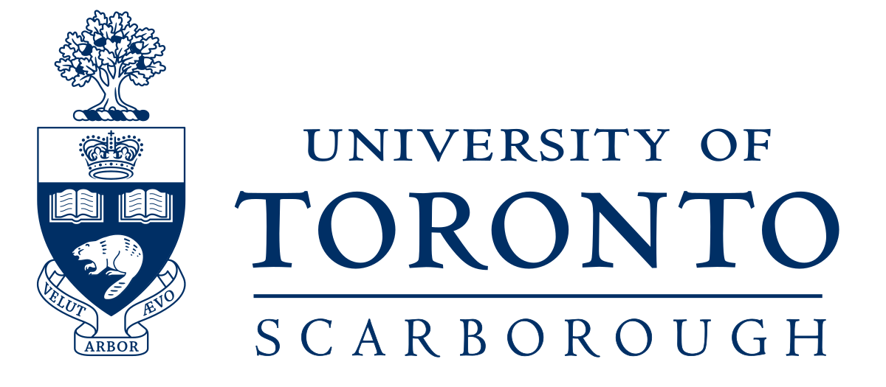
2nd Annual Student Conference -
English & Chinese Translation
Friday, March 10th, 2023
10:00 AM - 3:00 PM
University of Toronto Scarborough (UTSC)
Room MW 329 (Social Science Building)

Time | Event
9:45 AM - 10:00 AM | Check-in
10:00 AM - 10:20 AM | Presentation #1: Yi Liu - University of Toronto Scarborough - English Chinese translation Censorship in Queer literature: a coded culture 對酷兒文學作品英漢翻譯中加密現象的探討
10:25 AM - 10:45 AM | Presentation #2: Ella Chen - University of Toronto Scarborough
10:45 AM - 11:00 AM | Tea/ Coffee Break
11:00 AM - 11:45 AM | Keynote Speaker
11:50 AM - 12:10 PM | Presentation #3
12:15 PM - 1: 15 PM | Lunch
1: 20 PM - 1: 40 PM | Presentation #4
1: 45 PM - 2: 05 PM | Presentation #5: Junzhu Zhou, University of Toronto - "Eco-translatology: A Meta-analysis on Taoism, Buddhism, and Deep Ecology."
2: 05 PM - 2: 30 PM | Adjudication for winners
2: 30 PM - 3: 00 PM | Announcing winners and closing remarks

