Team Name Here
UTSC Mobile App Sample Blueprint

Team Members Names Here
4/20/2012

NOTICE: This document is only an example, and should only be used for reference. Each team should create their own blueprint according to their own situations. This includes target audience, features, and timelines.
UTSC Campus App
This mobile application will be the official mobile application for the University of Toronto Scarborough Campus. Currently, this app is being developed for Android devices.

Target Audience & Problems
All of the above features help solve a variety of issues for the key users of this app: the students. Students, especially new students, are often confused about many aspects of their university career, such as finding new room numbers, staff/faculty contacts, bus schedules, and so on. The UTSC Mobile App serves as a convenient central hub for all of this information, giving students easy access to everything they need.

Features
It will contain 7 main features that will be listed on the main screen. These features are:
- Bus Tracking
- Campus Map
- Computer Labs
- Courses
- Directory
- Timetable
- Videos

Bus tracking
This function tracks the expected arrival times of TTC buses in real time. The app takes information from TTC’s API and displays them to the user. Routes requested are the 38 Highland Creek (both eastbound and westbound), 95 York Mills Eastbound, and 116 Morningside Westbound. Further details of each route can be found by tapping/selecting it, where it will take the user to a display of Google Maps with each bus stop of the route overlaid.

Campus Map
This function will display a Google Map for the user, with campus buildings overlaid on the map. It will display the entire campus, including residence and surrounding areas. Other functions will allow the user to pinpoint his/her location via GPS and toggle building overlay on and off.

Computer Labs
Computer availability in the Library, IC, and BV wings will be displayed here. This function will allow users to see the number of free computers in each computer lab and room bookings in real time. The data will be taken from UTSC’s publically available databases.

Course Descriptions
Under this screen, users will be able to view the course descriptions of a particular. Users will have to enter the full course code, and a description will be pulled from the servers.

Directory
This function allows users to search for staff and faculty members by their entire/part of their name, phone number, or department. The search will generate a list of matches, after selecting one of the matches, it will take the user to a screen of the individual’s information. Source information will be pulled from UTSC’s publically available databases.

Timetable
The timetable allows users to find the lecture times for an individual course, and too bookmark a course into their “favorites” tab for future reference. This feature will use data services that are currently publicly available.

Video
A list of videos will appear after the user selects this function. Videos will all be UTSC related. Each video will take the user to an in-app browser, where the user will be watching the selected video on YouTube. The back button will take the user back to the videos menu.

Tentative Timeline

Date | Task
April 30th | Finalize and submit app idea and team members
Month of May | First team meeting to discuss general direction of project
May 25th | Complete app flowchart
May 31st | Finish and submit the Blueprint
June 1st | Blueprint Due
June 1st - 16th | Layout of each page
June 17th – July 17th | Background coding and connectivity programming
Week of July 16th | Prototype Demonstrations
July 18th – 27th | Refine design & GUI
July 28th – Aug 16th | Testing & fine-tuning
August 17th | Final App Submission Deadline

Course Description

SEARCH

Booking Schedule

Search
Library
BV xxx
BV xxx
IC xxx
IC xxx
Refresh
Google Maps
Google Maps
Bus Tracking
95 – York Mills >
[time1], [time2], [time3]
38 – Highland Creek – W >
[time1], [time2], [time3]
38 – Highland Creek – E >
[time1], [time2], [time3]
116 –Morningside – W >
[time1], [time2], [time3]

Bus Tracking
Campus Map
Computer Labs
Courses
Directory
Timetable
Videos

Query...

See Page 2

Query...
Text 1

Query...
Text1

YouTube
Query...
Videos
Video 1 >
Video 2 >
Video 3 >
Video 4 >
Video 5 >
Course 1

Time 1 – Room 1
Time 2 – Room 2
Time 3 – Room 3
Query...

Course 1
Course 2
Course 3
Course 4
Favourites
Search
Text 1
Favourites
Search

SEARCH
Query...
Text 1
Directory

SEARCH
Bus Tracking
Campus Map
Computer Labs
Courses
Directory
Timetable
Videos

Screenshots
Main Screen | Bus Tracking | Campus Map | Computer Labs
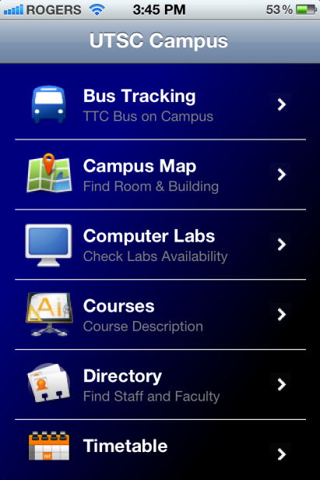 | 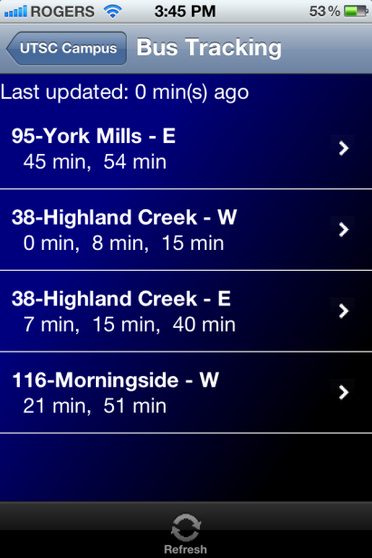 | 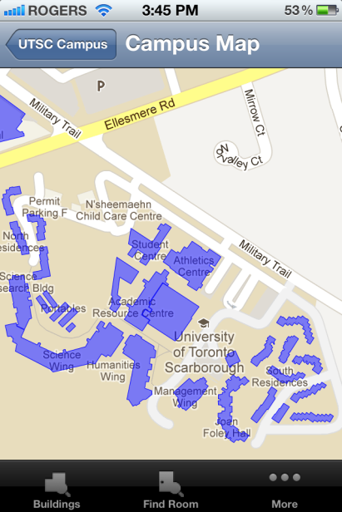 | 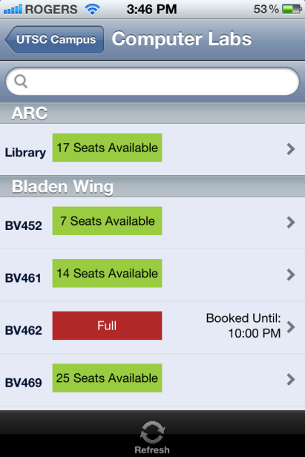
Computer Labs (Schedule) | Course Description | Directory | Timetable
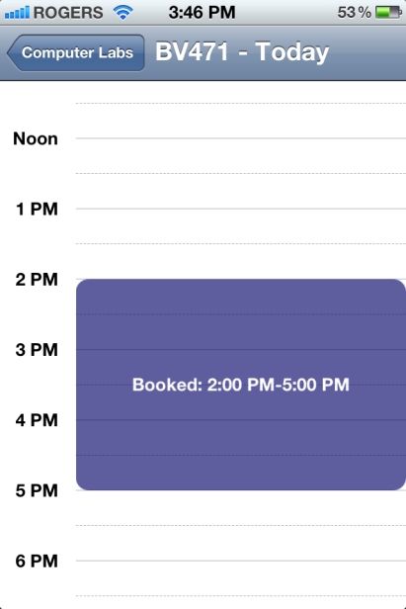 | 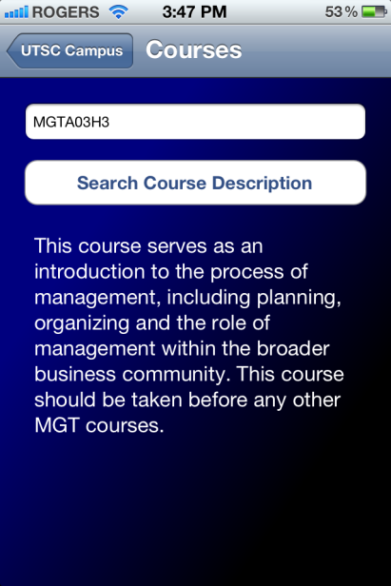 | 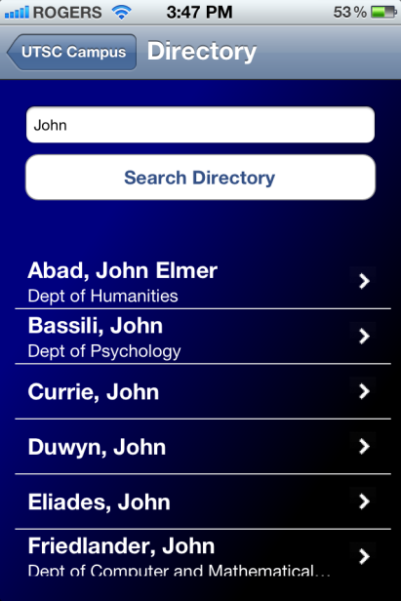 | 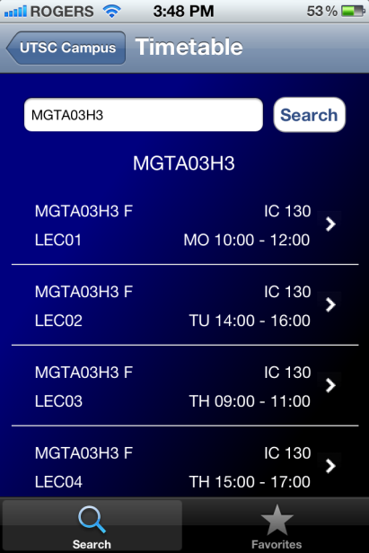
Videos
